Policy-relevant webometrics for individual scientific fields

Mike Thelwall
Statistical Cybermetrics Research Group, School of Computing and Information Technology, University of Wolverhampton, Wulfruna Street, Wolverhampton WV1 1SB, UK.
E-mail: m.thelwall@wlv.ac.uk
Tel: +44 1902 321470 Fax: +44 1902 321478
Antje Klitkou NIFU STEP Norwegian Institute for Studies in Innovation, Research and Education, Wergelandsveien 7, 0686 Oslo, Norway
E-mail: antje.klitkou@nifustep.no
Tel.: +47-22595149 Fax: +47-22595101
Arnold Verbeek
IDEA Consult, Kunstlaan 1-2, box 16, 1210 Brussels, Belgium
E-mail: arnold.verbeek@ideaconsult.be
Tel: +32-2-282-17-19 Fax: +32 2 28217 15
David Stuart
Statistical Cybermetrics Research Group, School of Computing and Information Technology, University of Wolverhampton, Wulfruna Street, Wolverhampton WV1 1SB, UK.
E-mail: dp_stuart@hotmail.com
Tel: +44 1902 321470 Fax: +44 1902 321478
Celine Vincent
IDEA Consult, Kunstlaan 1-2, box 16, 1210 Brussels, Belgium
E-mail: Celine.vincent@ideaconsult.be
Tel: +32 2 609 53 00 Fax: +32 2 28217 15

Despite over ten years of research there is no agreement on the most suitable roles for webometric indicators in support of research policy and almost no field-based webometrics. This article partly fills these gaps by analysing the potential of policy-relevant webometrics for individual scientific fields with the help of four case studies. Whilst webometrics cannot provide robust indicators of knowledge flows or research impact, it can provide some evidence of networking and mutual awareness. The scope of webometrics is also relatively wide, including not only research organisations and firms but also intermediary groups like professional associations, web portals and government agencies. Webometrics can therefore provide evidence about the research process to compliment peer review, bibliometric and patent indicators: tracking the early, mainly pre-publication development of new fields and research funding initiatives, assessing the role and impact of intermediary organisations and the need for new ones, and monitoring the extent of mutual awareness in particular research areas.

Introduction
Webometrics, the informetric analysis of web data, began in 1997 with bibliometric-like indicators (Aguillo, 1998; Almind & Ingwersen, 1997; Rodríguez i Gairín, 1997). Early webometric studies mainly assessed whether hyperlinks could be used to generate research impact indicators because of their structural similarity to citations in connecting two documents (Ingwersen, 1998; Smith, 1999). The findings from this body of work included that the number of links to UK university web sites correlated with their research productivities (Thelwall, 2001) because productive universities publish more online (Thelwall & Harries, 2004) and that hyperlinks were unreliable indicators of journal impact (Smith, 1999; Vaughan & Hysen, 2002). In addition, there were numerous methodological innovations (Thelwall, Vaughan, & Björneborn, 2005) many methods were developed to map web sites based on links to or between them (Heimeriks, Hörlesberger, & van den Besselaar, 2003; Heimeriks & van den Besselaar, 2006; Ortega, Aguillo, Cothey, & Scharnhorst, 2008; Vaughan, 2005, 2006) and alternatives to links were also assessed (Kousha & Thelwall, 2006, 2007; Vaughan & Shaw, 2003, 2005).
A big disadvantage of link analysis webometrics, in contrast to citation analysis, is that web publishing is heterogeneous, varying from spam to post-prints. As a result, the quality of the indicators produced is typically not high unless irrelevant content is manually filtered out, and the results also tend to reflect a range of phenomena rather than just research impact. This makes the indicators difficult to interpret. One success story from webometrics, however, is the world ranking of universities (Aguillo, Granadino, Ortega, & Prieto, 2006) which explicitly measures web publishing and wider impact rather than just research impact. Another success is the increasing incorporation of webometric indicators in policy-relevant contexts within the European Union (see below). Nevertheless, most policy-relevant webometrics operates on a large scale, dealing with collections of universities or countries, with the smallest scale covering collections of departments or research groups within a single discipline. Currently there is no clear way of tackling the issue of web heterogeneity when developing web indicators for the lower level of individual fields. At the level of whole universities or countries, this tends not to be a problem (Thelwall & Harries, 2004; Wilkinson, Harries, Thelwall, & Price, 2003) except perhaps for network diagrams (Harries, Wilkinson, Price, Fairclough, & Thelwall, 2004) but for individual research fields the low number of links involved makes the outputs vulnerable to domination by unusual web publishing strategies.
This article discusses the possibilities for policy-relevant webometrics for individual scientific fields in order to suggest how and when webometric analyses can support science policy decisions about individual fields. Although some previous webometric research has already analysed individual fields, as discussed below, it has not had the broad remit of developing policy-relevant findings. The aims are addressed through case studies of transdisciplinary scientific fields because these seem to require the most urgent and direct policy interventions, such as funding initiatives.

The development of policy-relevant webometrics
As introduced above, early link analysis webometrics developed methods or indicators but no clear practical applications. Early studies began with the Web Impact Factor, a type of calculation based on counting links to a web site or other web space (Ingwersen, 1998). This calculation was practical because links to a web space could be easily counted and listed using an advanced query in the web search engine AltaVista. It gave the promise that the impact of whole areas of the web, including entire countries, could be assessed and was inspired by the journal Impact Factor (Garfield, 1999). Subsequent research found problems including the unreliability of search engines (Bar-Ilan, 1999; Mettrop & Nieuwenhuysen, 2001) and the existence of links created for spam or recreational reasons (Smith, 1999). This may have prevented the early adoption of Web Impact Factors as policy-relevant indicators and they subsequently attracted less interest.
After then initial research there was a period of methodological development in which webometrics defined its key terminology (Björneborn & Ingwersen, 2004), developed specialist data collection and analysis software (Cothey, 2004; Heimeriks et al., 2003; Thelwall, 2001), assessed new methods for counting links (Thelwall, 2002), and introduced a range of visualisation techniques for presenting the results (Heimeriks et al., 2003; Heimeriks & van den Besselaar, 2006; Lamirel, Al Shehabi, Francois, & Polanco, 2004; Ortega et al., 2008; Prime, Bassecoulard, & Zitt, 2002; Vaughan, 2005, 2006).
Following the development phase link analysis emerged in several practical applications. Probably first was the Webometrics World Ranking of Universities on the Web (Aguillo et al., 2006) which was a web site listing the world’s universities in rank order based upon their web presences: in addition to links it incorporates various factors measuring the amount of web publishing of universities. This seemed to be a popular site, for example attracting an honorary doctorate for its founder from an overseas university, and hence qualifies as a genuine link analysis application. Two further applications were the European Union-commissioned projects NetReAct (Barjak, Li, & Thelwall, 2007) and RESCAR. These both included link network diagrams as part of the suite of evidence arranged to assess the extent of researcher international mobility in Europe for individual broad disciplines (social science, engineering, life sciences). In these projects, links were used as weak indicators of the extent of internationalism of each nation’s research groups and also as weak proxies of research productivity, as part of the sampling strategy for the interviews and questionnaires. As examples of commissioned policy-relevant indicators including links, these projects can also claim to demonstrate the crossover of link analysis webometrics from theory to practice. Probably the clearest evidence, however, is the inclusion of link diagrams in the European Commission Science, Technology and Competitiveness key figures report 2008/2009 (Directorate-General_for_Research, 2008) provided by the InternetLab team in CINDOC, Spain. Another type of application was the commissioning of six-monthly reports on the web impact of white paper-style documents published by the UK National Endowment for Science Technology and the Arts (NESTA) from September 2007.
This small collection of examples shows that webometric link analysis has demonstrated that it can deliver useful information although it is probably far less widely used than the pioneering originators of webometrics anticipated. Two key methods have occurred in most link analysis applications: network diagrams and tables of inlink counts, normally counting inlinking sites rather than inlinking pages. In both cases interpreting the results is a key issue because of the wide variety of reasons for which links are created. The NetReAct and RESCAR projects circumvented this problem to some extent by focusing on highly specific research group web sites that were likely to attract mainly research-relevant links. The Webometrics ranking of universities was able to justify incorporating and combining all types of web links in a single measure because of its focus on web publishing and its impact rather than research impact. The NESTA (unpublished confidential) reports mentioned above dealt with the issue by including a content analysis of a random sample of links to aid the interpretation of the statistics.
Finally, note that there are various different types of indicator, including input indicators, output indicators, and process indicators (Geisler, 2000) and although bibliometrics tends to produce output indicators (i.e., related to the end products of research), this is not true for webometrics. In the case of webometrics, indicators can also cover the process of research, for instance due to links that reflect collaboration or project membership.

Research Questions
This paper has two broad research questions that reflect its general aims.
- In which scientific fields are webometric indicators likely to be most policy-relevant?
- Which kinds of policy-relevant findings are likely to be derived from webometric indicators of individual scientific fields?
In order to address the research questions, the overall methodological approach was to conduct four case studies of webometric analyses of transdisciplinary scientific fields attracting the interest of policy makers and then generalise the findings into a theoretical framework and recommendations for future policy-relevant research.

Methods
Four transdisciplinary research areas were selected as varied and policy-relevant case studies in conjunction with the Directorate-General of Research in the EC, who funded the project that this article derives from.
- 2nd generation biofuels is a research area for sustainable biofuels (liquid fuels made from renewable material) that are based on non-food feedstock and are hence more sustainable than first generation biofuels, such as those based on rape seed or corn.
- Nanomaterials concerns materials with at least one dimension measuring between 1 and 100nm.
- Food safety is a research area of relevance to government and industry, drawing primarily on microbiology and biochemistry. Its importance has grown in the past decade due to swine fever, foot-and-mouth disease and BSE crises.
- Biotech pharmaceuticals concerns biotechnology in the development of therapeutics, in vivo diagnostics and vaccines.
As part of the policy-relevant remit for the research, the focus of the case study analyses was on the European Research Area countries (ERA) and their relationship to the USA, Japan, South Korea and the BRIC countries (Brazil, Russia, India and China).

Data collection
For each case study the web sites of relevant research organisations and research groups, companies, international associations and national authorities were identified. Relevant URLs were gathered from different sources, such as Google, Google Scholar, specialised directories, national and international agencies, databases (e.g., CORDIS, Scirus, ScienceDirect, FP6) and interviews with field experts.
Research groups were found from relevant scientific publications and research projects. For the URLs pointing to governmental institutions, the focus was on web sites of government agencies and of associations. The majority of the URLs found were for public research organisations and firms. We distinguished public research organisations (PRO), such as universities, academies of science and government research institutes or laboratories, and non-profit research and technology organisations (RTO) which play a clear role in some countries despite little government funding. The following classification scheme was used.
- Industry: Business, industry fair, industry association
- Public science: Public research organisation (university or academy of science), scientific journal, scientific conference, scientific association
- Government: National body, international body (organised by the UN, OECD or EU)
- Non-profit: Non-governmental organisations (NGOs); think tanks, other associations or intermediaries, other events, research and technology organisations (research institutes outside universities and academies, research foundations)
A sample of 150 URLs was selected for each technology field, covering the ERA countries, a sample of non-ERA countries (U.S., China, India, Brazil, Japan, South Korea and Russia), and international domains, including commercial addresses. In terms of international distribution, the following countries were best represented: USA (22%), United Kingdom (7%), Germany and the European Union (5% each), Sweden, France and Denmark (4% each), the Netherlands, Italy, Japan and China (3% each).
The final selection was made under the guidance of field experts. The primary objective of the selection process was not to give complete coverage but to generate sufficient relevant URLs in order to give a reasonable analysis. The URL samples are not fully representative because of the ERA-oriented remit and because geographic representation is biased by the intrinsic strengths of countries in specific subfields. For example, a country with a recognised strength in a field will probably have a larger population of active firms and research organisations in that field, and thus also a larger population of active web sites. Nevertheless, through manual searches and advice from the interviewees, the samples seem to include the most important organisations.
The coverage of BRIC countries, Japan and Korea was problematic due to language issues. The names of some of the identified organisations and firms varied in translation and in some cases organisations identified by publications or experts could not be found online, perhaps for this reason.
In addition to the geographic bias, there will also be a human bias in every sample. Even though the selection is aided by field experts, the personal position of the expert will influence the sample. Whilst this should not affect the main web sites, it might impact on the coverage of the specialisms of the experts and their countries of origin or work. However, since the results are dominated by the main organisations in the field, the overall outcome and conclusions should not be affected.
A practical link data collection issue for each case study was that the URLs representing web presences varied considerably. Whereas some organisations had a domain or a sub-domain that focused primarily on a relevant research topic, for other organisations only a part of the domain focused on the topic. For the latter, a single key page was used instead of the whole domain. This is because link searches can only be conducted for individual pages or whole domains or subdomains. Inlinks were collected through the Yahoo Application Programming Interface (API) by submitting queries in the form:
link:AAA.com/page.html -site:AAA.com
or, if a whole domain was used for a web site:
linkdomain:AAA.com -site:AAA.com
Whilst the search engine may return results showing more than one link between two web sites, it is more appropriate to ignore multiple links between sites (Thelwall, 2002) due to differences in the linking behaviour of organisations within the different sectors. A larger number of links from a university web site than a commercial web site is as likely to be a reflection of the linking practices in the different sectors as an increased knowledge flow (Stuart, Thelwall, & Harries, 2007).
Interview partners were identified and contacted during and after the URL selection process. A diverse geographic spread was sought, with larger and smaller European countries, international organisations and organisations in countries outside the European Research Area. Another selection criterion was the balance between policy makers, academic researchers and industry representatives. A total of 38 interviews were conducted with people from 13 countries as well as representatives of the EU and international organisations.
Some interviewees provided URLs and screened the collected samples of URLs, as described above. All were asked to give insights into the technology field and into their experience with knowledge flows, such as participation in conferences and seminars, collaboration in joint papers, use of scientific journals and use of web sites. The purpose of this was to inform the analysis of the webometric results. The interviews were therefore part of the strategy for coping with the heterogeneity of web links and the lack of robustness of webometric outputs.

Analysis
Network diagrams and summary statistics from social network analysis (SNA) were primarily used to analyse the link data. Network visualisation enables researchers to spot patterns in complex networks, something humans are good at (Rossi, 2006). There are many heuristics for positioning nodes in a network diagram and Kamada-Kawai (1989) and Fruchterman-Reingold (1991) are two of the most popular. The Kamada-Kawai algorithm, which has been used in numerous webometric studies (e.g., Holmberg & Thelwall, 2009) ignores connection strengths, however, and so the Fruchterman-Reingold algorithm was selected because it can treat directional binary connections as stronger (double strength) and hence should generate more meaningful pictures. Nevertheless, for the larger diagrams extensive manual rearrangement was used to produce readable maps with web site names not overlapping.
Whilst network diagrams provide an overview of the relationships within a network of actors, the field of social network analysis provides a number of methods for calculating the centrality of individual web sites within a network. The three most established and important centrality measures (Otte & Rousseau, 2002) are defined below.
For web networks, degree centrality (Wasserman & Faust, 1994) is the number of other web sites that each web site is connected to, whether with inlinks or outlinks. Whilst this can provide useful information, it fails to take into consideration the position of the nodes within the network. This issue is addressed in the calculation of betweenness centrality, for which an actor is considered central if it tends to lie on the geodesics of other actors, i.e., the shortest paths between any two actors (Wasserman & Faust, 1994). Specifically, the betweenness-centrality of a web site is the probability that it lies on a geodesic between two random web sites in the network. Closeness centrality is based on the idea that an actor is central to a network if it close to all the other actors. The closeness centrality of a web site is defined to be the reciprocal of the sum of the shortest paths (geodesics) of the web site with all other web sites (Wasserman & Faust, 1994). Hence, a high closeness centrality for a web site indicates that it can reach most other web sites through relatively short paths of links.
Network analysis metrics also enable comparisons to be made between different whole networks. Graph density refers to the proportion of connections present in a network out of all possible connections. The size of a network is likely to have an impact on the graph density: the more actors in a network, the more connections each actor needs to make for the network to have the same density. A version of graph density is also used to report the strength of inter-sector links: the percentage of total possible inter-sector links. This is the total number of links from web sites in sector A to web sites in sector B (e.g., government to industry links) as a percentage of the theoretical maximum number of links. For instance if there were 10 government web sites and 20 industry web sites and 5 links from government to industry web sites then the calculation would be 5/(10x20) x 100%. The maximum number of links is 10x20, i.e. every government web site linking to every industry web site.

Illustrative results
The results presented here are illustrative rather than exhaustive, focusing on 2nd generation biofuels in order to present a coherent narrative. In each subsection, a general analysis follows the case study findings.

Webometric analysis
Of the 150 selected 2nd generation biofuels web sites, 57 were found to be linked with at least one other web site in the study. These formed a 45-node sub-network, a 4-node sub-network, and four 2-node sub-networks (see Figure 1). Since just 38% of the 150 URLs were interlinked, the 2nd generation biofuels community is relatively loosely connected. This is confirmed by a network density (percentage of links that exist) statistic of 74/(150²-150)= 0.33%.

Table 1. Representation of the four sectors in the 57 interlinking sites.
Type | Web sites in  full sample (150) | Web sites selected  for interlinking (57)
Government | 18 | 4 (22%)
Industry | 47 | 20 (43%)
Public Science | 58 | 25 (43%)
Non-profit | 27 | 8 (30%)

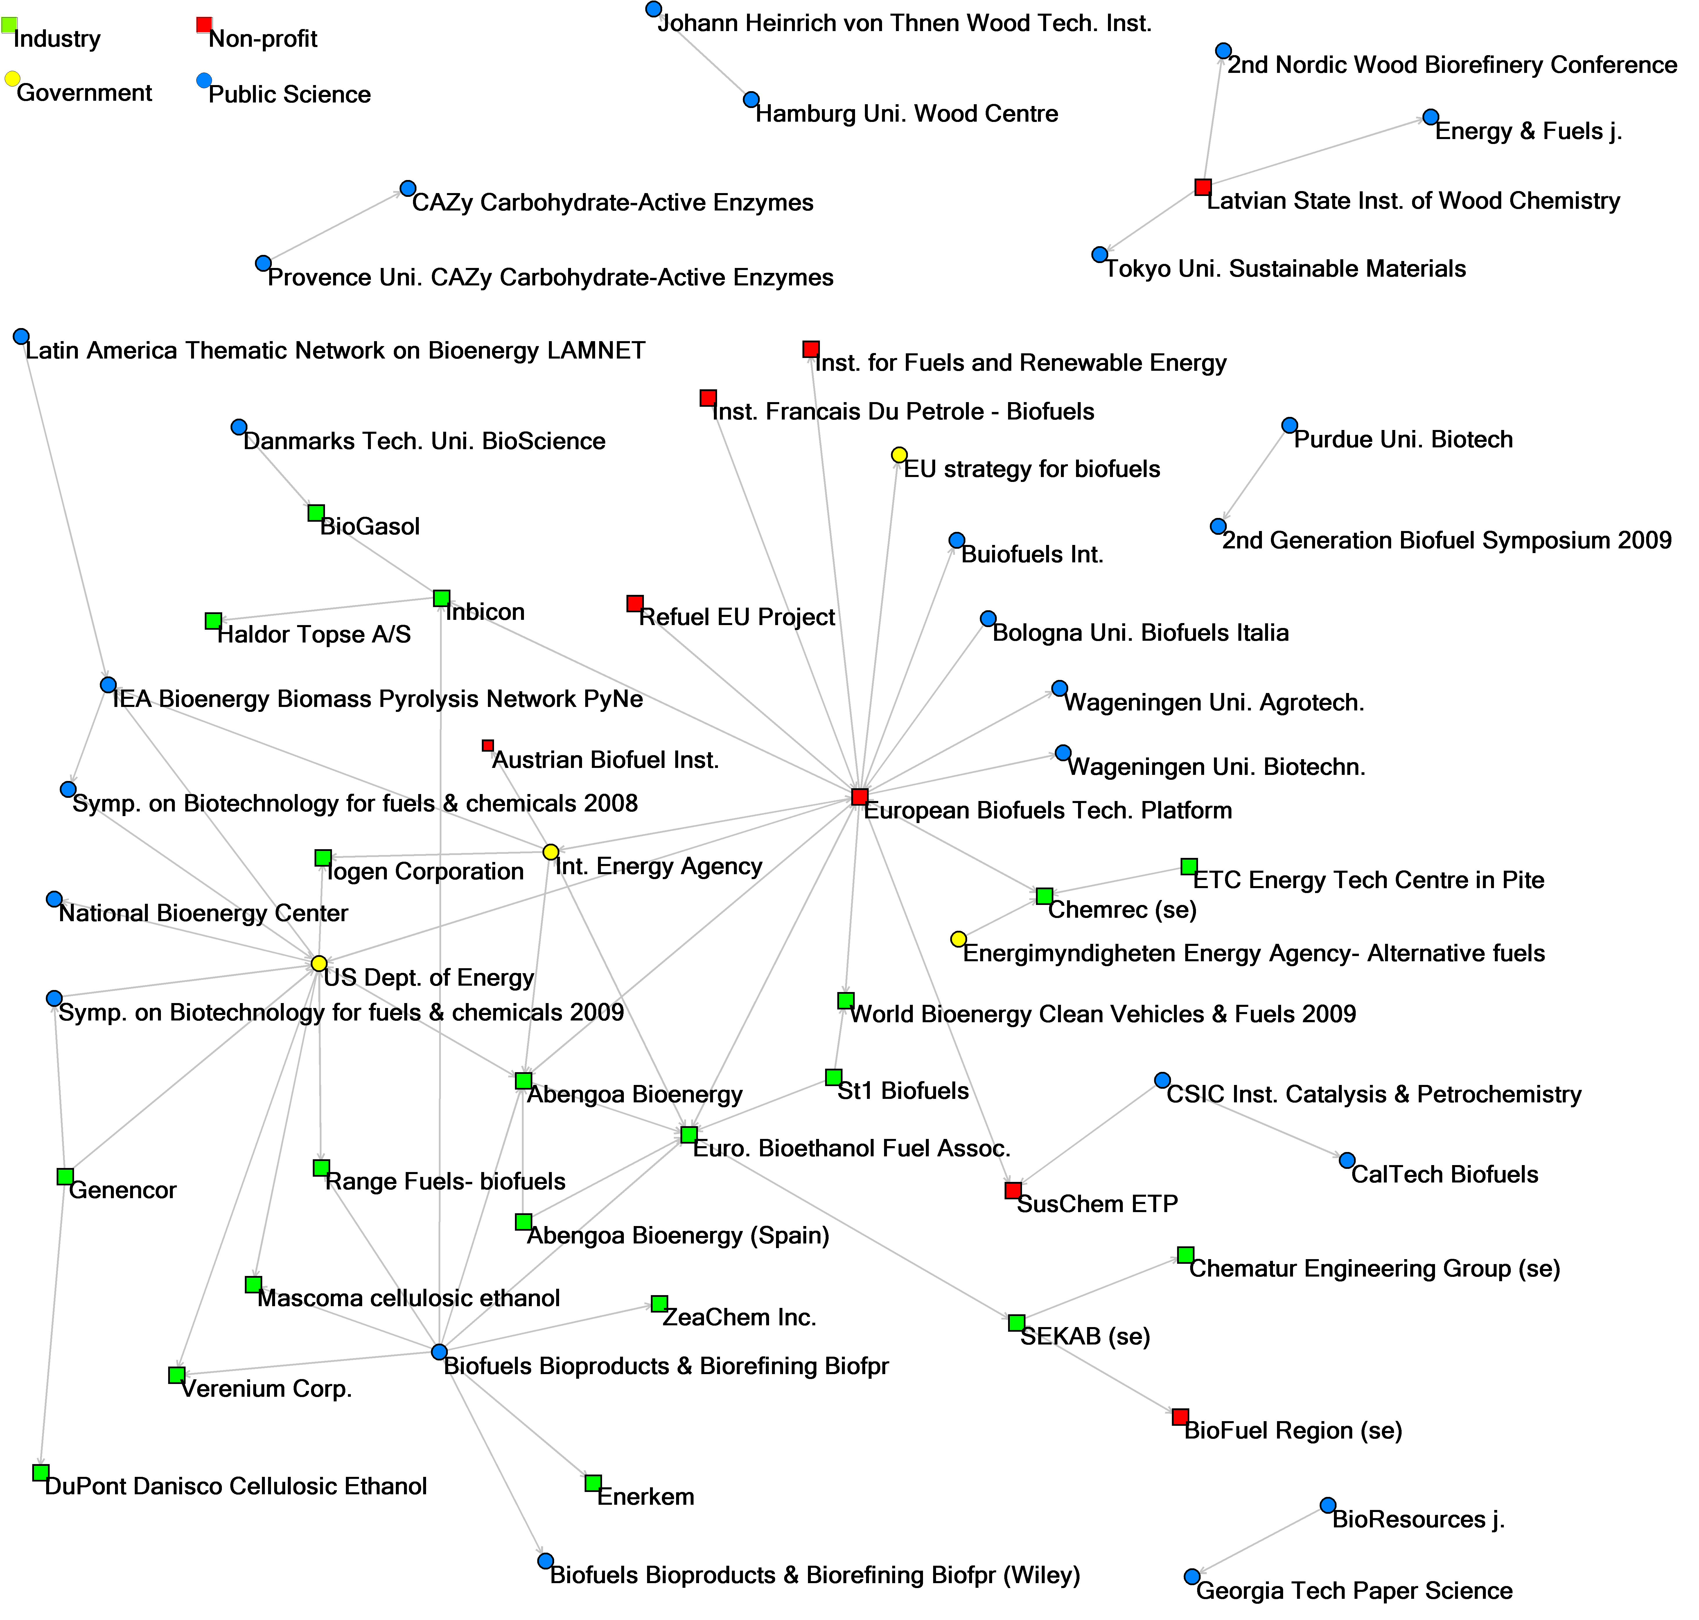
Figure 1. Linking between the 57 connected 2nd generation biofuels web sites.

Based upon Figure 1 and similar diagrams for the other three case studies, the value of a hyperlink network diagram of key organisations within a scientific field appears to be in delivering three different types of information.
- Overall network structure – as with author co-citation analysis (White & Griffith, 1982; White & McCain, 1998) or maps of science (Boyack, 2009; Small, 1999), having a graphical representation of a field is useful to help understand its structure. It seems that even a partial map, as given by webometrics, is useful, especially if complemented with expert commentaries.
- Network density – comparisons of different fields can suggest whether any particular field has enough connections to suggest “normal” functioning and hence whether remedial action may be needed to support networking.
- Individual actor roles – analysis of individual organisations in the diagram, such as ETPs, can suggest whether they are playing the role expected of them.

Individual web sites
Table 2 shows that in Europe the European Technology Platforms (ETP), European Biofuels Technology Platform, SusChem ETP, and one of the industry associations for biofuels, the European Bioethanol Fuel Association, are the most central. There were several European industry associations active in the field that could not be included in the URL list, so this shows the importance of international industry associations. The ETPs integrate both industry, research and technology organisations and public research organisations and are therefore central to the European knowledge system. In the United States the U.S. Department of Energy’s biomass program is central. It is also directly connected to the European network.
Only one of the scientific journals has a prominent position in the network, the recently started (2007) Journal of the Society of Chemical Industry, Biofuels, Bioproducts & Biorefining (Biofpr). It connects to several important industry players in 2nd generation biofuels, such as Abengoa, Inbicon and Range Fuels, and also connects to the European Bioethanol Association. However, it is joint bottom for betweenness centrality because it has no inlinks yet.
Several industry players are central in the network: Abengoa is active both in Europe (Spain) and the United States, Inbicon comes from Denmark and is also active on the U.S. market, and Chemrec and SEKAB are two Swedish companies, which are active in or collaborate with developing countries (China, Brazil, Tanzania).
Scientific conferences are less visible: only the 30th Symposium on Biotechnology for Fuels and Chemicals 2008, a special conference of the U.S. Society for Industrial Microbiology are at all central in the URL sample.
National bodies are least represented in the network: only the U.S. Department of Energy has a central position. The web sites of the European Commission, such as the Biofuels web site of the Directorate-General for Energy and Transport and the EU strategy for biofuels, are not prominent. The public research organisations are not in the centre of the network but are well connected to the associations and national bodies. However, there are several small networks of public research organisations which are not connected to the main network.

Table 2. Web sites with the highest centrality in the 2nd generation biofuels network.
Rank | Degree Centrality |  | Betweenness Centrality |  | Closeness Centrality
1 | European Biofuels Technology Platform | 20 | European Biofuels Technology Platform | 0.113 | European Biofuels Technology Platform | 0.429
2 | U.S. Department of Energy | 13 | European Bioethanol Fuel Association | 0.075 | ABENGOA Bioenergy | 0.366
3 | European Bioethanol Fuel Association | 9 | U.S. Department of Energy | 0.074 | U.S. Department of Energy | 0.362
4 | Biofpr | 9 | ABENGOA Bioenergy | 0.047 | European Bioethanol Fuel Association | 0.358
5 | International Energy Agency | 8 | Chemrec | 0.018 | International Energy Agency | 0.334
6 | ABENGOA Bioenergy | 7 | 30th Symposium on Biotechnology for fuels and chemicals, 2008 | 0.017 | Inbicon | 0.325
7 | Inbicon | 4 | PyNE - Biomass Pyrolysis Network | 0.015 | Biofpr | 0.307
8 | PyNE - Biomass Pyrolysis Network | 4 | SEKAB | 0.014 | Chemrec | 0.289
9 | Chemrec | 4 | Inbicon | 0.014 | SusChem ETP | 0.289
10 | SEKAB | 4 | International Energy Agency | 0.013 | Range Fuels | 0.285

The value of analysing the centrality of key organisations within a scientific field appears to be in identifying key actors. As the discussion above illustrates, although the different centrality measures tend to give similar web site rank orders, they can confirm which organisations form the key parts of the link network.

Sector types
Inter-sector links are not strong anywhere, although there are several links to government from public science and industry web sites and from government to non-profit web sites (Table 3).

Table 3: Links between the four sectors, and as a percentage of total possible links within the 57 sites.
From\To | Government | Industry | Public Science | Non-profit
Government | 0 (0.0%) | 9 (11.3%) | 3 (3.0%) | 2 (6.3%)
Industry | 4 (5.0%) | 11 (2.9%) | 1 (0.2%) | 3 (1.9%)
Public Science | 2 (2.0%) | 9 (1.8%) | 8 (1.3%) | 2 (1.0%)
Non-profit | 3 (9.4%) | 6 (3.8%) | 6 (3.0%) | 5 (8.9%)

Whilst industrial sector organisations are spread throughout the network, the importance of these sites is clearer when the sites are aggregated according to organisational type (see Figure 2). Scientific journals, national bodies and other associations point mainly to firms, while the firms point in a much lower degree to national bodies, international and other associations, and scientific conferences. Fairs are less active, pointing to no other organisations, but gaining links from firms and other associations. Firms clearly play an important role. Whilst they have more inlinks than outlinks, a feature of commercial organisations that has been noticed in previous investigations (e.g., Shaw, 2001), they nonetheless have a significant number of outlinks.

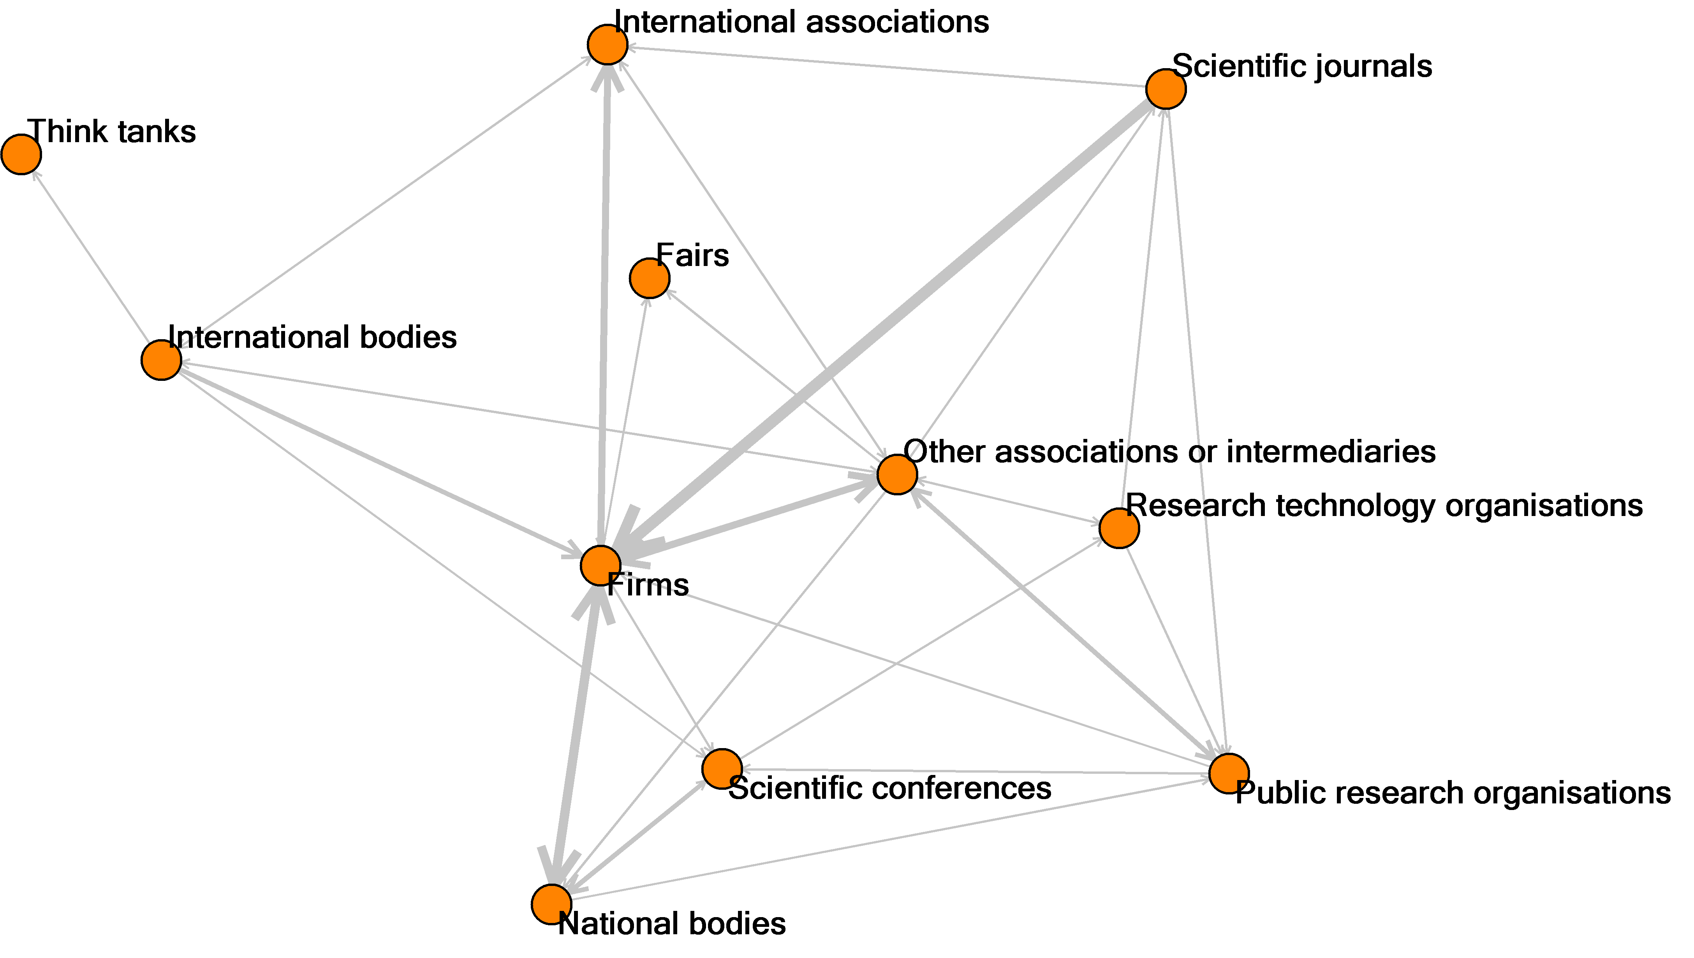
Figure 2: Linking between organisational types in 2nd generation biofuels.

The value of hyperlink network diagrams and statistics about the extent of interlinking between key organisation types within a scientific field appears to be in assessing the overall role of each sector type within the scientific field. Interpretation of the results is made difficult by the likely different roles for links within each sector type, however, and so this type of information provides only weak evidence.

Nations
Figure 3 shows the linking between web sites aggregated at the country level. Whilst the network is dominated by the USA, international organisations, and European organisations, there are also strong positions for Spain and Denmark, since companies in both countries (Abengoa and Inbicon) are active in the U.S. market. However, the direction of links seems to be mainly from Europe to the U.S., with a mediating position of international web sites. The European countries are well connected by European web sites, but some of them (Spain, Denmark, Austria, Finland and Latvia) are connected to international web sites. Outside the ERA only the US, Canada and Japan appear in this analysis and web sites from the BRIC countries and South Korea are omitted due to being disconnected. The new EC member states are represented by Latvia and Poland.

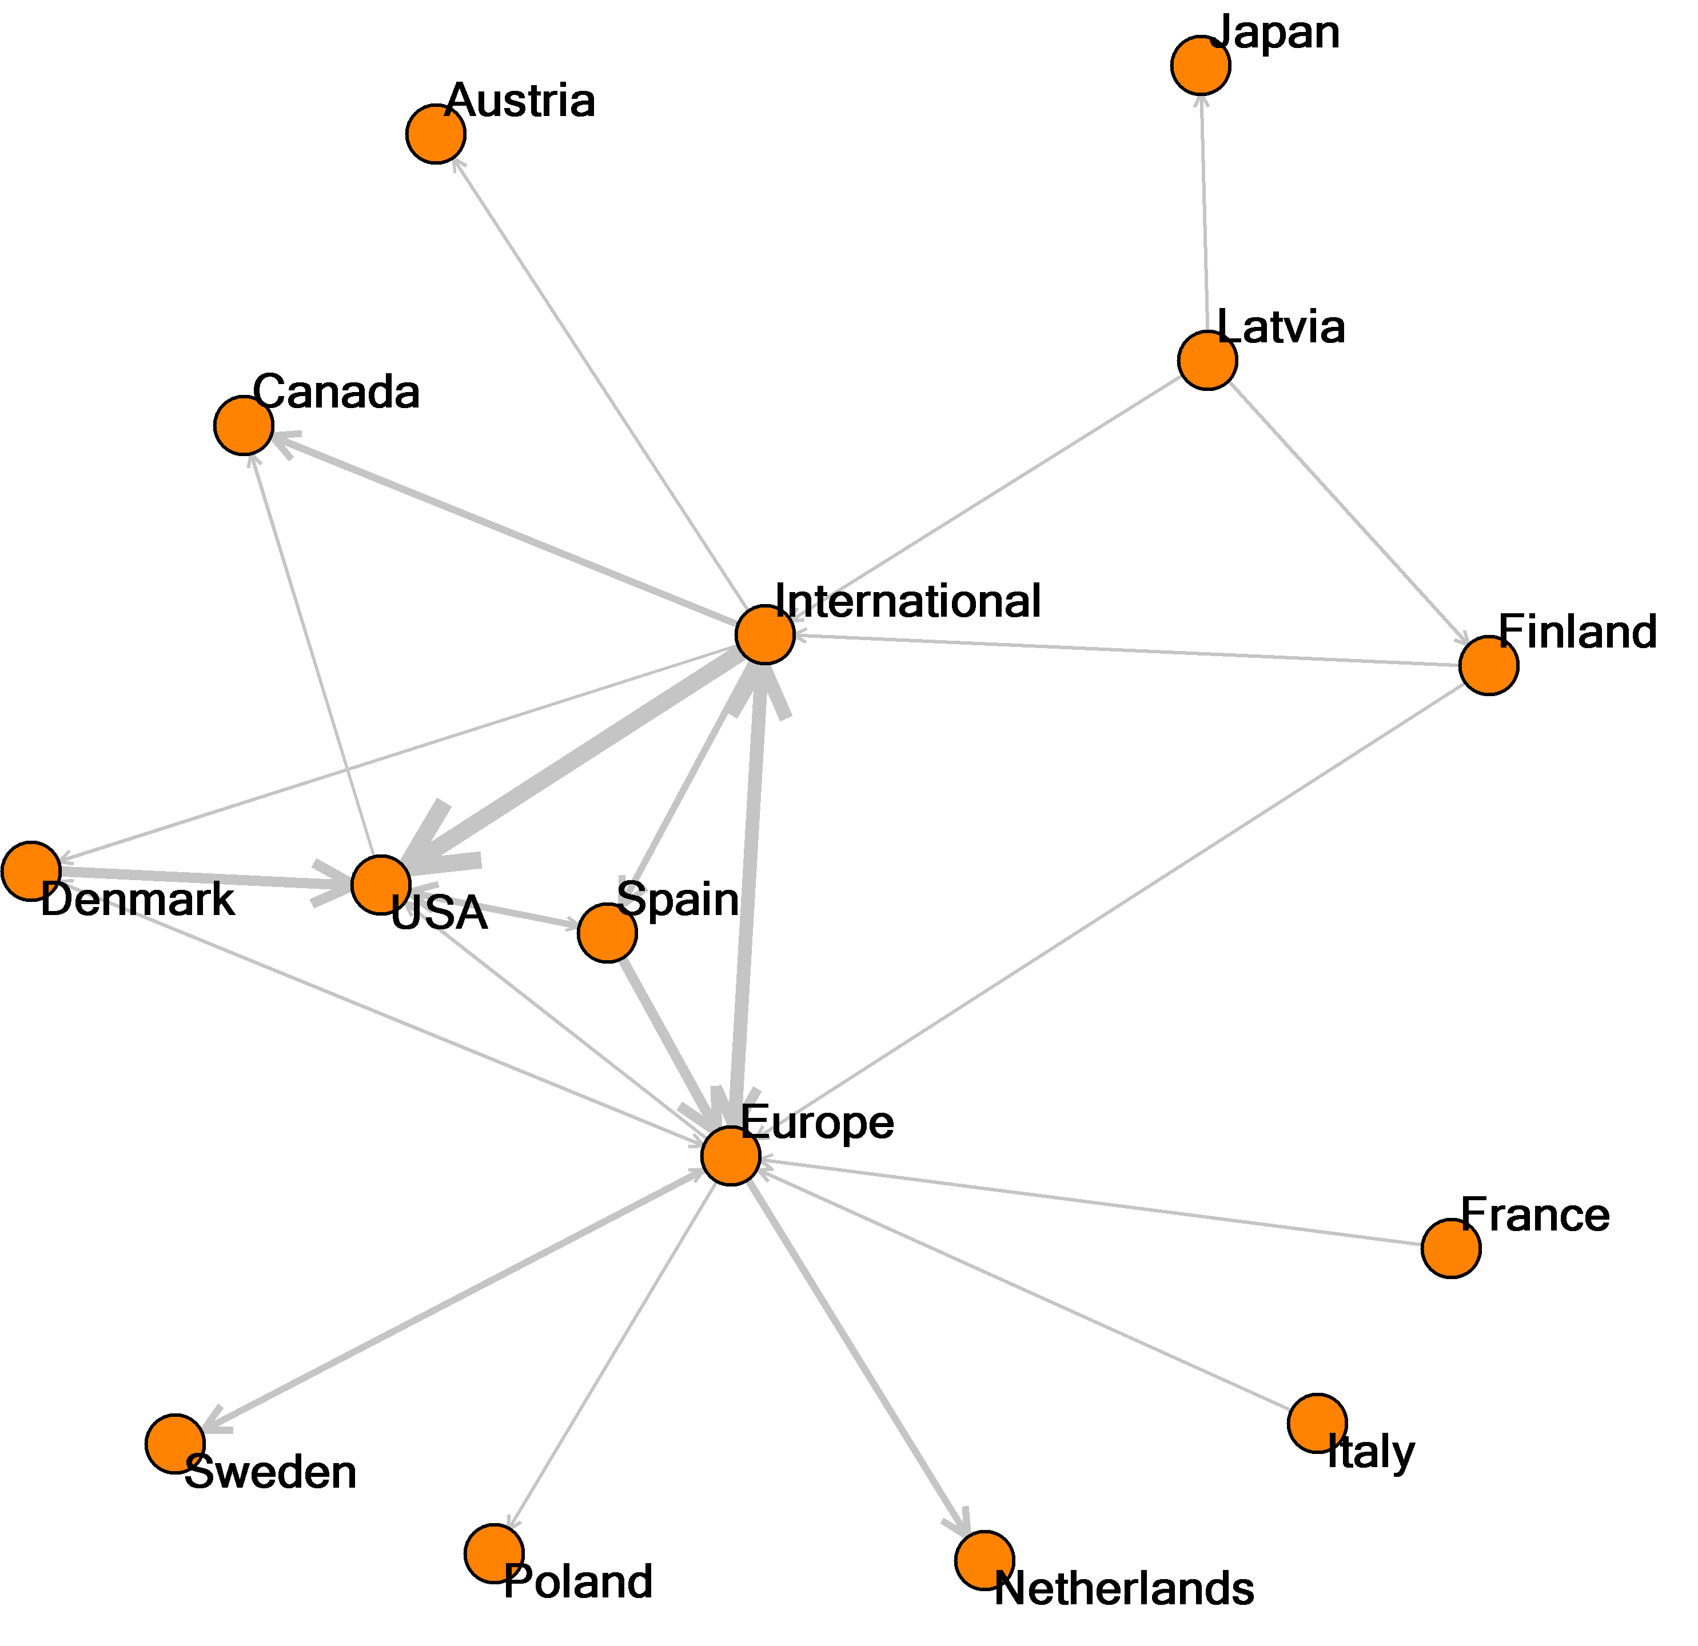
Figure 3: Linking between countries in 2nd generation biofuels.

The value of hyperlink network diagrams and statistics about the extent of interlinking between nations within a scientific field appears to be in identifying key nations and international connections within the scientific field.

Interviews and case study conclusions
There are many channels for knowledge transfer, and “policy makers should not overemphasize one single channel (such as patents, spin-offs or contract research)” (Bekkers & Bodas Freitas, 2008). Access to scientific journals and technical reports and participation in scientific conferences and specialised seminars and workshops were described by the interviewees as important channels of knowledge transfer for the 2nd generation biofuels community. This importance is also visible in the webometric analysis, but less prominent. However, the interviewees also highlighted differences between general conferences and specialised seminars or workshops. Most of the interviewees preferred specialised events as a knowledge exchange channel, while the general conferences were thought to be good for networking.
The usage of webometrics was unknown by all of the interviewees and they had not thought about the importance of hyperlinks. Organisations often have specialised departments for updating web sites, but the interviewees from the industry associations showed that most of the knowledge gathered in their network is only available via an Extranet rather than the web. The web is more used for public reports and advertisement. Nevertheless, the link networks were a useful aid for showing the structure of the field.
The webometric analysis shows that the network for 2nd generation biofuels is centred on the industry-related web sites. Central are the collaboration of industry firms in international technology networks, such as the European Technology Platforms, the connection to international industry associations and the scientific conferences and seminars. The analysis reveals the connecting position of international industry associations, the International Energy Agency and ETPs. This was expected, since this is one of their main tasks, as one of the interviewees pointed out. This position of international organisations would not be visible in a bibliometric or patent analysis, since the address field for publication indexes such as the Web of Science contains no ETPs, only the primary affiliation of the authors. The same applies to patent databases.
The importance of conferences for knowledge exchange could be better assessed by bibliometric measures, since historical data would also be available and conferences organised by specific organisations could be addressed separately. In the webometric study of 2nd generation biofuels many conferences were invisible because web sites of older conferences are often not maintained.

Discussion of all case study results
The following key results emerged from the case studies of 2nd generation biofuels, food safety, nanomaterials, and biotech pharmaceuticals.

Organisational relationships
One of the most important assets of webometrics is the potential to highlight the roles of organisations that may be less visible in traditional bibliometric and patent analysis; for example, the role of government agencies was clearly shown in the area of food safety and the importance of intermediaries was shown in the case of nanomaterials, biotech pharmaceuticals and second generation biofuels. This is an important feature that distinguishes webometric analysis from other traditional network visualisation methods based for example on co-patenting and/or co-publication analysis. Whereas the latter clearly reflect ‘collaboration’ patterns, the relationships identified through webometrics are more loosely coupled and may reflect a weaker form of networking and/or collaboration. Webometrics thus provides the opportunity to see the broader picture of the network in which industrial players, researchers and government operate.

Cross-sector relationships
Webometric analysis can reveal cross-sector patterns and relations. Clustering and labelling relevant web sites as public science, government, non-profit and industry, webometric analysis can show interrelations between broader groups of actors (sectors). In each of the case studies, the analysis revealed a different picture, suggesting sensitivity to field-specific patterns. The value added of this lies in the analysis or the assessment of the role of types of organisation in a particular field (e.g., research institutes and government). Cross-sector relationships can also be studied with bibliometrics (Calvert & Patel, 2003) or patents (Leydesdorff, 2004), however.

Field dynamism and maturity
Webometric analysis and indicators, such as network density statistics, make comparisons between different technology fields possible. They provide insights about the maturity of a technology field, how well organisations in the field are connected, and how certain type of actors play their role in the network compared to other fields. An almost 10-fold difference between the field of nanomaterials (graph density 2.39%) and second generation biofuels (graph density 0.33%) illustrates this. Access to historical data would provide the opportunity to better understand the changing nature of subfield networks over time, as well as the relative position (centrality) of individual actors, which is of interest when studying fields from an evolutionary perspective.
Taking this a step further, webometrics can provide insights for strategic discussions about when bridging organisations (e.g., ETPs) are needed. The four case studies included several ETPs that fulfil the bridging role between industry, academia and government. It can thus be argued that setting up platforms in sparsely connected fields may to help bridge the gaps between organisations (a brokerage function) and thus speed up the development of a field. Webometrics may provide evidence which can help policy makers to take this decision.

Theoretical framework for assessing the usefulness of webometrics for individual fields
Science is a diverse undertaking in many dimensions, including the organisation of disciplines (Whitley, 2000), the extent of applied or theoretical orientation (Stokes, 1997) and research cultures (Becher & Trowler, 2001). It is hence logical that webometrics would not have the same relevance for every scientific field. Drawing upon the case studies, the literature review and additional analysis, the following seem to be the key factors that make webometrics relatively more useful for a given field, in contrast to bibliometrics, which is still the default and normally the best choice for quantitative analyses of science.
Factors undermining the value of bibliometrics
- Fast moving or new fields are likely to not be well covered by bibliometric indicators due to the publication time lag – two years may be a common gap between starting research and a first publication appearing in print. This therefore increases the relative value of webometrics because research groups can publish general information online about their research, such as research group or project web sites, even before starting research.
- Social sciences and humanities research is less well covered by bibliometric databases due to differing publishing cultures including more importance attached to books (White et al., 2009) and chapters in edited volumes rather than journal articles (Moed, 2005, p. 147-151).
- Similarly, fields in which outputs are not well covered by the Web of Science, Scopus or other bibliometric databases, would be less likely to be sufficiently analysed by bibliometric methods (e.g., Van Impe & Rousseau, 2006).
- Applied fields are likely to include types of research that are not published in formal academic outputs and hence are likely to be insufficiently covered by bibliometrics. This gap can be partly filled by patents (Leydesdorff, 2004; Oppenheim, 2000).
- Multidisciplinary fields seem likely to be more complex to analyse with bibliometrics due to difficulties identifying relevant articles, varying citation cultures (especially if involving both sciences and social sciences or humanities) and possibly varying coverage in bibliometric databases.
Factors increasing the intrinsic value of webometrics
- Fields in which substantial web sites are common are more likely to generate enough publishing for webometric indicators. This probably includes most areas of computer science, but also many sciences (Tang & Thelwall, 2003).
- Fields in which substantial web publishing is common (e.g., blogs, wikis, web sites for resources or software) in contrast to traditional journal publishing are more likely to generate enough publishing for webometric indicators (e.g., Fry, 2006). This may apply mainly to more discursive subjects in the humanities and social sciences, but there seems to be no systematic evidence for this and field differences in the use of online communication are known to be complex (Kling & McKim, 2000; Matzat, 2001, 2004; Nentwich, 2003).
- Fields in which standards and types of web publishing are relatively uniform are more likely to generate reliable web indicators. For example, in fields in which a few research groups produce huge web-based resources (e.g., online genome databases, online dictionaries, field-based web portals) these would probably dominate the webometrics and render the results meaningless or trivial.
- Fields in which networking is underdeveloped or problematic are more likely to benefit from webometric indicators of networking because, unlike standard bibliometrics, these include connections falling short of formal collaborations on published work.
- Smaller fields are more amenable to webometric analysis, particularly the network diagrams. Fields that are too large (e.g., nanomaterials) are difficult to meaningfully analyse with current standard webometrics techniques.
Operational factors
- Webometric studies seem to be cheaper and faster than comparable bibliometric studies because web data is free and data cleaning is less time consuming, although time is needed to select the URLs to be analysed.
It seems likely that fields to which many of the above apply are the best candidates for webometrics. As discussed above, however, there are many known limitations of webometrics, such as the lack of quality control over much web publishing, the fact that web publishing is an optional activity for many researchers, in contrast to scientific publishing, and data collection and interpretation difficulties (Bar-Ilan, 2001, 2004; Björneborn & Ingwersen, 2001; Rousseau, 1999). As a result, webometric measures are always weak indicators of the phenomenon studied and need to be combined with other approaches whenever possible.

Conclusion and policy recommendations
The above framework points to contexts in which webometrics is most likely to be useful and the following summarises the policy-relevant evidence that it may provide.
- Patterns and relationships among organisations and sectors (economic sectors, but also sectors of activity) that could not otherwise have been identified with metrics. In particular, entire organisations (e.g., scientific associations, technology portals) are present in webometrics that are important for fields but do not publish and hence would be absent from standard bibliometric analyses.
- Patterns and relationships among the wider network and the intensity of interactions (network density) among actors in a field(s). For example, how closely related are actors in specific fields? Who plays a pivotal role: academia, industry or government? Which countries host key organisations?
These points highlight that webometrics should be seen primarily as a source of evidence about the research process, rather than as a source of evaluative indicators, and a number of recommendations can be made. Webometrics can provide a unique scope of coverage of organisation types and can be carried out at an earlier stage in the development of a field than traditional bibliometrics. Nevertheless, the results suggest that it is not suited to large or mature fields. Hence, webometrics is recommended for monitoring new fields, particularly strategic new fields. The network diagrams generated by webometrics can be particularly useful in giving an overview of key actors within an emerging or heterogeneous field. Webometrics could provide insights into the relationships between organisations and countries, regardless of the nature of the relationship. A webometric analysis could be used in conjunction with bibliometrics as long as a field is not too new, otherwise insights to support the webometrics should be gained from interviews with field experts.
Webometrics can also be used to compare different subfields. This could provide relevant insights about the density of linkages in a certain field compared to others and hence help to target policy efforts to enhance collaboration and cooperation. The large difference between nanomaterials and the other fields was particularly revealing of a significantly different overall structure.
As argued above, webometrics provides a snapshot of the interrelations between actors and countries. In terms of policy, this snapshot can be used to identify types of missing relationship. The case studies have shown the importance of intermediate organisations in bridging borders (national and organisational). Webometrics can thus provide an early warning system with respect to the need to install bridging mechanisms in fields that are too loosely connected (e.g., ETPs or scientific organisations).
The ability of webometric analysis, through indicators such as degree centrality, closeness centrality and betweenness centrality, to reveal important organisations in a specific field can also be exploited in order to identify effective channels for communication. From a policy perspective it can be important to establish partnerships or cooperate with leading organisations in the field in order to reach as many people as possible, such as organising conferences in collaboration with leading institutes that are visible in the webometric network analysis, and targeting communication towards key organisations.
In conclusion, whilst webometrics is still inferior to bibliometrics for most purposes it seems that it has advantages for some types of field, particularly new, small fields, and can deliver policy-relevant (process) indicators to promote effective collaboration and communication.

Acknowledgement
This paper is based on the project “The use of webometrics for the analysis of knowledge flows within the European Research Area”, funded by the European Commission, DG Research, Unit C3 Economic analysis and monitoring of national research policies and the Lisbon strategy PP-CT-M2-2005-0001, for 126,425 Euros. We thank the European Commission Services for its financial support. Moreover, we thank Mrs. Maud Skäringer, the European Commission project officer, for her constructive and valuable suggestions. We also thank Sylvan Katz, Ismael Rafols and Mark Knell for help with the study. The opinions expressed in the article are those of the authors and do not represent the Commission’s official position.

References
Aguillo, I. F. (1998). STM information on the Web and the development of new Internet R & D databases and indicators. In Online Information 98 (pp. 239-243): Learned Information.
Aguillo, I. F., Granadino, B., Ortega, J. L., & Prieto, J. A. (2006). Scientific research activity and communication measured with cybermetrics indicators. Journal of the American Society for Information Science and Technology, 57(10), 1296-1302.
Almind, T. C., & Ingwersen, P. (1997). Informetric analyses on the World Wide Web: Methodological approaches to 'Webometrics'. Journal of Documentation, 53(4), 404-426.
Bar-Ilan, J. (1999). Search engine results over time - a case study on search engine stability. Retrieved January 26, 2006, from http://www.cindoc.csic.es/cybermetrics/articles/v2i1p1.html
Bar-Ilan, J. (2001). Data collection methods on the Web for informetric purposes - A review and analysis. Scientometrics, 50(1), 7-32.
Bar-Ilan, J. (2004). The use of Web search engines in information science research. Annual Review of Information Science and Technology, 38, 231-288.
Barjak, F., Li, X., & Thelwall, M. (2007). Which factors explain the web impact of scientists' personal home pages? Journal of the American Society for Information Science and Technology, 58(2), 200-211.
Becher, T., & Trowler, P. (2001). Academic tribes and territories (2ed).Milton Keynes, UK: Open University Press.
Bekkers, R., & Bodas Freitas, I. M. (2008). Analysing knowledge transfer channels between universities and industry: To what degree do sectors also matter? Research Policy, 37(10), 1837-1853.
Björneborn, L., & Ingwersen, P. (2001). Perspectives of Webometrics. Scientometrics, 50(1), 65-82.
Björneborn, L., & Ingwersen, P. (2004). Toward a basic framework for webometrics. Journal of the American Society for Information Science and Technology, 55(14), 1216-1227.
Boyack, K. (2009). Using detailed maps of science to identify potential collaborations. Scientometrics, 79(1), 27-44.
Calvert, J., & Patel, P. (2003). University-industry research collaborations in the UK: bibliometric trends. Science and Public Policy, 30(2), 85-96.
Cothey, V. (2004). Web-crawling reliability. Journal of the American Society for Information Science and Technology, 55(14), 1228-1238.
Directorate-General_for_Research. (2008). A more research-intensive and integrated European Research Area: Science, Technology and Competitiveness key figures report 2008/2009. European Commission, Retrieved October 28, 2009 from: http://ec.europa.eu/research/era/pdf/key-figures-report2008-2009_en.pdf.
Fruchterman, T. M. J., & Reingold, E. M. (1991). Graph drawing by force-directed placement. Software: Practice and Experience, 21(11), 1129–1164.
Fry, J. (2006). Studying the scholarly web: How disciplinary culture shapes online representations. Cybermetrics, 10(1), http://www.cindoc.csic.es/cybermetrics/articles/v10i11p12.html.
Garfield, E. (1999). Journal impact factor: a brief review. Canadian Medical Association Journal, 161(8), 979-980.
Geisler, E. (2000). The metrics of science and technology.Westport, CT: Quorum Books.
Harries, G., Wilkinson, D., Price, E., Fairclough, R., & Thelwall, M. (2004). Hyperlinks as a data source for science mapping. Journal of Information Science, 30(5), 436-447.
Heimeriks, G., Hörlesberger, M., & van den Besselaar, P. (2003). Mapping communication and collaboration in heterogeneous research networks. Scientometrics, 58(2), 391-413.
Heimeriks, G., & van den Besselaar, P. (2006). Analyzing hyperlink networks: The meaning of hyperlink-based indicators of knowledge. Cybermetrics, 10(1), Retrieved August 1, 2006 from: http://www.cindoc.csic.es/cybermetrics/articles/v2010i2001p2001.html.
Holmberg, K., & Thelwall, M. (2009). Local government web sites in Finland: A geographic and webometric analysis. Scientometrics, 79(1), 157-169.
Ingwersen, P. (1998). The calculation of Web Impact Factors. Journal of Documentation, 54(2), 236-243.
Kamada, T., & Kawai, S. (1989). An algorithm for drawing general undirected graphs. Information Processing Letters, 31(1), 7-15.
Kling, R., & McKim, G. (2000). Not just a matter of time: Field differences and the shaping of electronic media in supporting scientific communication. Journal of the American Society for Information Science, 51(14), 1306-1320.
Kousha, K., & Thelwall, M. (2006). Motivations for URL citations to open access library and information science articles. Scientometrics, 68(3), 501-517.
Kousha, K., & Thelwall, M. (2007). Google Scholar citations and Google Web/URL citations: A multi-discipline exploratory analysis. Journal of the American Society for Information Science and Technology, 58(7), 1055 -1065.
Lamirel, J.-C., Al Shehabi, S., Francois, C., & Polanco, X. (2004). Using a compound approach based on elaborated neural network for Webometrics: An example issued from the EICSTES project. Scientometrics, 61(3), 427-441.
Leydesdorff, L. (2004). The university-industry knowledge relationship: Analyzing patents and the science base of technologies. Journal of the American Society for Information Science and Technology, 54(11), 991-1001.
Matzat, U. (2001). Social networks and cooperation in electronic communities: a theoretical-empirical analysis of academic communication and Internet discussion groups. University of Groningen, Groningen.
Matzat, U. (2004). Academic communication and Internet Discussion Groups: transfer of information or creation of social contacts? Social Networks, 26(3), 221-255.
Mettrop, W., & Nieuwenhuysen, P. (2001). Internet search engines - fluctuations in document accessibility. Journal of Documentation, 57(5), 623-651.
Moed, H., F. (2005). Citation analysis in research evaluation.New York: Springer.
Nentwich, M. (2003). Cyberscience: Research in the age of the Internet.Vienna: Austrian Academy of Sciences.
Oppenheim, C. (2000). Do patent citations count? In B. Cronin & H. B. Atkins (Eds.), The web of knowledge: a festschrift in honor of Eugene Garfield (pp. 405-432). Metford, NJ: Inormation Today Inc. ASIS Monograph Series.
Ortega, J. L., Aguillo, I., Cothey, V., & Scharnhorst, A. (2008). Maps of the academic web in the European Higher Education Area: an exploration of visual web indicators. Scientometrics, 74(2), 295-308.
Otte, E., & Rousseau, R. (2002). Social network analysis: a powerful strategy, also for the information sciences. Journal of Information Science, 28(6), 441-453.
Prime, C., Bassecoulard, E., & Zitt, M. (2002). Co-citations and co-sitations: A cautionary view on an analogy. Scientometrics, 52(4), 291-308.
Rodríguez i Gairín, J. M. (1997). Valorando el impacto de la información en Internet: AltaVista, el "Citation Index" de la Red. Revista Española de Documentación Científica, 20(2), 175-181.
Rossi, F. (2006). Visualization methods for metric studies. Paper presented at the International Workshop on Webometrics, Informetrics and Scientometrics, Nancy, France.
Rousseau, R. (1999). Daily time series of common single word searches in AltaVista and NorthernLight. Cybermetrics, 2/3, Retrieved July 25, 2006 from: http://www.cindoc.csic.es/cybermetrics/articles/v2002i2001p2002.html.
Shaw, D. (2001). Playing the Links: Interactivity and Stickiness in.Com and ﾓNot.Comﾔ web Sites. First Monday, 6(3), Retrieved November 2, 2009, from http://firstmonday.org/htbin/cgiwrap/bin/ojs/index.php/fm/article/view/2837/2746.
Small, H. (1999). Visualising science through citation mapping. Journal of American Society for Information Science, 50(9), 799-813.
Smith, A. G. (1999). A tale of two web spaces; comparing sites using Web Impact Factors. Journal of Documentation, 55(5), 577-592.
Stokes, D. E. (1997). Pasteur's quadrant: Basic science and technological innovation.Washington, D.C.: Brookings Institution.
Stuart, D., Thelwall, M., & Harries, G. (2007). UK academic web links and collaboration - an exploratory study. Journal of Information Science, 33(2), 231-246.
Tang, R., & Thelwall, M. (2003). U.S. academic departmental Web-site interlinking: Disciplinary differences. Library & Information Science Research, 25(4), 437-458.
Thelwall, M. (2001). Extracting macroscopic information from web links. Journal of American Society for Information Science and Technology, 52(13), 1157-1168.
Thelwall, M. (2001). A web crawler design for data mining. Journal of Information Science, 27(5), 319-325.
Thelwall, M. (2002). Conceptualizing documentation on the Web: An evaluation of different heuristic-based models for counting links between university web sites. Journal of American Society for Information Science and Technology, 53(12), 995-1005.
Thelwall, M., & Harries, G. (2004). Do better scholars' Web publications have significantly higher online impact? Journal of American Society for Information Science and Technology, 55(2), 149-159.
Thelwall, M., Vaughan, L., & Björneborn, L. (2005). Webometrics. Annual Review of Information Science and Technology, 39, 81-135.
Van Impe, S., & Rousseau, R. (2006). Web-to-print citations and the humanities. Information - Wissenschaft und Praxis, 57(8), 422-426.
Vaughan, L. (2005). Exploring website features for business information. Scientometrics, 61(3), 467-477.
Vaughan, L. (2006). Visualizing linguistic and cultural differences using Web co-link data. Journal of the American Society for Information Science and Technology, 57(9), 1178-1193.
Vaughan, L., & Hysen, K. (2002). Relationship between links to journal Web sites and impact factors. ASLIB Proceedings, 54(6), 356-361.
Vaughan, L., & Shaw, D. (2003). Bibliographic and Web citations: What is the difference? Journal of the American Society for Information Science and Technology, 54(14), 1313-1322.
Vaughan, L., & Shaw, D. (2005). Web citation data for impact assessment: A comparison of four science disciplines. Journal of the American Society for Information Science & Technology, 56(10), 1075-1087.
Wasserman, S., & Faust, K. (1994). Social network analysis: Methods and applications.Cambridge, NY: Cambridge University Press.
White, H. D., Boell, S. K., Yu, H., Davis, M., Wilson, C. S., & Cole, F. T. H. (2009). Libcitations: A measure for comparative assessment of book publications in the humanities and social sciences. Journal of the American Society for Information Science and Technology, 60(6), 1083-1096.
White, H. D., & Griffith, B. C. (1982). Author co-citation: a literature measure of intellectual structure. Journal of American Society for Information Science, 32(3), 163-172.
White, H. D., & McCain, K. W. (1998). Visualizing a discipline: An author co-citation analysis of information science, 1972-1995. Journal of the American Society for Information Science, 49(4), 327-355.
Whitley, R. (2000). The intellectual and social organization of the sciences (2 ed.). Oxford: Oxford University Press.
Wilkinson, D., Harries, G., Thelwall, M., & Price, E. (2003). Motivations for academic Web site interlinking: Evidence for the Web as a novel source of information on informal scholarly communication. Journal of Information Science, 29(1), 49-56.

Thelwall, M., Klitkou, A., Verbeek, A., Stuart, D. & Vincent, C. (2010). Policy-relevant webometrics for individual scientific fields, Journal of the American Society for Information Science and Technology, 61(7) 1464-1475. © copyright 2010 John Wiley & Sons.
http://www.netreact-eu.org/
http://www.erawatch-network.eu/en/Projects/research-inventory-service/collection-and-analysis-of-existing-data-on-researchers-careers-and-implementation-of-new-data-collection-activities.html

