Quantitative Comparisons of Search Engine Results

Mike Thelwall
School of Computing and Information Technology, University of Wolverhampton, Wulfruna Street, Wolverhampton WV1 1SB, UK. E-mail: m.thelwall@wlv.ac.uk
Tel: +44 1902 321470 Fax: +44 1902 321478

Search engines are normally used to find information or web sites, but webometric investigations use them for quantitative data such as the number of pages matching a query and the international spread of those pages. For this type of application, the accuracy of the hit count estimates and range of URLs in the full results are important. Here, we compare the applications programming interfaces of Google, Yahoo! and Live Search for 1,587 single word searches. The hit count estimates were broadly consistent but with Yahoo! and Google reporting 5-6 times more hits than Live Search. Yahoo! tended to return slightly more matching URLs than Google, with Live Search reporting significantly fewer. Yahoo!’s result URLs included a significantly wider range of domains and sites than the other two and there was little consistency between the three engines in the number of different domains. In contrast, the three engines were reasonably consistent in the number of different top-level domains represented in the result URLs, although Yahoo! tended to return the most. In conclusion, quantitative results from the three search engines are mostly consistent but with unexpected types of inconsistency that users should be aware of. Google is recommended for hit count estimates but Yahoo! is recommended for all other webometric purposes.

Introduction
The growing information science field of webometrics is concerned with finding and measuring web based phenomena drawing upon informetric techniques (Björneborn & Ingwersen, 2004). Although specialist research web crawlers are sometimes used to collect data analysed (e.g., Björneborn, 2006; e.g., Heimeriks, Hörlesberger, & van den Besselaar, 2003), commercial search engines are the only choice for some applications (e.g., Aguillo, Granadino, Ortega, & Prieto, 2006; Barjak & Thelwall, 2008, to appear; Cronin, Snyder, Rosenbaum, Martinson, & Callahan, 1998; Ingwersen, 1998; Kousha & Thelwall, 2007; Vaughan & Shaw, 2005), especially those needing information from the whole web (as far as possible) rather than just from a limited set of web sites (Thelwall, 2004). Other fields, such as corpus linguistics (Resnik & Smith, 2003), also sometimes use search engines for research purposes.
A fundamental problem with scientific uses of commercial search engines is that their results can be unstable (Bar-Ilan, 1999, 2004; Mettrop & Nieuwenhuysen, 2001; Rousseau, 1999) and their algorithms are not fully documented in the public domain. Previous studies comparing search engines have discovered limited overlaps between their results (for a brief review see: Spink, Jansen, Blakely, & Koshman, 2006) as well as significant international biases in coverage (Vaughan & Thelwall, 2004; Vaughan & Zhang, 2007) and ranking (Cho & Roy, 2004). As an extreme example, the results on the first page have a very small overlap: a comparison of Live Search, Google, Yahoo! and Ask Jeeves found that 84.9% of the combined results for a query (sponsored and non-sponsored links) were unique to only one search engine (Spink et al., 2006).
Many previous search engine studies have taken the perspective of the typical user, assessing the value, freshness and/or completeness of the information returned (e.g., Bar-Ilan & Peritz, 2004; Lewandowski, Wahlig, & Meyer-Bautor, 2006) or the overlap between the results of multiple search engines (Ding & Marchionini, 1996; Lawrence & Giles, 1999). In contrast, the webometrics community tends to employ the hit count estimates or URLs returned in search engine results to analyse web structure or to generate other meta-information such as concerning the international spread of ideas on the web (see review below). Unfortunately, webometric investigations using only one search engine are vulnerable to accusations that their results may be dependant upon the particular search engine used. This paper assesses the extent to which search engine results in webometric investigations are engine-dependent through a comparison of the results across a set of queries.

Search Engines and Web Crawlers
Modern commercial search engines are highly complex engineering products designed to give relevant results to users. Here, the concept of relevance is negotiated between engineers and marketers, but implemented by engineers (Van Couvering, 2007). Although the exact details of search engines’ methods are commercial secrets, especially concerning results ranking, their mode of operation is broadly known (Arasu, Cho, Garcia-Molina, Paepcke, & Raghavan, 2001; Brin & Page, 1998; Chakrabarti, 2003). In terms of the results delivered, there are three key operations: crawling, results matching, and results ranking.
The crawling process involves identifying, downloading and storing in a database as many potentially useful web pages as possible, given constraints of time, bandwidth and storage. This is the key mediator between the pages that exist on the web and the pages that the search engine “knows about”. Crawlers find new pages primarily by following links on known pages but also through user-submitted URLs. No search engine is able to download all pages it finds and so needs to have criteria to decide which to ignore. These criteria may include simple rules such as a maximum number of pages to download per web site (e.g., Huberman & Adamic, 2001), as well as complex criteria in an attempt to ignore pages in large databases and other “spider traps” (Sherman & Price, 2001). An additional important factor in the coverage of any search engine is historical: probably about half of the pages in a search engine’s database cannot be found by following links from the main web sites but can be found from the engine’s ‘memory’ of previously visited pages (Broder et al., 2000), whether live or dead (no longer existing or accessible). A consequence of all historical and technical differences in crawling is that search engine databases may have surprisingly little overlap (Ding & Marchionini, 1996; Lawrence & Giles, 1999).
The second key operation, results matching, is the process by which a search engine identifies the pages in its database that match any user query. In theory this is straightforward, but in practice it is not. For instance the search informetrics does not result in a list of all pages containing this word in an engine’s database (Bar-Ilan & Peritz, 2004). The following examples illustrate why this is the case.
- The parser program that extracts words from the web pages’ HyperText Markup Language (HTML) may fail to identify some words due to incorrect or complex HTML or because the page that is longer then the maximum size parsed.
- The major search engines (Google, Yahoo!, Live Search) return a maximum of 1000 results per query (as of June 2007).
- A search engine’s database may not be fully searched either because insufficient time is available during busy periods or because the database is split into different pieces and the engine’s internal logic has not invoked all pieces for a particular query, e.g., because there are too many results.
The most serious issue, however, is filtering. Because most searchers view only the first two pages of results (Spink & Jansen, 2004), it is important to maximise the chance that a relevant URL is listed amongst the first 10. As a consequence, the first URLs returned should all be different from each other to avoid redundancy of information. On the web there are many pages that are duplicates of each other and the engine will attempt to identify this and return only unique pages. In addition, the engine needs to avoid returning pages that are too similar, for the same reason (e.g., Dean & Henzinger, 2000), even if the near-duplicate pages are on different web sites (Henzinger, 2006). It seems that search engines use algorithms that do not compare all pairs of pages based upon their full text because this would take too long. Instead, they use heuristics based upon seeking duplicate strings of characters or sets of words, which is much faster but is highly error-prone (Henzinger, 2006). Moreover, page similarity may not only be judged by comparing the pages but possibly also by comparing the snippets created from pages to be presented to the user (Thelwall, 2008). These snippets are normally created from the pages’ titles and phrases around the word(s) searched for. Hence pages that are ‘locally similar’ in this sense may be judged effectively duplicates and all except one removed from the search engine results. The effect of this and the other two factors above is that the number of pages returned by a search may be significantly lower than the actual number of matching pages in the database (see Figure 1).

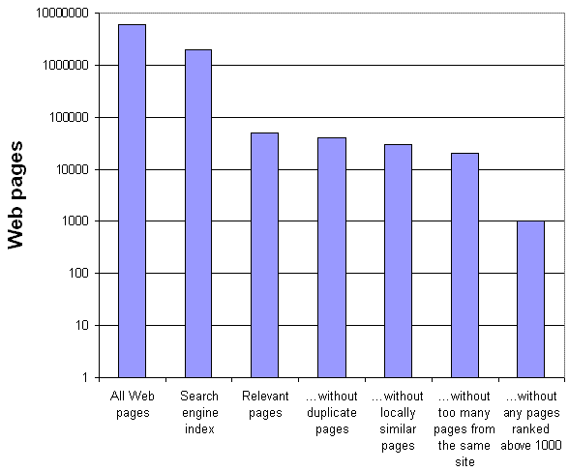
Figure 1. Factors influencing the number of results returned for a search (hypothetical figures, but note the logarithmic scale).

Results ranking is the third key operation. A search engine will arrange the matching URLs to maximize the probability that a relevant result is in the first or second pages. The rank order depends upon many factors including the extent to which the search terms are important and occur frequently in the page, whether previous searchers have selected the link and how many links point to the pages (Baeza-Yates & Ribeiro-Neto, 1999; Brin & Page, 1998; Chakrabarti, 2003). Hence the first few pages are a deliberately biased sample of all the results and the same is true of the top n results for any n less than the total number of results returned.
Finally, although search engines are entirely logical because they are computer programs, their complexity means that the results they present often have inconsistencies and unexpected variability. For example, the hit count estimates may fluctuate, even over short periods of time (Bar-Ilan, 1999; Rousseau, 1999), and individual URLs may unexpectedly disappear from the results (Mettrop & Nieuwenhuysen, 2001). Moreover, the specific workings of a search engine may have apparently strange peculiarities. For example Live Search hit count estimates seem to approximate “relevant pages” in Figure 1 when over 8,000 but to reflect “…without too many pages from the same site” when less than 200 (Thelwall, 2008).

Webometric applications
In webometrics, the most common form of data used from search engines is the hit count estimate (HCE), a number near the top of the results page estimating the total number of results available to the search engine. Multiple HCEs are sometimes used in research for comparisons. For example, using advanced queries the number of pages linking to each of a set of countries could be compared to see which country had the most inlinks – the highest online impact (Ingwersen, 1998). Alternatively the frequency of occurrence of a key phrase such as “integrated water resource management” across international domains could be compared via the HCEs of a series of searches (Thelwall, Vann, & Fairclough, 2006). Hit counts are also sometimes used to estimate the number of links or colinks between all pairs of web spaces in a set, such as biotechnology organisations’ Web sites, with the resulting matrix of data used to create a network diagram or other visualisation (Heimeriks et al., 2003; Vaughan & You, 2005).
In order for the results of any of the above applications to have validity for comparisons, it is desirable for there to be a high correlation between the results of the same queries submitted to search engines (i.e., convergent validity). As discussed in the introduction, previous studies have suggested that the overlaps between search engines are relatively small (Lawrence & Giles, 1999), at least for queries with fewer results than the maximum imposed by any of the search engines compared (typically 1,000). Despite the low overlap between search engine result lists, their hit count estimates can correlate highly with each other. For example, an investigation into the number of pages in 9,330 university web sites found Spearman’s rho values from 0.822 to 0.917 between Google, Teoma, MSN (now Live Search), and Yahoo!, with Google and MSN returning estimates about three times larger than the other two search engines (Aguillo et al., 2006). From these findings, it seems reasonable to average the HCEs of multiple search engines to get the most reliable results, but only if no engine has a demonstrable bias.
A second type of data used from commercial search engines used in webometrics is a complete list of URLs matching a query, with the list being subsequently processed to extract summary statistics (Thelwall & Wilkinson, 2008, to appear), such as the number originating from each Top Level Domain (TLD: e.g., .com, .uk). In such cases it is reasonable from a validity perspective to ask whether the summary statistics produced are significantly dependant upon the engine used for the data, e.g., whether the results from different engines would highly correlate.

Research Objectives
A previous paper has examined Live Search, Yahoo! and Google from a webometric perspective and addressed the question of how to get the most accurate and complete results from each individual engine (Thelwall, 2008). Nevertheless, it did not compare these search engines against each other to discover the best and to give external checks of accuracy and coverage. The overall goal of this follow-up research is to assess the extent to which the results returned by the main three search engines used in webometrics are consistent with each other in terms of the conclusions that would be drawn from their data. More specifically, the following questions are addressed.
- Are there specific anomalies that make the HCEs of Google, Live Search or Yahoo! unreliable for particular values?
- How consistent are Google, Live Search and Yahoo! in the number of URLs returned for a search, and which of them typically returns the most URLs?
- How consistent are the search engines in terms of the spread of results (sites, domains and top-level domains) and which search engine gives the widest spread of results for a search?
Note that the questions are not expressed in the form of a simple hypothesis test. It is a priori almost certain that there will be highly significant correlations between the search engines, so this is not an appropriate test. Moreover, an interpretive method to evaluate whether the search engine choice affects likely conclusions from research is also not the goal here because the objective is to cast light upon the issue in general. Hence the research questions are designed to support a data-lead discussion of the key issues.

Data
A list of 2,000 words of varying usage frequency was used as the set of queries. The words were extracted primarily from blogs using selection criteria based purely upon word frequency. Due to the data source used, there is a bias towards words in English language blogs. Many of the words are spelling mistakes or unusual names.
Each of the 2,000 words was submitted to Google, Windows Live, and Yahoo! During May and June of 2007 via their Applications Programming Interfaces (APIs), which allow automatic query submission and are commonly used in webometric investigations, although they may give fewer results and estimates than the normal web interfaces (Mayr & Tosques, 2005; Thelwall, 2008). For each query and each engine the first page HCE and the set of up to 1,000 URLs returned were recorded. A manual comparison of the results was undertaken afterwards and it was discovered that some of the words were not being searched for in the expected way, yielding errors or mismatched results. To resolve this problem, all words containing non-alphanumeric characters were removed (mainly hyphenated words and words containing an apostrophe). The remaining data set of 1,587 words was analysed (see http://cybermetrics.wlv.ac.uk/paperdata/se_data_and_graphs_v2.xls). Note that the API estimates, like those of the standard web interfaces, are often rounded to one or two significant figures when the size of the estimate is large.

Results

Hit count estimates
The hit count estimates of Google, Yahoo! and Live search correlate significantly, with Google and Live Search having a particularly high value (Pearson’s r= 0.96, see Figure 2b) but with Yahoo! correlating less with both Google (r=0.80, see Figure 2a) and Live Search (r=0.83, see Figure 2c). The reason for the different Yahoo! results was that Yahoo! automatically corrected some apparent user errors: either typos (e.g., ‘ia’ in curtian), or merged words (e.g., marketrelated) in 15 cases. An investigation of the results showed that the uncorrected and corrected search terms were found in different pages, so Yahoo! was apparently searching both. Note also the odd gaps around 4,000-10,000 results for Google (Fig 2a/2b), 150-600 for Live Search (Fig 2b/2c), and 3,000-8,000 for Yahoo! (Fig 2a/2c). On average, Yahoo!’s estimates were about six times larger than those of Live Search and Google’s were about five times larger than those of Live Search.

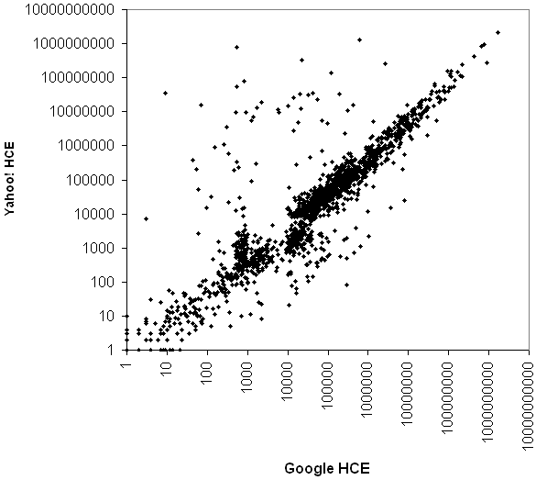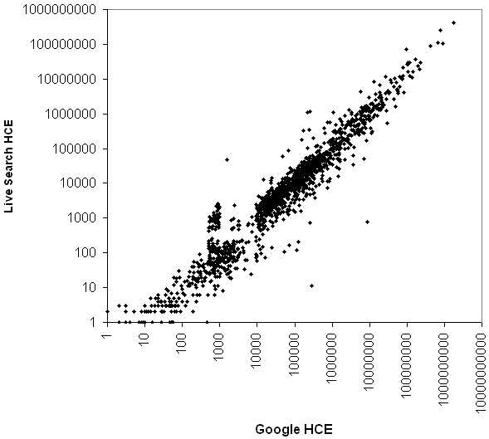
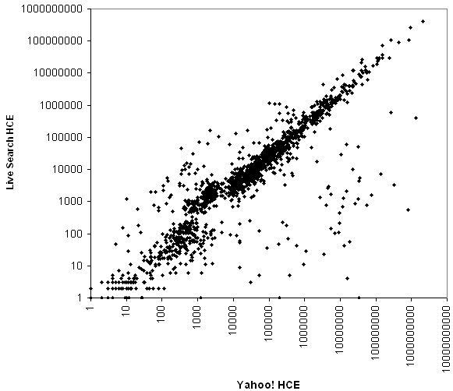
Figure 2a,b,c. Hit count estimates of the three search engines compared (logarithmic scales, excluding data with zero values; r=0.80, 0.96, 0.83).

Number of URLs returned
Figures 3a-c report the number of URLs returned for a query. In theory, these graphs should also be approximately straight lines since the search engines report similar hit count estimates and should return as many URLs as their estimate, or the maximum of 1,000 if the estimate is higher than 1,000. In contrast, whilst there are clusters at the bottom left hand corner and top right hand corner of each graph, as expected, the graphs are otherwise quite scattered.
The clusters along the top or right-hand edges of a graph indicate cases where one search engine has frequently reported the maximum number of results and another has reported significantly less. Although it is not surprising that this sometimes happens, it is clear from the right hand side clustering in contrast to the absence of clustering at the top of figures 3b and 3c that it is common for both Google and Yahoo! to return a maximum number of URLs when Live Search returns less.

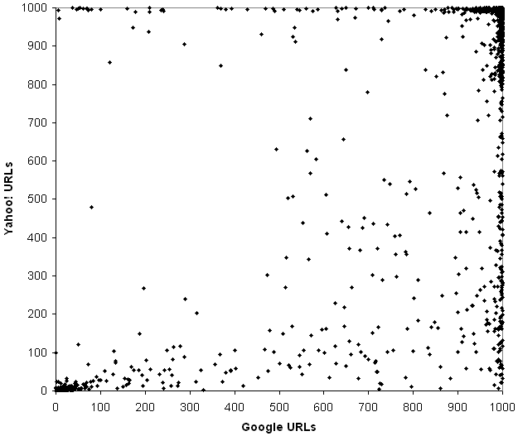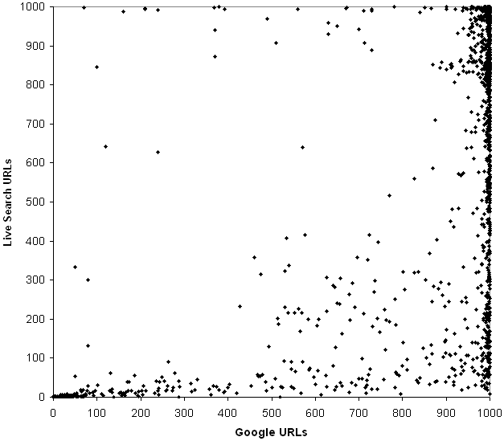
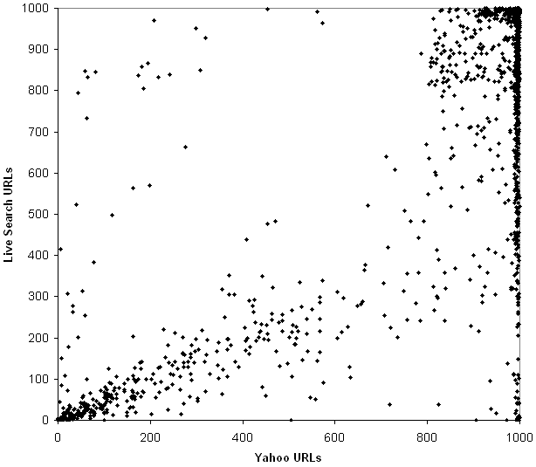
Figure 3a,b,c. URLs returned by the three search engines compared (r=0.71, 0.68, 0.84).

Number of domains returned
The data in figures 4a-c is the number of unique domains (e.g., www.wlv.ac.uk, www.wikipedia.org) extracted from the list of URLs returned from each search. The graphs should be approximately straight lines, assuming that each search engine returns URLs equally spread around different web domains. There is inevitably a cluster around the origin (mainly for searches returning few URLs) and a weak linear pattern at the bottom left hand corner of each graph, but there is an overall scattered pattern in all the graphs. Hence the number of different domains represented in the results of any given search will vary greatly by search engine.
The dense cloud near the top of Figure 4a and the right of Figure 4c indicate that Yahoo! often returns results from about 800 different domains when Google only returns results from between 300 and 700 domains, or when Live Search returns results from between 400 and 900 domains. Similarly, from Figure 4b Live Search tends to return more different domains in its results, at least for queries for which Google includes at least 300 domains. Overall, however, Yahoo! tends to return the largest number of domains in its results URLs, at least for queries that match URLs in many different domains.

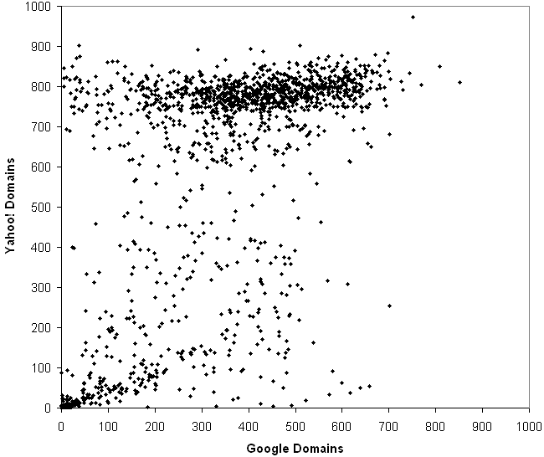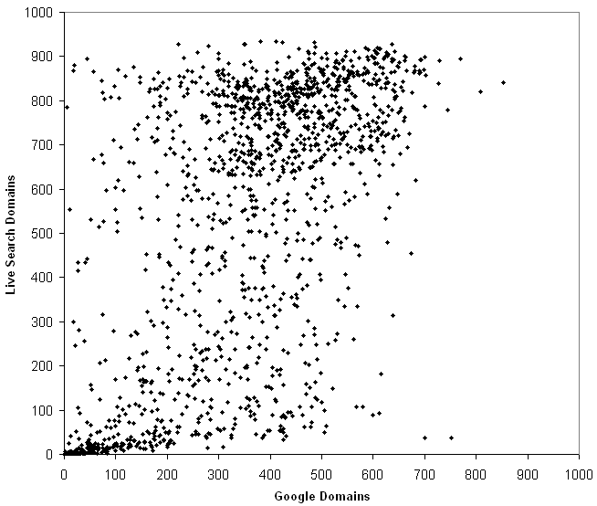
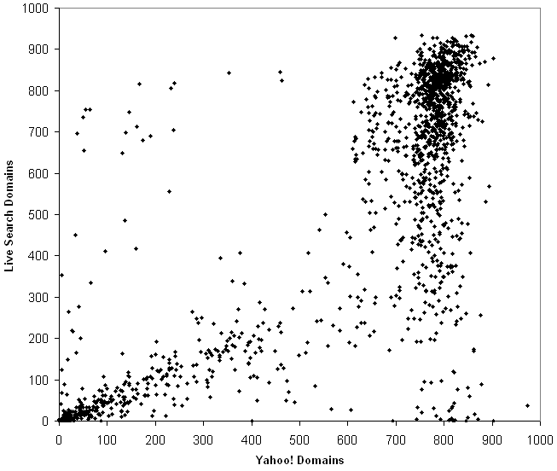
Figure 4a,b,c. Domains returned by the three search engines compared (r=0.65, 0.69, 0.83).

Number of Sites returned
The data in figures 5a-c is the number of unique sites extracted from the list of URLs returned from each search. Here a site is equated with the domain name ending of an URL. For most domains this is the end of the domain name including two dot-separated segments. For example www.microsoft.com -> microsoft.com and uk.groups.yahoo.com -> yahoo.com. For sites with second-level domain name systems, such as ac.uk in the UK or edu.ph in the Phillipines, the site is the domain name ending including three dot-separated segments. For example, www.admu.edu.ph -> admu.edu.ph and www.scit.wlv.ac.uk -> wlv.ac.uk. The same patterns are evident in figures 5a-c as are in figures 4a-c. This suggests either that search engines treat web sites similarly to domains, or that the results contain few multiple-domain web sites (e.g., university web sites, blog and social network sites).

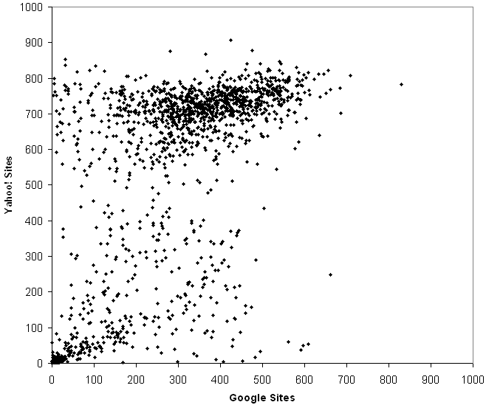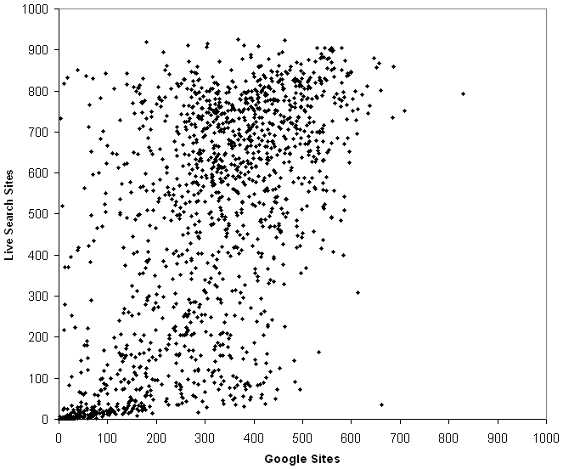
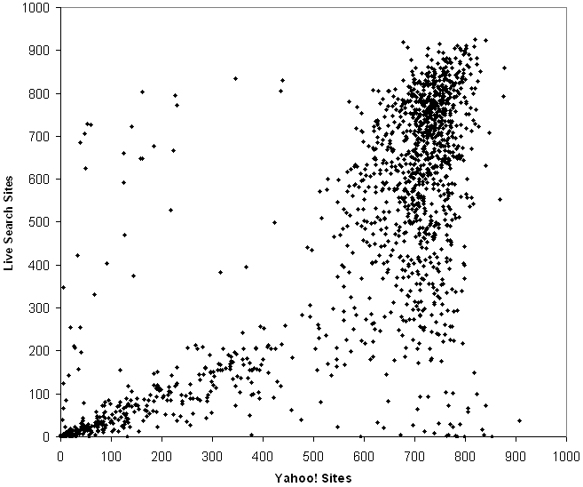
Figure 5a,b,c. Sites returned by the three search engines compared (r=0.66, 0.69, 0.81).

Number of TLDs returned
The data in figures 6a-c is the number of unique top-level domains (TLDs) extracted from the list of URLs returned from each search. Since most TLDs approximately equate to countries, this is also a test of the internationally spread of the results of the search engines. The graphs show that they are approximately the same in this regard, but a linear regression with an intercept set to zero indicated that Yahoo! returns about 10% more TLDs than the other two search engines.

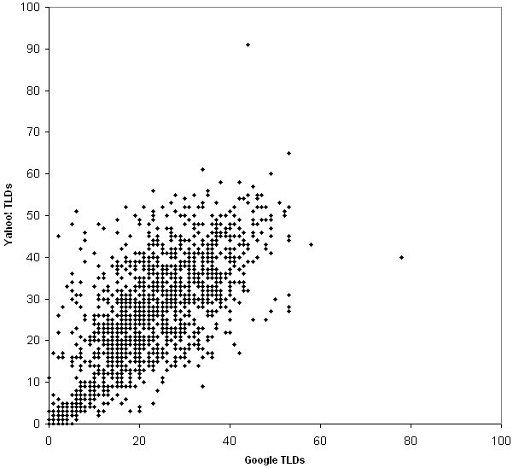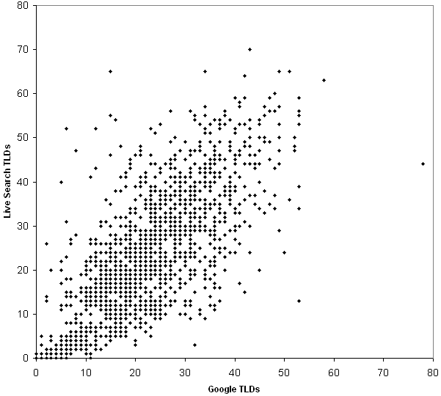
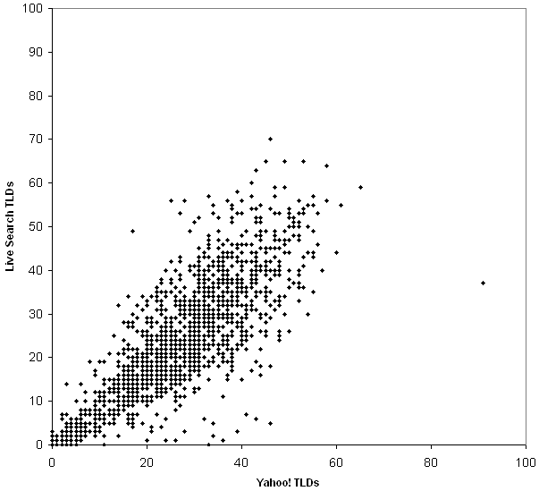
Figure 6a,b,c. TLDs returned by the three search engines compared (r=0.74, 0.77, 0.84).

Comparison within results
Figures 7a-c illustrate the relationship between the hit count estimates (on the x axis), the number of URLs returned (in black, mostly above the other points), the number of unique sites returned in the result URLs (in light grey, mostly in the middle of the graphs), and the number of unique TLDs returned in the result URLs (in dark grey, near the bottom of the graphs underneath the line y=100). The graphs echo the data and to some extent the results of figures 2, 3, 4 and 6, but present a new perspective.
Google’s graph is probably the only one that is as might be expected: the number of URLs returned approximately corresponds to the HCE until the HCE reaches 1,000, when the number of URLs returned is mostly above 950, although, surprisingly, it is not always at 1,000, even for large HCEs. The occasional dark dots within the middle of Figure 7a indicate that some searches with large HCEs return substantially less than 1,000 matching URLs. Although not clearly visible on the graph, the number of TLDs returned reaches a peak at a HCE of 5,000 and then stays approximately constant around an average of 25.
The Live Search graph shows a smooth relationship between HCEs and URLs except for a cluster at around 850 URLs. Live Search seems to stick at about 850 URLs even for HCEs of up to 5,000. Moreover, the line below 850 is not as smooth as that of Google. The TLDs returned peaks at an average of about 30 at a HCE of 10,000 but then declines, with the last 12 being 20 or under.
The Yahoo! graph is quite different to those of Google and Live Search. The slope of the HCEs for up to 1,000 results is the least smooth, suggesting that the Yahoo! HCEs may be the most approximate. The TLD pattern is broadly the same as Live Search but Yahoo! peaks at about 50,000 with an average of about 35 before declining to an average of around 20. The ‘stalactite’ at about 20,000-50,000 results from 800-1,000 in the URL data is strange: it suggests that a HCE of 20,000-50,000 is often a misleading estimator of the available results.

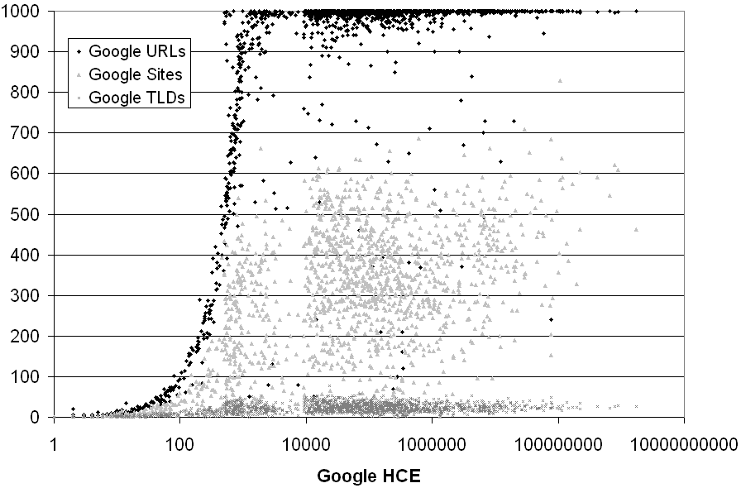
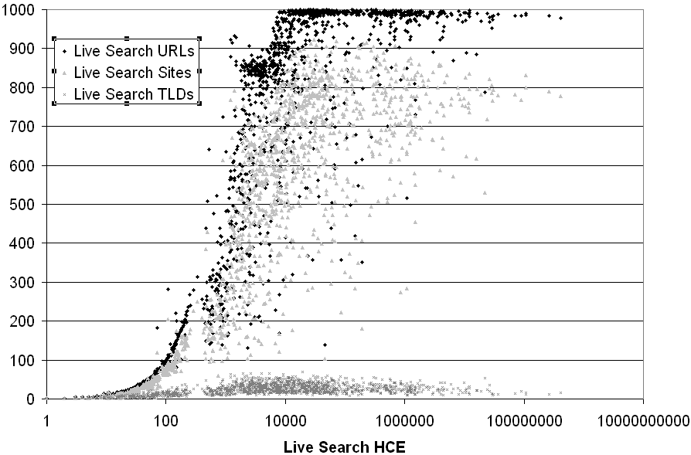
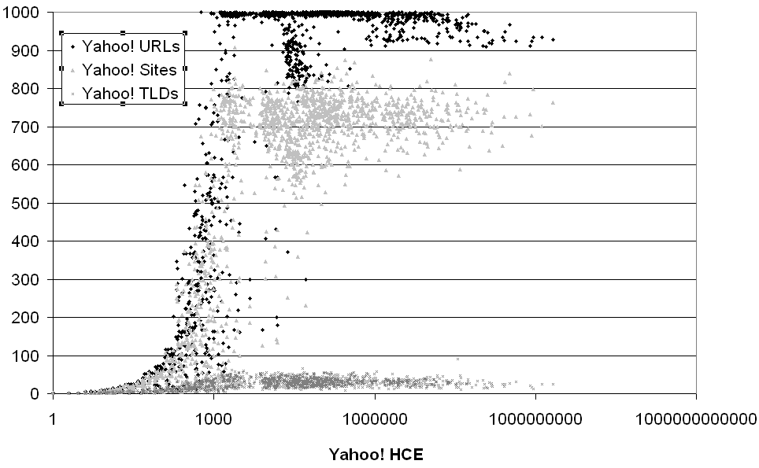
Figure 7a,b,c. Comparison of statistics within each search engine (logarithmic x-axis scale).

Discussion
The research has some limitations, which should be taken into consideration. First, recall that 15 Yahoo! results are very large in comparison to those of the other search engines due to Yahoo! automatically correcting hypothesised typos. This small number of potentially spurious data points does not affect the overall interpretation of the results, however.
The search terms used are an important limitation. These are all words written in alphanumeric characters and the results may be different for non-ASCII languages such as Japanese and Arabic. It is also possible that other types of search, such as multiple-word searches, search phrases and advanced searches could give different results. This would be especially likely if any or all of the search engines used different algorithms and datasets to respond to different types of query.
The biggest limitation of this research is that search engine algorithms change frequently and so it is not known for how long the results will be valid. Nevertheless, the graphical methods introduced here can be repeated periodically to reassess the findings, for example before any future major webometric exercise.
Finally, note that the results are specific to the applications programming interfaces of the three search engines, which deliver different results to the standard web interfaces. The findings should therefore not be extrapolated to the results of human web queries.

Conclusion
The graphs clearly show that the three search engines are reasonably consistent in their hit count estimates and the number of different top-level domains in the URLs of their results. In contrast, they have significant inconsistencies for the number of different URLs, sites and domains returned within the search results. Moreover, these inconsistencies sometimes manifest themselves in quite irregular ways, and there are inconsistencies in Yahoo! and Live Search that make their hit count estimates seem less reliable than those of Google.
Based upon the above findings, recommendations can now be made about which search engine is the most suitable for various tasks. Recall that search engine algorithms are updated regularly and so these recommendations need to be periodically checked and revised. Google currently seems to be the most consistent in terms of the relationship between its HCEs and the number of URLs returned, and so it is recommended for webometrics tasks when consistent HCEs are needed. In contrast, Yahoo! is recommended if the (webometrics or general search) objective is to get results from the widest variety of web sites, domains or TLDs. For the latter tasks, other methods can sometimes also be used to obtain additional results (Thelwall, 2008).

References
Aguillo, I. F., Granadino, B., Ortega, J. L., & Prieto, J. A. (2006). Scientific research activity and communication measured with cybermetrics indicators. Journal of the American Society for Information Science and Technology, 57(10), 1296-1302.
Arasu, A., Cho, J., Garcia-Molina, H., Paepcke, A., & Raghavan, S. (2001). Searching the Web. ACM Transactions on Internet Technology, 1(1), 2-43.
Baeza-Yates, R., & Ribeiro-Neto, B. (1999). Modern information retrieval. Wokingham, UK: Addison-Wesley.
Bar-Ilan, J. (1999). Search engine results over time - a case study on search engine stability. Retrieved January 26, 2006, from http://www.cindoc.csic.es/cybermetrics/articles/v2i1p1.html
Bar-Ilan, J. (2004). Search engine ability to cope with the changing web. In M. Levene & A. Poulovasilis (Eds.), Web Dynamics. Berlin: Springer-Verlag.
Bar-Ilan, J., & Peritz, B. C. (2004). Evolution, continuity, and disappearance of documents on a specific topic on the Web: A longitudinal study of 'informetrics'. Journal of the American Society for Information Science and Technology, 55(11), 980 - 990.
Barjak, F., & Thelwall, M. (2008, to appear). A statistical analysis of the web presences of European life sciences research teams. Journal of the American Society for Information Science and Technology.
Björneborn, L. (2006). 'Mini small worlds' of shortest link paths crossing domain boundaries in an academic Web space. Scientometrics, 68(3), 395-414.
Björneborn, L., & Ingwersen, P. (2004). Toward a basic framework for webometrics. Journal of the American Society for Information Science and Technology, 55(14), 1216-1227.
Brin, S., & Page, L. (1998). The anatomy of a large scale hypertextual Web search engine. Computer Networks and ISDN Systems, 30(1-7), 107-117.
Broder, A., Kumar, R., Maghoul, F., Raghavan, P., Rajagopalan, S., Stata, R., et al. (2000). Graph structure in the web. Journal of Computer Networks, 33(1-6), 309-320.
Chakrabarti, S. (2003). Mining the Web: Analysis of hypertext and semi structured data. New York: Morgan Kaufmann.
Cho, J., & Roy, S. (2004). Impact of Web search engines on page popularity. Proceedings of the World-Wide Web Conference, May 2004, Retrieved February 4, 2007 from: http://oak.cs.ucla.edu/~cho/papers/cho-bias.pdf.
Cronin, B., Snyder, H. W., Rosenbaum, H., Martinson, A., & Callahan, E. (1998). Invoked on the web. Journal of the American Society for Information Science, 49(14), 1319-1328.
Dean, J. Henzinger, M. (2000). Method for identifying near duplicate pages in a hyperlinked database. USPTO, http://www.google.co.uk/patents?id=onkGAAAAEBAJ. USA: AltaVista Company.
Ding, W., & Marchionini, G. (1996). A comparative study of web search service performance. Proceedings of the 59th Annual Meeting of the American Society for Information Science, Baltimore, M.D., 136-142.
Heimeriks, G., Hörlesberger, M., & van den Besselaar, P. (2003). Mapping communication and collaboration in heterogeneous research networks. Scientometrics, 58(2), 391-413.
Henzinger, M. (2006). Finding near-duplicate web pages: a large-scale evaluation of algorithms. In Proceedings of the 29th annual international ACM SIGIR conference on Research and development in information retrieval (pp. 284-291). New York, NY, USA: ACM Press.
Huberman, B. A., & Adamic, L. (2001). Growth dynamics of the world wide Web. Nature, 401, 131.
Ingwersen, P. (1998). The calculation of Web Impact Factors. Journal of Documentation, 54(2), 236-243.
Kousha, K., & Thelwall, M. (2007). Google Scholar citations and Google Web/URL citations: A multi-discipline exploratory analysis. Journal of the American Society for Information Science and Technology, 58(7), 1055 -1065.
Lawrence, S., & Giles, C. L. (1999). Accessibility of information on the web. Nature, 400(6740), 107-109.
Lewandowski, D., Wahlig, H., & Meyer-Bautor, G. (2006). The freshness of web search engine databases. Journal of Information Science, 32(2), 131-148.
Mayr, P., & Tosques, F. (2005). Google Web APIs: An instrument for webometric analyses? Retrieved January 20, 2006, from http://www.ib.hu-berlin.de/%7Emayr/arbeiten/ISSI2005_Mayr_Toques.pdf
Mettrop, W., & Nieuwenhuysen, P. (2001). Internet search engines - fluctuations in document accessibility. Journal of Documentation, 57(5), 623-651.
Resnik, P., & Smith, N. (2003). The Web as a parallel corpus. Computational Linguistics, 29(3), 349-380.
Rousseau, R. (1999). Daily time series of common single word searches in AltaVista and NorthernLight. Cybermetrics, 2/3, Retrieved July 25, 2006 from: http://www.cindoc.csic.es/cybermetrics/articles/v2002i2001p2002.html.
Sherman, C., & Price, G. (2001). The invisible web: Uncovering information sources search engines can't see. Medford, NJ: Information Today.
Spink, A., & Jansen, B. J. (2004). Web search: Public searching of the web. Dordrecht: Kluwer Academic Publishers.
Spink, A., Jansen, B. J., Blakely, C., & Koshman, S. (2006). A study of results overlap and uniqueness among major Web search engines. Information Processing & Management, 42(5), 1379-1391.
Thelwall, M. (2004). Link analysis: An information science approach. San Diego: Academic Press.
Thelwall, M. (2008). Extracting accurate and complete results from search engines: Case study Windows Live. Journal of the American Society for Information Science and Technology, 59(1), 38-50.
Thelwall, M., Vann, K., & Fairclough, R. (2006). Web issue analysis: An Integrated Water Resource Management case study. Journal of the American Society for Information Science & Technology, 57(10), 1303-1314.
Thelwall, M., & Wilkinson, D. (2008, to appear). A generic lexical URL segmentation framework for counting links, colinks or URLs. Library and Information Science Research.
Van Couvering, E. (2007). Is relevance relevant? Market, science, and war: Discourses of search engine quality. Journal of Computer-Mediated Communication, 12(3), Retrieved May 14, 2007 from: http://jcmc.indiana.edu/vol2012/issue2003/vancouvering.html.
Vaughan, L., & Shaw, D. (2005). Web citation data for impact assessment: A comparison of four science disciplines. Journal of the American Society for Information Science & Technology, 56(10), 1075-1087.
Vaughan, L., & Thelwall, M. (2004). Search engine coverage bias: evidence and possible causes. Information Processing & Management, 40(4), 693-707.
Vaughan, L., & You, J. (2005). Mapping business competitive positions using Web co-link analysis. In P. Ingwersen & B. Larsen (Eds.), Proceedings of 2005: The 10th International Conference of the International Society for Scientometrics and Informetrics (pp. 534–543). Stockholm, Sweden: ISSI.
Vaughan, L., & Zhang, Y. (2007). Equal representation by search engines? A comparison of websites across countries and domains. Journal of Computer-Mediated Communication, 12(3), Retrieved May 14, 2007 from: http://jcmc.indiana.edu/vol2012/issue2003/vaughan.html.

Thelwall, M. (2008). Quantitative comparisons of search engine results, Journal of the American Society for Information Science and Technology, 59(11), 1702-1710, © copyright 2008 John Wiley & Sons

