Social network site changes over time:
The case of MySpace
David Wilkinson, Statistical Cybermetrics Research Group, University of Wolverhampton, UK. d.wilkinson@wlv.ac.uk
Mike Thelwall, Statistical Cybermetrics Research Group, University of Wolverhampton, UK. m.thelwall@wlv.ac.uk

The uptake of social network sites (SNSs) has been highly trend-driven, with Friendster, MySpace and Facebook being successively the most popular. Given that teens are often early adopters of communication technologies, it seems reasonable to assume that the typical user of any particular SNS would change over time, probably becoming older and covering different segments of the population. This article analyses changes in MySpace self-reported member demographics and behaviour from 2007 to 2010 using four large samples of members and focussing on the US. The results indicate that despite its take-up rate declining, with only about one in ten members being active a year after joining, the dominant (modal) age for active US members remains mid-adolescence but has shifted by about two years from 15 to 17, and the US dominance of MySpace is shrinking. There has also been a dramatic increase in the median number of Friends for new US members, from 12 to 96 – probably due to MySpace’s automated Friend finder. Some factors show little change, however, including the female majority, the 5% minority gay membership and the approximately 50% private profiles. In addition, there has been an increase in the proportion of Latino/Hispanic US members, suggesting a shifting ethnic profile. Overall, MySpace has surprisingly stable membership demographics and is apparently maintaining its primary youth appeal, perhaps because of its music orientation.

Introduction
The rise of SNSs from obscurity in 2003 to amongst the world’s most popular websites by 2006 has been remarkable, even for an Internet phenomenon. In February 2010, according to Alexa (2010a), the top twenty most visited websites included Facebook (#2), YouTube (#3, SNS features but predominantly for video sharing), Twitter (#12, microblogging site with SNS features) and MySpace (#17 but #6 in the US). The rapid viral growth suggests that SNSs fill a deep-seated human desire: to communicate with, and keep track of the activities of, a wide circle of others (Donath, 2007; Tufekci, 2008b). If SNSs really do fulfil such a desire then they should easily spread through society to the exclusion of few social groups with web access. As a result of their rapid rise there have been many concerns about the social impact of SNSs, in terms of risks to children’s and others’ wellbeing, education and social development (cf. Wang & Wellman, 2010) and hence research is needed to understand them more fully (Livingstone & Brake, 2010; Ybarra & Mitchell, 2008). Moreover, as early adopters are joined by those that were slower to join and are perhaps less innovative (see below: SNS adoption), it seems reasonable to expect the usage patterns of any individual SNS to change significantly over time. This is important to confirm, however, given the centrality of SNSs to many people’s social lives and the consequent costs of misunderstanding shifts in their role.
Formerly the world’s most popular SNS, MySpace was supplanted by Facebook in about April 2008 (comscore, 2008; see also: Torkjazi, Rejaie, & Willinger, 2009). Unlike Facebook, which does not seem to target any particular user group despite its origins as a college network, MySpace has a focus on music that makes it particularly attractive to a teen audience (Antin & Earp, 2010; Shklovski & boyd, 2006). It has an embedded music player on home pages, special profiles for musicians and no restrictions on members connecting with musicians (boyd & Ellison, 2007). It also runs promotional events like sponsored music competitions (Anonymous, 2010), sells music and naturally allows a kind of personal connection with bands for followers that might be too young to see them perform live (boyd, 2008a, p.99). In general, pop music is not only frequently important for youth identity formation and social group membership, but also for socialising and mood management (Roberts & Christenson, 2001). Previously, the first to shift their allegiance from Friendster to MySpace seem to have been “musicians and indie rock bands” (boyd, 2008a, p. 98), underlining the importance of music. In summary it seems likely that MySpace could survive as a music-oriented youth niche site. Another important feature of MySpace is appearance. MySpace profiles can be extensively visually customised, and this apparently accidental feature is particularly appealing to youth for the complex issue of identity expression (boyd, 2008b; Brake, 2009; Jones, Millermaier, Goya-Martinez, & Schuler, 2008; Liu, 2007; Livingstone, 2008; Nakamura, 2008; Parks, in press; Perkel, 2008), although the textual features and friend selection in Facebook may also help to send social signals, if not to construct an identity (Lampe, Ellison, & Steinfield, 2007; Walther, Van der Heide, Kim, Westerman, & Tong, 2008). For MySpace, then, there is a tension between a natural youth appeal and the trend for new technologies to attract a changing and perhaps wider audience due to the natural aging of members and spreading throughout society, as has occurred outside the US for the SNSs Cyworld and Nasza Klasa (see below).
This article assesses the extent to which there have been long-term changes in the demographics of US MySpace users (its majority group) based upon a systematic sample of members in February 2010 and three other member samples. The methods used are quantitative and descriptive. This is the largest-scale longitudinal academic analysis of SNS users and uses.

MySpace vs. Facebook in the US
SNSs are complex systems designed for highly social uses. A typical SNS allows members to create a personal profile, publicly connect to other members as Friends and publicly or privately communicate with their Friends (boyd & Ellison, 2007). The attraction of SNSs seems to lie in the way they allow people to stay in contact with a large network of friends and acquaintances, both by directly exchanging messages (Thelwall & Wilkinson, 2010) and by passively browsing for social information (Joinson, 2008; Tufekci, 2008a). SNSs spread in a viral way because members benefit from more friends joining and connecting, and new members will get most benefit if they have friends already in the system. This explains the rapid growth of SNSs but also suggests inertia: any new SNS would have an immediate disadvantage compared to others due to its much smaller existing user base. Nevertheless, new SNSs can and do succeed: MySpace overtook Friendster, Facebook overtook MySpace and in various countries local SNSs are more popular than the earlier US giants: Mixi in Japan (Takahashi, 2010), HabboHotel in Finland (Johnson, 2007), Nasza Klasa in Poland (Callahan, 2008), Vkontakte and Odnoklassniki in Russia (Alexanyan, 2009), StudiVz in Germany, Skyrock in France although Cyworld (Ahn, Han, Kwak, Moon, & Jeong, 2007; Chun et al., 2008; Haddon & Kim, 2007; Kim & Yun, 2007) in South Korea predated MySpace and Facebook (boyd & Ellison, 2007).

SNS adoption
At an abstract level, any SNS is an innovation and as such may be expected to follow certain patterns. The most influential diffusion of innovations theory splits up adopters into several different categories: innovators, early adopters, early majority, late majority, and laggards (Rogers, 1962, p. 150). Innovators are the first to try out new technologies, with early adopters quickly following their lead. The early majority, in contrast, join in only when there is a sufficient mass already and laggards may never join. In consequence, the typical profile of users of any innovation is likely to change over time as the proportions of the different types of user change. For example, in the US blog writing has become more popular with older people and less popular with younger people (Lenhart, Purcell, Smith, & Zickuhr, 2010). In addition to users changing over time, uses are also likely to change because the usage of any complex software is likely to be socially shaped (Dutton, 2004; MacKenzie & Wajcman, 1985; Selwyn, Gorard, & Furlong, 2005). SNSs should not be seen as a separate world to the offline world, however, because computer-mediated communication theories show that new technologies embed fairly seamlessly into users’ lives (e.g., Wellman et al., 2003).
More generally, social phenomena with differential adoption rates can sometimes be characterised as either based upon cohorts or on life phases (Ling, 2010). Whereas cohort-based phenomena stay with a particular group society as they age, such as a 70s music preference staying with those that were teenagers in the 70s, life phase phenomena, such as liking current chart music, are prevalent within a particular age group. Research with multiple groups of Norwegians has shown that the use of text messaging is a life phase activity that is prevalent amongst older teens and those in their early twenties (Ling, 2010), perhaps because of a range of specific youth-oriented social uses (Oksman & Turtiainen, 2004). As another type of information and communication technology (ICT), this suggests that SNS use might also be a life phase activity. Nevertheless, different age groups may continue to use an ICT but find different uses for it (Henderson, Taylor, & Thomson, 2002) and generations may have an affinity for particular computing technologies (McMullin, Comeau, & Jovic, 2007).
Age certainly seems to be an important factor for some SNSs, supporting the life phase concept. Although Nasza Klasa and Cyworld seem to have attracted multigenerational audiences and Nasza Klasa seems to encourage different age connections within families and between teachers and pupils (Callahan, 2008), MySpace has historically been a youth site (boyd, 2008b; Thelwall, 2008), helped by its musical orientation and profile customisation opportunities. For a while, MySpace seemed to have been adopted by the majority of US teens, creating peer pressure for the remainder to join, in addition to a likely pool of online friends and acquaintances to connect to. An additional appeal for youth, in common to some extent with other forms of computer-mediated communication, was the ability to socialise online after school in a relatively safe environment, replacing the often forbidden shopping mall visits of earlier generations (boyd, 2008b). Gender is also important and MySpace seems to support cross-gender friendship particularly well compared to the offline world (Thelwall, 2009a), including elements of play, performance and flirting (Van Doorn, in press), although cross-gender friendship may be common in different online forums too (e.g., Parks, 1996).
According to Pew Internet Project reports from February 2010 (Lenhart et al., 2010), although blogging had halved amongst US teens and young adults (12-29 years old) from 28% to 14-15% between 2006 and 2009, SNS use rose to about 82% amongst online 14-17 year olds. Nevertheless, SNSs have probably not become ubiquitous in any country, or any segment of society, despite the likely peer pressure when one platform becomes common. This is not only due to differentials in Internet access but is also due to personality differences: people who do not enjoy gossip seem less likely to join (Joinson, 2008; Tufekci, 2008b). Other factors influencing the tendency to join SNSs include gender and privacy concerns (Tufekci, 2008b) as well as age (Hargittai, 2007).

MySpace vs. Facebook
Since its eclipse by Facebook at the global level, MySpace seems to have steadily declined in use. This is not necessarily a terminal decline, however, because there is a precedent: Friendster, formerly dominant in the US, has survived in the Philippines, where it is the sixth most popular web site (Alexa, 2010b). Moreover, many SNSs seem to thrive within a national or other niche market. For instance, BlackPlanet, MiGente, AsianAvenue and Glee all target an ethnic or sexual minority market (e.g., Byrne, 2007; Thelwall, 2009b), and Last.FM is an explicitly music-focused SNS (Baym & Ledbetter, 2009). In addition, social software is highly complex and there are many factors that appeal to different people and therefore attract niche users (Dwyer, Hiltz, & Passerini, 2008); for example MySpace seems to be particularly good for meeting new people compared to Facebook (Dwyer, Hiltz, & Passerini, 2007), and the music orientation may encourage ethnically-based subgroups because of ethnically-related music preferences (Christenson & Roberts, 1998). Younger MySpace members also use the site differently from older users: having more friends, friends of similar ages, and using a greater variety of media types (Pfeil, Arjan, & Zaphiris, 2009), and there is also a difference in adoption rates between the city and the suburbs (Zhao, 2009).
In the US, in September 2009, MySpace was about equal in popularity with Facebook for those under 30 but for older users Facebook was far more popular (Lenhart et al., 2010). There have been many discussions of the reasons behind Facebook’s success at the expense of MySpace. For example, the key factor has been claimed to be technical (earlier email address book integration, allowing Friend connections to be made quickly) rather than because of its overall design (Garrahan, 2009).
Amongst US teens in 2007 the articulated reason for choosing either Facebook or MySpace was based on a perception of Facebook’s greater maturity/dullness (for evidence of the prevalence of articulated risky behaviour in MySpace see: Moreno, Parks, Zimmerman, Brito, & Christakis, 2009) or “the presence of friends, specific features or aesthetics, or their understanding of safety” (boyd, 2008a, p.197). Another possibility comes from a content analysis study of changes in the information displayed by MySpace members from 2006 to 2007, finding an increased concern for privacy and additional care over the type of information presented (Patchin & Hinduja, 2010). This favours Facebook because of its greater privacy. In contrast, a longitudinal survey-based investigation into Facebook studied differences between samples of Michigan State University undergraduates over three years (Lampe, Ellison, & Steinfield, 2008) and found changes in attitudes but not in uses, even though attitudes and perceptions of privacy are known to impact on computer-mediated communication (Joinson, 2001).
Other factors influencing the shift from MySpace to Facebook may have been middle class parental pressure to leave MySpace due to its perceived dangers, excessive spam and fraud (boyd, in press). Prestige may be another reason because Facebook originated in universities and so switching from MySpace to Facebook could be seen as a natural progression for older education-oriented youth. This is supported by a partial class divide in the US (boyd, 2007), with more educated users preferring Facebook (Lenhart et al., 2010) and higher parental educational background associating with Facebook (and Xanga and Friendster) rather than MySpace use (Hargittai, 2007). Older teens might also be alienated by the profile customisation, seeing their choice of friends as a subtle and more appropriate identity marker (Livingstone, 2008, based on interviews with 16 UK 13-16 year olds). Related to this, Facebook’s simpler and less customisable interface makes it perhaps more functional and therefore less likely to be seen as a passing fad. Finally, the simpler interface probably appeals to an older audience, the majority of the population, hence gaining new members in addition to MySpace converts.
Ethnicity is also important in the choice of SNS (Watkins, 2009, p. 77). Hargiatti's (2007) survey of over 1,000 first year students at a US university found a preference for MySpace from Hispanic youth and for Facebook from Asian-American youth, although she found little difference between membership of the two sites for white or African-American teens. Boyd (in press) theorises that US MySpace has become ghettoised in the sense that some teens associate it with ethnic minority members, urban music and lower class users (see also: Carroll, 2008). As part of this, boyd argues that MySpace attracts teen subcultures and black and Latino teens, whereas Facebook attracts Asian (high educational achievers - Sue & Okazaki, 1990) and white teens.
Hargiatti's (2007) study also found a significant gender difference between Facebook and MySpace: although Facebook was the SNS of choice, used by 78% of males and 80% of females, significantly more females (59%) used MySpace than males (49%). There does not seem to be any theorised reason for this difference, however, and it is possible that it would not be present for younger members or for those that do not attend a university. If MySpace is genuinely more attractive to females than males then this may be due to the artistic possibilities of profile design. This seems relevant because US females rate themselves more creative in the visual-artistic domain than do males (Kaufman, 2006). It may even be that gendered concerns over personal appearance (e.g., Pliner, Chaiken, & Flett, 1990) extend to SNS profiles as an extension of personal identity (boyd, 2008b). The gender difference is perhaps at odds with the MySpace music focus, however, since females tend to prefer more mainstream pop music that would need less hunting for (for a summary of relevant research see: Roberts & Christenson, 2001), so MySpace does not seem to have an advantage for females finding music. Nevertheless, the possible ghetto/urban orientation may be attractive for white females, who show more affiliation to music of black origin than do white males (Christenson & Roberts, 1998, p.89-90; Delsing, ter Bogt, Engels, & Meeus, 2008).
There is no recent large-scale academic contextual evidence about the MySpace audience, leaving an important gap in knowledge. The latest large-scale study uses data collected in March, 2008 (Thelwall, 2009b) and a smaller-scale analysis used data from summer 2008 (Parks, in press).

Research questions
As the above discussion illustrates, the issue of changing SNS membership is topical, particularly for MySpace. It is also important because of the commercial value of SNSs and because of their role in hundreds of millions of lives. Nevertheless, there is no large-scale detailed quantitative evidence about changing membership patterns for MySpace (or any other major SNS) with the partial exception of the survey-based research mentioned above. In consequence, the research questions are designed to give an overview of changes. The research questions focus on the US because this is the dominant group within MySpace and shifting patterns of international membership could influence results for MySpace as a whole in a way that would not reflect patterns within individual nations.
- Have the common attributes of active US MySpace members changed over time, in particular with regard to declared age, ethnicity and gender?
- Which personal attributes of US MySpace members declared in their profiles predict whether they will be active participants?

Methods
The overall approach was to generate systematic samples of MySpace members, download and extract information from their profiles and then compare the characteristics of new and older users. Four samples were used: one each of members that joined on specific recent and older dates and one each of all members from recent and older dates. This double sample allows comparisons of overall members as well as of changes in new members.

Raw data
Each MySpace member has a unique numerical ID that can be appended to the URL http://profile.myspace.com/index.cfm?fuseaction=user.viewprofile&friendid= to retrieve their profile. These IDs are assigned in ascending order and so it is possible to calculate any member’s joining date from their ID (e.g., see http://cybermetrics.wlv.ac.uk/socialnetworks/). This makes it easy to select genuinely random samples of either all members or all members joining within a specific range of dates. For this study, however, a systematic sample was used instead of every kth member or kth member joining on specific dates. The systematic sample is preferable because it avoids the possibility of “clumping” by selecting a cluster of friends joining at the same time.
The sample for each data set was selected by identifying the earliest and latest IDs within the sample range, starting at a random point after the first ID and selecting every k=d/nth profile after, where d is the difference between the largest and smallest ID and n is the desired sample size. See Table 1 for the details of the samples. Each profile was downloaded by SocSciBot and profile information extracted automatically. The two older samples are reused from previous papers (Thelwall, 2008, 2009b) but their information was re-extracted from the previously saved profiles with a slightly upgraded program and so there may be minor differences in the results. The fourth data set harvested profiles from five joining days rather than one. The purpose of this was to avoid single unusual days biasing the results. Unfortunately the same precaution could not be taken retrospectively for the third data set.

Table 1. Data set names and basic information.
Data set name | Joining dates | Harvesting dates | Profiles
June 2007 all profiles | Up to June 22, 2007 | July 2-7, 2007 | 20000
Feb 2010 all profiles | Up to Feb 7, 2010 | Feb 7, 2010 | 50000
March 2008 year on | Mar 10, 2007 | Mar 10-11, 2008 | 40000
Feb 2010 year on | Feb 10-14, 2009 | Feb 11-14, 2010 | 50000

Sub-sample selection
A proportion of the profiles downloaded had been deleted by their owner or MySpace, leaving a standard error message, and these were not used. Moreover, special profiles (automatically identified by differing underlying code) for people declaring themselves to be musicians, comedians and film makers were all removed on the grounds that these are for a different type of user. For example, musicians may obey commercial imperatives in their friending patterns (Antin & Earp, 2010). Of the remainder, many were set to private and only revealed basic information such as age, gender and last login date. The profile information for members with public profiles was typically not complete, however, because only a very basic set of information is compulsory. For instance, members can choose whether to fill in the standard profile section reporting religion and ethnicity. This information is often not filled in initially but may be returned to and completed later (e.g., Parks, in press). The analysis below typically reports the percentage of missing responses but compares only the valid responses.
An important issue is whether all MySpace members should be included in the analysis. For instance, if someone joined in 2003 and has not used MySpace since, is it valid to consider them a member? They are a member in the technical sense of not having deleted their profile but are not an active user and are therefore not interesting for a social science investigation. To circumvent this problem, only members that had logged on in the previous month are considered in the main analysis, and these are termed active members to avoid ambiguity. Moreover, to prevent the inclusion of recently-joined inactive members, only people that joined at least two months prior to the data collection are considered for the active members category. This is an oversimplification and relatively arbitrary (e.g., Parks (in press) uses 6 months instead, and another paper compared a random sample of members to a crawl based on Friend connections (Caverlee & Webb, 2008)) because it omits some members who check their MySpace less often than monthly, and weights members who logon monthly equally with those who are active daily, but seems like a reasonable and practical step. As shown in Table 2, a majority of members are inactive with this definition. A previous study set a minimum Friend level of 2 to identify active members, given that members used to receive one “free” Friend but this is not reliable since members sometimes receive two free Friends (e.g., one international and one country-specific) and Friends can be made almost automatically using email address book integration and so Friends no longer seem to be reliable indicators of activity.

Table 2. Valid profiles by membership group.
Data set | All  profiles | Public  profiles | Active  members | Active US  members
Valid June 2007 all profiles | 14915 | 10914 (73.2%) | 4564 (30.6%) | 3329 (22.3%)
Valid Feb 2010 all profiles | 27677 | 19047 (68.8%) | 5023 (18.1%) | 2988 (10.8%)
Valid March 2008 year on | 27916 | 18086 (64.8%) | 7900 (28.3%) | 5995 (21.5%)
Valid Feb 2010 year on | 32264 | 21947 (68.0%) | 6185 (19.2%) | 3368 (10.4%)

Analysis
Although the analysis is primarily descriptive, the results were supplemented with statistical hypothesis tests for differences. For numerical data, the Mann-Whitney U test was used to check for differing central tendencies. This is a fairly safe test to use for data that is not normally distributed. For category data, chi-square tests were used, with Yates corrections for 2x2 cases. This test only shows that a table is biased but does not prove what the bias is: individual table biases are identified manually without statistical verification; although they are clear in most cases, they are not proven.

Results
The results for the main research questions for US members are presented after a preliminary analysis of all members, which is given first to set the context.

Key statistics for all members
Table 3 reports some basic statistics for the four data sets. In terms of privacy, which is relevant to most of the analyses reported here, whilst about half of active members have public profiles, overcoming earlier (June-August 2006) significant reluctance to alter default privacy settings (Acquisti & Gross, 2006; Hinduja & Patchin, 2008), the overall active membership is about 10% less likely to have a public profile although members of 1 year are 8% more likely to have one. The large differences in Friends are discussed below (section: Other information for active US members).

Table 3. Descriptive statistics for active members of all countries (statistics for all members in brackets).
Data set | Median Friends* | Median age** | Median join age** | % over 85 | % with public profiles | Mean membership
Valid June 2007 all profiles | 10 (1) | 21 (21) | 20 (20) | 2.5% | 62.9% | 6 months
Valid Feb 2010 all profiles | 85 (1) | 21 (23) | 18 (20) | 2.9% | 52.2% | 2 years 7 months
Valid March 2008 year on | 5 (1) | 20 (20) | 19 (19) | 2.8% | 46.1% | 1 year
Valid Feb 2010 year on | 36 (2) | 20 (22) | 19 (21) | 3.1% | 54.4% | 1 year
*Only for members with public profiles **Only for members with ages under 85

After a declared age of 40 years old the proportion of members approximately uniformly decreases except for a peak at about 100, for people lying about their age (Hinduja & Patchin, 2008). For this reason some age analyses ignore all those reporting an age over 85. The proportion of this excluded set is approximately the same in all data sets (chi-square, p>0.05 for a difference) so comparative analyses should not be affected. From Table 3 the median declared age of active members has remained constant over time. For all active members the 2010 median age is 21, unchanged from 2007 and for members joining in February 2009 the median age is slightly younger at 20 (this is unsurprising since if everyone joined at the same average age then more recent members would tend to be younger), unchanged from 2007 (see also the section below on active US member ages). Note that the figures are generally higher when inactive members are included, showing the importance of differentiating between the two groups. Figure 1 shows that the similar medians hide a significant difference: in both cases the most recent data set the peak (mode) age has changed from 15 to 19. This is probably due to an increased number of older teen non-US members (compare with Figure 2 below).

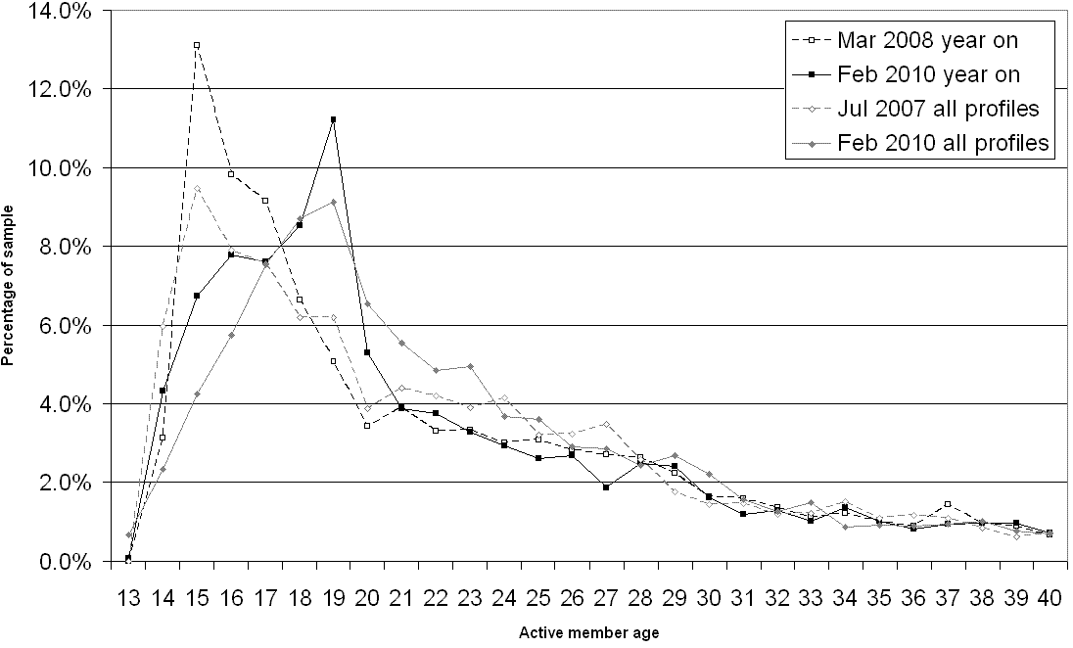
Figure 1. Declared ages up to 40 of active members from all countries.

Females are less likely than males to have public profiles in three out of four data sets (Table 4), so all of the public profile analyses reported below have a slight male bias.

Table 4. Proportion of members from all countries declaring a female gender (all members declare a gender).
Data set | All profiles | Public profiles | Active members
Valid June 2007 all profiles | 50.8% | 47.5% | 52.0%
Valid Feb 2010 all profiles | 49.6% | 46.0% | 52.8%
Valid March 2008 year on | 53.2% | 50.4% | 54.4%
Valid Feb 2010 year on | 47.9% | 44.7% | 51.4%

Table 5 shows that although MySpace continues to host a majority of US active members, this US domination has decreased. Nevertheless, few other countries have many members: Other countries were: UK (3.7% overall), Australia (1.9%), Mexico (1.6%), Germany (1.3%), Canada (1.0%), and the remainder all had a share of under 0.2% each (Feb 2010 all profiles).

Table 5. Declared country location for active members.
Member location | Valid Mar 2008 year on (active members only) | Valid Feb 2010 year on (active members only) | Valid Jul 2007 all profiles (active members only) | Valid Feb 2010 all profiles (active members only)
USA % | 75.9% | 54.5% | 72.9% | 59.6%

Declared age for active US members
Figure 2 displays reported ages (up to 40) of active US members in the four sets, and Table 6 includes additional age-related statistics. The median age of active US members is 21 except for the most recent members, those that joined in February 2009, with a younger median age of 19 (difference significant with p=0.000, Mann-Whitney U test; no significant difference between all profiles ages, p>0.05, Mann-Whitney U test). Below the median age there are some shifts in age patterns. The two older data sets both have a modal age of 15 whereas the Feb 2010 all profiles group has a modal age of two years older at 17 and the Feb 2010 year on group has a much shallower peak at 15, suggesting that amongst the teen users of MySpace there has been a general shift towards older teens. This is a small difference of about two years and remains in the period of social and identity development sometimes known as mid-adolescence (Kroger, 2007, p. 60) so its social significance should not be overestimated. The change cannot be due to a “generation MySpace” effect with the late peak being the same people two years on because the year on samples include only members of one year duration. Hence, this signals a genuine cultural shift in peak use. No underlying cause for the shift can be discerned from the quantitative data but one possible explanation is that MySpace is particularly important for the transition from school to work or college to keep track of old friends. Since possessing profiles in two different SNSs is common (Lenhart et al., 2010), this could even represent teens signing up for a secondary SNS to avoid loosing contact with those who did not use the same primary SNS.

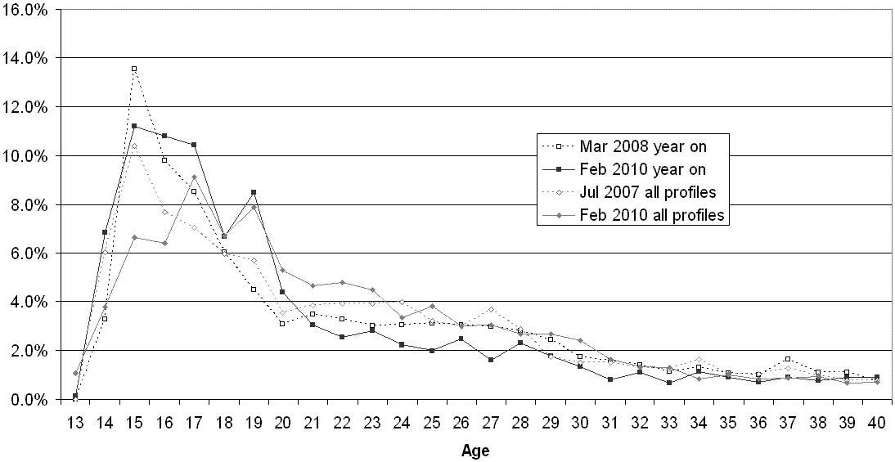
Figure 2. Declared current ages up to 40 of active US members.

The median joining age (i.e., the age at which the member joined, approximated using their declared current age and their joining date) is younger for current members than previously for both types of data set (difference significant with p=0.000, Mann-Whitney U test).

Table 6. Descriptive statistics for active US members.
Data set | Friends* | Current age** | Joining age** | % over 85 | Median membership
Valid June 2007 all profiles (active US members only) | 31 | 21 | 21 | 2.3% | 5 months
Valid Feb 2010 all profiles (active US members only) | 31 | 21 | 17 | 2.3% | 2 years, 10 months
Valid March 2008 year on (active US members only) | 12 | 21 | 20 | 2.5% | 1 year
Valid Feb 2010 year on (active US members only) | 96 | 19 | 18 | 2.9% | 1 year
*Only for members with public profiles **Only for members with ages under 85

One large temporal shift in MySpace is that active members in February 2010 had been users for much longer than active members in 2007. Part of the reason for this is the natural short average membership in any rapidly growing site, making the six months figure for 2007 perhaps misleading. Nevertheless, it is impressive that half of active members had been loyal for over two and a half years.

Declared gender for active US members
A majority of active members are female in all data sets (Table 7) but this has not changed over time for either type of member sample (chi-square, p>0.05 for both tests). Females therefore seem to continue to engage best with MySpace.

Table 7. Gender breakdown for active US members.
Gender | Valid Mar 2008 year on (active US members only) | Valid Feb 2010 year on (active US members only) | Valid Jul 2007 all profiles (active US members only) | Valid Feb 2010 all profiles (active US members only)
Male | 45.4% | 46.5% | 46.9% | 45.1%
Female | 54.6% | 53.5% | 53.1% | 54.9%
Total | 100.0% | 100.0% | 100.0% | 100.0%
N= | 5995 | 3368 | 3329 | 2988

Declared ethnicity for active US members
Declared ethnic profiles have changed for the year on groups (Table 8, chi-square p=0.000 for year on changes, p>0.05 for all profiles changes), with about a 7% increase in the Latino/Hispanic category, a 7% decrease in the White/Caucasian category and a 3% decrease in the Black/African descent category. Although only about a quarter declare an ethnicity and it is possible that the tendency to declare an ethnicity might vary by ethnic background, it seems that MySpace has become a substantially ethnically mixed site, particularly for Latino/Hispanic members, so this may be a niche that it is filling. This conclusion had been suggested previously in a Pew report (Lenhart et al., 2010), but with insufficient evidence to confirm it. The proportion of Latinos in the US was estimated to be 14.8% according to a 2006 American Community Survey (U.S._Census_Bureau, 2006), so unless the proportions have changed in three years or there is a significantly higher proportion of Latino youth, then US Latinos seem to be a few percentage points more prevalent in MySpace than in the general population. The same is true for Black members, despite the fall in their share, with about 12.4% of the US being Black (U.S._Census_Bureau, 2008).

Table 8. Declared ethnicity for active US members.
Ethnicity | Valid Mar 2008 year on (active US members only) | Valid Feb 2010 year on (active US members only) | Valid Jul 2007 all profiles (active US members only) | Valid Feb 2010 all profiles (active US members only)
Asian | 1.4% | 2.9% | 2.7% | 2.3%
Black / African descent | 19.5% | 16.2% | 17.2% | 17.7%
East Indian | 0.1% | 0.0% | 0.7% | 0.1%
Latino / Hispanic | 14.6% | 21.4% | 13.5% | 16.1%
Middle Eastern | 0.2% | 0.2% | 0.4% | 0.4%
Native American | 1.2% | 3.1% | 1.1% | 2.1%
Other | 4.2% | 4.2% | 5.9% | 6.1%
Pacific Islander | 0.3% | 0.6% | 0.7% | 1.0%
White / Caucasian | 58.5% | 51.4% | 57.9% | 54.1%
Total | 100.0% | 100.0% | 100.0% | 100.0%
N= | 1397 | 543 | 845 | 701

Other information for active US members
From Table 6, the median number of friends for active US members has shown a sharp increase over time for people who have been members for over a year (Mann Whitney U-test p=0.000). This is probably due to MySpace’s integration with email address books to automate the invitation process (Find People You Email) but could also represent a cultural shift towards more liberal Friending. Figure 3, a double logarithmic plot, shows a typical hooked power law shape (Pennock, Flake, Lawrence, Glover, & Giles, 2002), except for the high values for 1, 2, 3 and 4 Friends that are probably due to automatically suggested Friends, otherwise confirming that having Friends helps in making new Friends. Very few active US members have no Friends. Although it is possible to use MySpace without having any Friends, such as just for music browsing or for forums or blogging, it seems that in practice this is rarely attempted.

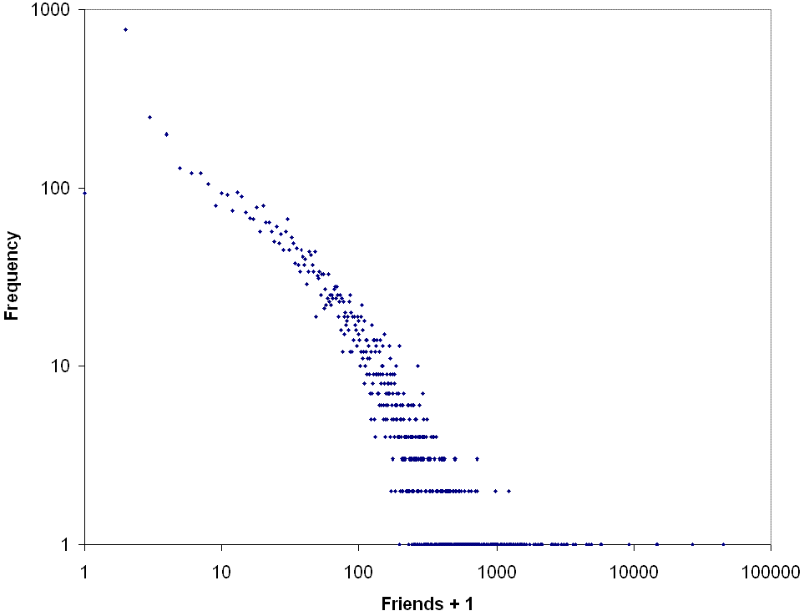
Figure 3. Friend distribution for active US members Feb 2010 year on data.

MySpace is dominated by those declaring their marital status as the default value of single (Table 9). Nevertheless, about half do not declare a status and the percentages in the categories have changed over time (chi-square p=0.000 for both year on and all profiles tables). It is surprising that the more recent year on group includes more singles given that they are slightly older, but not surprising that the reverse is true for the all profiles group. No explanation seems plausible for the former phenomenon.

Table 9. Declared marital status for active US members.
Marital Status | Valid Mar 2008 year on (active US members only) | Valid Feb 2010 year on (active US members only) | Valid Jul 2007 all profiles (active US members only) | Valid Feb 2010 all profiles (active US members only)
Divorced | 1.8% | 1.0% | 1.5% | 1.1%
Engaged | 0.9% | 2.3% | 0.0% | 4.1%
In a Relationship | 17.4% | 12.8% | 14.7% | 19.9%
Married | 20.6% | 14.5% | 12.8% | 16.8%
Single | 58.5% | 69.3% | 69.8% | 56.5%
Swinger | 0.8% | 0.1% | 1.1% | 1.7%
Total | 100.0% | 100.0% | 100.0% | 100.0%
N= | 2512 | 1216 | 1950 | 1083

There has been little change in religious affiliation declared over time although only about 20% report this (Table 10). There is a slight increase in declared Christians of various types (chi-square p=0.003 for year on changes, p>0.05 for all profiles changes). There has been no change in active members’ declared sexual orientation (chi-square p>0.05, Table 11), with a continued straight overwhelming majority, although there are gay enclaves within MySpace (Crowley, 2010) and some may hesitate to publicly declare sexual orientations other than straight.

Table 10. Declared religion for active US members.
Religion | Valid Mar 2008 year on (active US members only) | Valid Feb 2010 year on (active US members only) | Valid Jul 2007 all profiles (active US members only) | Valid Feb 2010 all profiles (active US members only)
Agnostic | 2.2% | 1.8% | 3.7% | 2.7%
Atheist | 2.5% | 1.6% | 1.4% | 2.3%
Buddhist | 1.0% | 0.8% | 1.3% | 1.0%
Catholic | 21.8% | 23.1% | 20.7% | 21.4%
Christian - other | 56.6% | 61.6% | 59.9% | 57.5%
Hindu | 0.1% | 0.5% | 0.5% | 0.4%
Jewish | 0.6% | 0.3% | 1.4% | 0.2%
Mormon | 0.8% | 1.8% | 0.5% | 0.4%
Muslim | 0.7% | 1.6% | 0.6% | 0.6%
Other | 9.0% | 3.6% | 6.7% | 8.9%
Protestant | 2.8% | 1.0% | 1.9% | 2.1%
Scientologist | 0.6% | 0.8% | 0.0% | 0.2%
Taoist | 0.0% | 0.5% | 0.3% | 0.4%
Wiccan | 1.2% | 1.0% | 1.0% | 1.9%
Total | 100.0% | 100.0% | 100.0% | 100.0%
N= | 1072 | 385 | 623 | 518

Table 11. Declared sexual orientation for active US members.
Sexual Orientation | Valid Mar 2008 year on (active US members only) | Valid Feb 2010 year on (active US members only) | Valid Jul 2007 all profiles (active US members only) | Valid Feb 2010 all profiles (active US members only)
Bi | 2.0% | 2.1% | 2.2% | 1.9%
Gay | 0.8% | 0.9% | 1.5% | 0.8%
Lesbian | 0.8% | 0.4% | 1.5% | 0.8%
Not Sure | 1.3% | 1.3% | 1.2% | 0.6%
Straight | 95.2% | 95.4% | 93.7% | 95.8%
Total | 100.0% | 100.0% | 100.0% | 100.0%
N= | 1732 | 560 | 1011 | 825

Predictors of active membership
For the Feb 2010 year on data set activity levels were tested against the other statistics to see which member properties were most strongly associated with being active. This analysis covers US members only, but a preliminary investigation showed that these were themselves the most likely to be active: chi-square tests found active membership to associate with declared country of origin (p=0.000), with US users the only group more likely to be active (19.0% compared to 7.7% for the rest averaged).
A Mann-Whitney U-test found that active membership for US members was unsurprisingly associated with having more friends (p=0.000) and being younger (p=0.000). Figure 4 shows that the active user group has a relatively larger share of ages 13-18 but the inactive members have a higher share of ages 19 upwards.

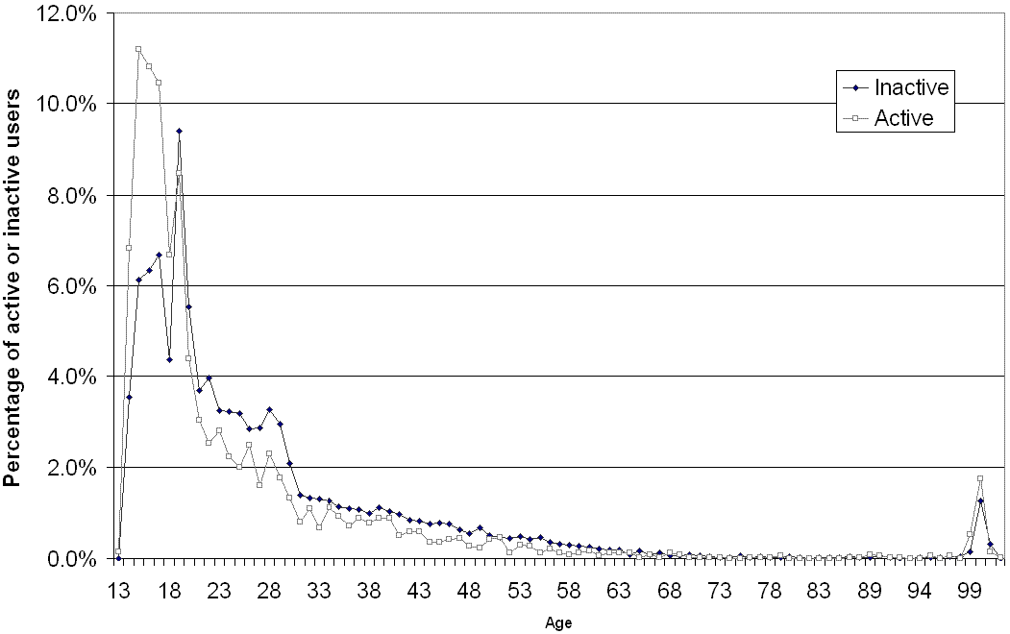
Figure 4. Age distributions for active (10.4%) and inactive (89.6%) US members - Feb 2010 year on data.

Chi-square tests found that active membership was associated with being female (p=0.000, 17.6% of males and 20.4% of females were active), and having a private profile (p=0.000, 33.6% of private profile members were active and 11.1% of public profile members). The latter is consistent with a study that found about 10% of new members changed their profile from public to private during the first seven weeks (Parks, in press). People with any marital status other than single or swinger (but only n=19 for the swinger category) were more likely to be active (chi-square, p=0.000; 8.4% of singles and 5.3% of swingers were active compared to at least 39.5% of the rest – probably because single is a MySpace default, so changing it is in itself an activity action.
Chi-square tests also found active membership to associate with attitude towards children (p=0.000), with the Proud Parent (47.0%), Expecting (60.7%) and Someday (49.0%) categories being more active than the average for those who answered the question (46.0%). There was some evidence that people declaring they were Here for Friends and nothing else (46.1%) were more likely to be active (chi-square p=0.015 for the whole table) than average for those who answered the question (42.6%). Declared sexual orientation was also a significant predictor of activity (chi-square p=0.006 for the whole table), with members declaring straight (44.9%) being much more likely than members declaring Gay (33.3%), Lesbian (22.6%) or Bi (22.6%) to be active.
Chi-square tests showed no significant association between activity and declared religion or ethnicity. In the latter case, this is consistent with a similar analysis from 2007 which found no ethnic group to have logged on significantly more recently than others (Parks, in press).

Limitations
This study has a number of limitations, mainly related to reliance upon user-declared information and the selection of an appropriate sample for analysis. User-declared information is an issue because MySpace profiles can be performances rather than accurate identity projections and misinformation is also deliberately given in some cases, and particularly for age. MySpace profiles can be performances in the sense that there is nothing to stop anyone from creating a profile for somebody that does not reflect their offline identity, such as a musician or someone of a different gender. This does not seem to be a big problem, however, since the typical use of MySpace seems to be to connect with offline friends (boyd, 2008b). In consequence, it seems to be used as a projection or extension of offline identity and so the inclusion of significantly misleading information would be counterproductive, except perhaps for play purposes. Nevertheless, there is no systematic evidence to clearly prove that MySpace is typically reasonably accurate, although one study found evidence of age inflation in 8.3% of profiles where the stated age was under 18 (Hinduja & Patchin, 2008) and so, adding up to 3.1% over 85 (Table 3) suggests that age inflation may be present about 11.4% of the time. Finally, the automatically-calculated statistics from MySpace’s software such as the number of Friends may also be inaccurate (Parks, 2008) but this should not impact on the analyses unless there are systematic biases.
In terms of sample limitations, the main problem is that most of the analyses are restricted to public profiles. The results therefore primarily reflect the less cautious users, with a consequent slight male bias and probably other unknown biases. In addition there are limitations in terms of how the sample was selected. The main analyses were restricted to a concept of active users, based upon last login date. This heuristic is clearly an oversimplification since people could log on occasionally without really being active users and others could be very active but away for long periods, such as in prison, at college, or away in the army. Moreover, older people may use the site sporadically – such as to contact young relatives around birthdays and holidays – and so the age profiles reported here may underestimate the participation of older people. It is also possible to be a MySpace user without joining, such as through visiting the profiles of bands for music or information. More significant probably is the selection of the entire US for the main analysis. MySpace users are quite heavily segmented by country (Thelwall, 2009a) and so global results would not reflect individual countries well. This is confirmed, for instance, in by an analysis of Spanish participants in MySpace forums that show national differences in age and gender (Kaltenbrunner, Banchs, & Bondia, 2009). The US is a large country, however, and so the results may well differ between different regions. Hence the findings are probably an aggregation of different regional and urban/suburban/rural usage practices.
Finally, MySpace is changing and evolving constantly and the situation in February 2010 is likely to change subsequently. Although it is possible to extrapolate from the changes to predict future trends, such predictions may be invalidated by future developments, such as mergers or marketing initiatives, or the rise of new SNSs.

Conclusions
The results show that the active US membership of MySpace has been surprisingly stable over the past few years, with some age and ethnicity exceptions. In addition there is a decreasing US membership majority and the large increase in the average number of friends – the latter probably for technical reasons. The dominant age group has switched from about 15 to about 17 but this change seems too small to suggest different underlying social uses and the continued predominantly young membership suggests that MySpace may be a life phase activity more than a cohort-based activity. In terms of ethnicity, there is a clearly increasing Latino/Hispanic user group, which is consistent with a ghetto perception amongst some teens (boyd, in press). Nevertheless, the ethnic change is only a small tendency and minorities in the US are still minorities in MySpace, but with Latinos and African Americans seeming to be less of a minority than in the general population. Note that the proportion of Latino/Hispanic users out of the total number of Latinos/Hispanics in the US may still be declining, but not at as great a rate as for other ethnic groups. This is suggested, for instance, from surveys of University of Illinois students in 2007 and 2009 (Hargittai, 2009).
The confirmed and continued dominance of females in MySpace, apparently to a much larger extent than for Facebook (Hargittai, 2007), is remarkable. As discussed above, two possible explanations are gendered differences in visual creativity (for profile customisation) and music preferences.
Of the people that sign up to MySpace, those most likely to become active are females and US members, as well as people declaring certain types of interest or attitude, but ethnicity and religion was not a useful predictor of activity for US members.
In summary, US MySpace is not developing into a generic SNS that appeals across age groups but continues to be a place for youth, and particularly females. Its majority white membership with an increasing Latino/Hispanic and continued above-average African American uptake is consistent with an increasing ethnically-specialised association. From a future research perspective, studies of MySpace may also shed light on this relatively disenfranchised section of the US population because of the public nature of MySpace. Moreover, comparisons of reasons for joining SNSs and activities in them may also help to understand the nature of ethnic divisions within the US.

References
Acquisti, A., & Gross, R. (2006). Imagined communities: Awareness, information sharing, and privacy on the facebook. Lecture Notes in Computer Science, 4258, 36-58.
Ahn, Y.-y., Han, S., Kwak, H., Moon, S., & Jeong, H. (2007). Analysis of topological characteristics of huge online social networking services. WWW2007, Retrieved March 18, 2010 from: http://www2007.org/papers/paper2676.pdf.
Alexa. (2010a). Top Sites. http://www.alexa.com/topsites, Retrieved February 22, 2010.
Alexa. (2010b). Top Sites in Philippines. http://www.alexa.com/topsites/countries/PH, Retrieved February 22, 2010.
Alexanyan, K. (2009). The RuNet - Lost in translation. Russian Analytical Digest, 69(14 December 2009), 2-7.
Anonymous. (2010). Profiting from friendship. The Economist, 394(8667), 129.
Antin, J., & Earp, M. (2010). With a little help from my friends: Self-interested and prosocial behavior on MySpace Music. Journal of the American Society for Information Science & Technology, 61(5), 952-963.
Baym, N., & Ledbetter, A. (2009). Tunes that bind? Predicting friendship strength in a music-based social network. Information, Communication & Society, 12(3), 408-427.
boyd, d. (2007). Viewing American class divisions through Facebook and MySpace. Apophenia Blog Essay (June 24), Retrieved July 12, 2007 from: http://www.danah.org/papers/essays/ClassDivisions.html.
boyd, d. (2008a). Taken out of context: American teen sociality in networked publics. University of California, Berkeley, Berkeley.
boyd, d. (2008b). Why youth (heart) social network sites: The role of networked publics in teenage social life. In D. Buckingham (Ed.), Youth, identity, and digital media (pp. 119-142). Cambridge, MA: MIT Press.
boyd, d. (in press). White flight in networked publics? How race and class shaped American teen engagement with MySpace and Facebook. In L. Nakamura & P. Chow-White (Eds.), Digital Race Anthology.London: Routledge.
boyd, d., & Ellison, N. (2007). Social network sites: Definition, history, and scholarship. Journal of Computer-Mediated Communication, 13(1), Retrieved May 7, 2009 from: http://jcmc.indiana.edu/vol2013/issue2001/boyd.ellison.html.
Brake, D. (2009). Shaping the 'me' in MySpace: The framing of profiles on a social network site. In K. Lundby (Ed.), Digital Storytelling, Mediatized Stories: Self-Representations in New Media (pp. 285-300). New York: Peter Lang.
Byrne, D. (2007). Public discourse, community concerns, and their relationship to civic engagement: Exploring black social networking traditions on blackplanet.com. Journal of Computer-Mediated Communication, 31(1), Retrieved May 18, 2008 from: http://jcmc.indiana.edu/vol2013/issue2001/byrne.html.
Callahan, E. (2008). Class Reunion - the success of Nasza-Klasa (our class). AoIR Conference, http://j.rsl.ru/index.php/record/view/10.
Carroll, K. S. (2008). Puerto Rican language use on MySpace.com. Centro Journal, 20(1), 96-111.
Caverlee, J., & Webb, S. (2008). A large-scale study of MySpace: Observations and implications for online social networks. Second International Conference on Weblogs and Social Media, Retrieved March 18, 2010 from: http://faculty.cs.tamu.edu/caverlee/pubs/caverlee2008alarge.pdf.
Christenson, P., & Roberts, D. (1998). It's not only rock and roll: Popular music in the lives of adolescents.Cresskil, NJ: Hampton Press.
Chun, H., Kwak, H., Eom, Y.-H., Ahn, Y.-Y., Moon, S., & Jeong, H. (2008). Comparison of online social relations in volume vs interaction: a case study of cyworld. Proceedings of the Internet Measurement Conference 2008, 57-69.
comscore. (2008). Social networking explodes worldwide as sites increase their focus on cultural relevance. Retrieved February 22, 2010 from: http://www.comscore.com/Press_Events/Press_Releases/2008/2008/Social_Networking_World_Wide.
Crowley, M. (2010). how r u? Lesbian and bi-identified youth on MySpace. Journal of Lesbian Studies, 14(1), 52-60.
Delsing, M. J. M. H., ter Bogt, T. F. M., Engels, R. C. M. E., & Meeus, W. H. J. (2008). Adolescents' music preferences and personality characteristics. European Journal of Personality, 22(2), 109-130.
Donath, J. (2007). Signals in social supernets. Journal of Computer-Mediated Communication, 13(1), Retrieved June 17, 2008 from: http://jcmc.indiana.edu/vol2013/issue2001/donath.html.
Dutton, W. H. (2004). Bridging broadband Internet divides: Reconfiguring access to enhance communicative power. Journal of Information Technology, 19(1), 28-38.
Dwyer, C., Hiltz, S. R., & Passerini, K. (2007). Trust and privacy concern within social networking sites: A comparison of Facebook and MySpace. Proceedings of AMCIS 2007, Keystone, CO, Retrieved May 18, 2008 from: http://csis.pace.edu/~dwyer/research/DwyerAMCIS2007.pdf.
Dwyer, C., Hiltz, S. R., & Passerini, K. (2008). Understanding development and usage of social networking sites: The social software performance model. In Proceedings of the 41st Hawaii International Conference on System Sciences (pp. Retrieved May 6, 2009 from: http://csis.pace.edu/~dwyer/research/DwyerHICSS2008.pdf). New York, NY: IEEE.
Garrahan, M. (2009). The rise and fall of MySpace. FTWeekend, Sunday December 6, 1-2.
Haddon, L., & Kim, S. D. (2007). Mobile phones and web-based social networking - Emerging practices in Korea with Cyworld. Journal Of The Communications Network, 6, 5-12.
Hargittai, E. (2007). Whose space? Differences among users and non-users of social network sites. Journal of Computer-Mediated Communication, 13(1), Retrieved March 3, 2010 from: http://jcmc.indiana.edu/vol2013/issue2011/hargittai.html.
Hargittai, E. (2009). Popularity of Facebook and MySpace changes, but SES differences in use persist. Retrieved March 3, 2010 from: http://www.esztersblog.com/2009/2007/2008/popularity-of-facebook-and-myspace-changes-but-ses-differences-in-use-persist/.
Henderson, S., Taylor, R., & Thomson, R. (2002). In touch: Young people, communication and technologies. Information, Communication & Society, 5(4), 494-512.
Hinduja, S., & Patchin, J. W. (2008). Personal information of adolescents on the Internet: A quantitative content analysis of MySpace. Journal of Adolescence, 31(1), 125-146.
Johnson, M. (2007). Unscrambling the "average user" of Habbo Hotel. Human Technology, 3(2), 127-153.
Joinson, A. (2001). Self-disclosure in computer-mediated communication: The role of self-awareness and visual anonymity. European Journal of Social Psychology, 31(1), 177-192.
Joinson, A. N. (2008). Looking at, looking up or keeping up with people? Motives and use of facebook. Proceeding of the twenty-sixth annual SIGCHI conference on Human factors in computing systems, 1027-1036.
Jones, S., Millermaier, S., Goya-Martinez, M., & Schuler, J. (2008). Whose Space is MySpace? A content analysis of MySpace profiles. First Monday, 13(9), Retrieved March 3, 2010 from: http://firstmonday.org/htbin/cgiwrap/bin/ojs/index.php/fm/article/view/2202/2024.
Kaltenbrunner, A., Banchs, R., & Bondia, E. (2009). Analyzing and ranking the Spanish speaking MySpace community by their contributions in forums. WWW 2009, Retrieved February 23, 2010 from: http://ellayelabanico.org/www2009madrid/pdf/submissions/wwwiberoamerica2009_submission_2012.pdf.
Kaufman, J. C. (2006). Self-reported differences in creativity by ethnicity and gender. Applied Cognitive Psychology, 20(8), 1065-1082.
Kim, K.-H., & Yun, H. (2007). Cying for me, Cying for us: Relational dialectics in a Korean social network site. Journal of Computer-Mediated Communication, 13(1), 298-318.
Kroger, J. (2007). Identity development: Adolescence through adulthood (2 ed.). Thousand Oaks, CA: Sage.
Lampe, C., Ellison, N., & Steinfield, C. (2008). Changes in use and perception of Facebook. In Proceedings of the ACM 2008 conference on Computer supported cooperative work (pp. 721-730). San Diego, CA: ACM Press.
Lampe, C. A. C., Ellison, N., & Steinfield, C. (2007). A familiar face(book): Profile elements as signals in an online social network. Proceedings of the SIGCHI conference on Human factors in computing systems, 435-444.
Lenhart, A., Purcell, K., Smith, A., & Zickuhr, K. (2010). Social media & mobile internet use among teens and young adults. Pew Internet & American Life Project, Retrieved February 5, 2010 from: http://pewinternet.org/Reports/2010/Social-Media-and-Young-Adults.aspx.
Ling, R. (2010). Texting as a life phase medium. Journal of Computer Mediated Communication, 15(1), 277-292.
Liu, H. (2007). Social network profiles as taste performances. Journal of Computer-Mediated Communication, 13(1), Retrieved June 5, 2008 from: http://jcmc.indiana.edu/vol2013/issue2001/liu.html.
Livingstone, S. (2008). Taking risky opportunities in youthful content creation: Teenagers' use of social networking sites for intimacy, privacy and self-expression. New Media & Society, 10(3), 393-411.
Livingstone, S., & Brake, D. (2010). On the rapid rise of social networking sites: New findings and policy implications. Children & Society, 24(1), 75-83.
MacKenzie, D., & Wajcman, J. (Eds.). (1985). The social shaping of technology: How the refrigerator got its hum.Philadelphia, PA: Open University Press.
McMullin, J. A., Comeau, T. D., & Jovic, E. (2007). Generational affinities and discourses of difference: a case study of highly skilled information technology workers. British Journal of Sociology, 58(2), 297-316.
Moreno, M. A., Parks, M. R., Zimmerman, F. J., Brito, T. E., & Christakis, D. A. (2009). Display of health risk behaviors on MySpace by adolescents. Archives of Pediatrics and Adolescent Medicine, 163(1), 27-34.
Nakamura, L. (2008). Digitizing race: Visual cultures of the Internet.Minneapolis: University of Minnesota Press.
Oksman, V., & Turtiainen, J. (2004). Mobile communication as a social stage. New Media & Society, 6(3), 319-339.
Parks, M. R. (1996). Making friends in cyberspace. Journal of Computer Mediated Communication, 1(4), Retrieved January 4, 2010 from: http://jcmc.indiana.edu/vol2011/issue2014/parks.html.
Parks, M. R. (2008). Characterizing the communicative affordances of MySpace: A place for friends or a friendless place? Paper presented at the International Communication Association, Montreal.
Parks, M. R. (in press). Boundary conditions for the application of three theories of computer-mediated communication to MySpace. Journal of Communication.
Parks, M. R. (in press). Social network sites as virtual communities. In Z. Papacharissi (Ed.), The networked self: Online social networks.New York: Routledge.
Patchin, J. W., & Hinduja, S. (2010). Trends in online social networking: Adolescent use of MySpace over time. New Media & Society, 12(2), 197-216.
Pennock, D., Flake, G. W., Lawrence, S., Glover, E. J., & Giles, C. L. (2002). Winners don't take all: Characterizing the competition for links on the web. Proceedings of the National Academy of Sciences, 99(8), 5207-5211.
Perkel, D. (2008). Copy and paste literacy: Literacy practices in the production of a MySpace profile. In K. Drotner, H. S. Jensen & K. Schroeder (Eds.), Informal learning and digital media: Constructions, contexts, consequences (pp. 203-224). Newcastle, UK: Cambridge Scholars Press.
Pfeil, U., Arjan, R., & Zaphiris, P. (2009). Age differences in online social networking - A study of user profiles and the social capital divide among teenagers and older users in MySpace. Computers in Human Behavior, 25(3), 643-654.
Pliner, P., Chaiken, S., & Flett, G. L. (1990). Gender differences in concern with body weight and physical appearance over the life span. Personality and Social Psychology Bulletin, 16(2), 263-273.
Roberts, D., & Christenson, P. (2001). Popular music in childhood and adolescence. In D. G. Singer & J. L. Singer (Eds.), Handbook of children and the media (pp. 395-413).
Rogers, E. M. (1962). Diffusion of Innovations.Glencoe: Free Press.
Selwyn, N., Gorard, S., & Furlong, A. (2005). Whose Internet is it anyway? Exploring adults' (non)use of the Internet in everyday life. European Journal Of Communication, 20(1), 5-26.
Shklovski, I., & boyd, d. (2006). Music as cultural glue: Supporting bands and fans on MySpace. Retrieved March 5, 2010 from: http://www.danah.org/papers/BandsAndFans.pdf.
Sue, S., & Okazaki, S. (1990). Asian-American educational achievements: A phenomenon in search of an explanation. American Psychologist, 45(8), 913-920.
Takahashi, T. (2010). MySpace or Mixi? Japanese engagement with SNS (social networking sites) in the global age. New Media & Society, 12(3), 453-475.
Thelwall, M. (2008). Social networks, gender and friending: An analysis of MySpace member profiles. Journal of the American Society for Information Science and Technology, 59(8), 1321-1330.
Thelwall, M. (2009a). Homophily in MySpace. Journal of the American Society for Information Science and Technology, 60(2), 219-231.
Thelwall, M. (2009b). Social network sites: Users and uses. In M. Zelkowitz (Ed.), Advances in Computers (pp. 19-73). Amsterdam: Elsevier.
Thelwall, M., & Wilkinson, D. (2010). Public dialogs in social network sites: What is their purpose? Journal of the American Society for Information Science & Technology, 61(2), 392-404.
Torkjazi, M., Rejaie, R., & Willinger, W. (2009). Hot today, gone tomorrow: on the migration of MySpace users. ACM SIGCOMM, Retrieved March 18, 2010 from: http://conferences.sigcomm.org/sigcomm/2009/workshops/wosn/papers/p2043.pdf.
Tufekci, Z. (2008a). Can you see me now? Audience and disclosure regulation in online social network sites. Bulletin of Science, Technology and Society, 28(1), 20-36.
Tufekci, Z. (2008b). Grooming, gossip, Facebook and MySpace: What can we learn about these sites from those who won't assimilate? Information, Communication & Society, 11(4), 544-564.
U.S._Census_Bureau. (2006). Hispanic or Latino origin by specific origin. Retrieved March 5, 2010 from: http://factfinder.census.gov/servlet/DTTable?_bm=y&-context=dt&-ds_name=ACS_2006_EST_G2000_&-CONTEXT=dt&-mt_name=ACS_2006_EST_G2000_C03001&-tree_id=03306&-redoLog=false&-currentselections=ACS_02006_EST_G02000_B02001&-currentselections=ACS_02006_EST_G02000_B02003&-currentselections=ACS_02006_EST_G02000_C02003&-geo_id=01000US&-search_results=01000US&-format=&-_lang=en.
U.S._Census_Bureau. (2008). Race universe - Total population. Retrieved March 8, 2010 from: http://factfinder.census.gov/servlet/DTTable?_bm=y&-context=dt&-ds_name=ACS_2008_2011YR_G2000_&-CONTEXT=dt&-mt_name=ACS_2008_2011YR_G2000_B02001&-tree_id=02306&-redoLog=false&-all_geo_types=N&-currentselections=ACS_02006_EST_G02000_B02001&-geo_id=01000US&-search_results=01000US&-format=&-_lang=en.
Van Doorn, N. (in press). The ties that bind: the networked performance of gender, sexuality and friendship on MySpace. New Media & Society.
Walther, J., Van der Heide, B., Kim, S., Westerman, D., & Tong, S. T. (2008). The role of friends' appearance and behavior on evaluations of individuals on Facebook: Are we known by the company we keep? Human Communication Research, 34, 28-49.
Wang, H., & Wellman, B., A. (2010). Social connectivity in America: Changes in adult friendship network size from 2002 to 2007. American Behavioral Scientist, 53(8), 1148-1169.
Watkins, S. C. (2009). The young and the digital: What the migration to social network sites, games, and anytime, anywhere media means for our future.Boston: MA: Beacon Press.
Wellman, B., A., Quan-Hasse, J., Boase, W., Chen, K., Hampton, I., de Diaz, I., et al. (2003). The social affordances of the Internet for networked individualism. Journal of Computer-Mediated Communication, 8(3), Retrieved April 15, 2009 from: http://jcmc.indiana.edu/vol2008/issue2003/wellman.html.
Ybarra, M. L., & Mitchell, K. J. (2008). How risky are social networking sites? a comparison of places Online where youth sexual solicitation and harassment occurs. Pediatrics, 121(2), E350-E357.
Zhao, S. (2009). Teen adoption of MySpace and IM: Inner-city versus suburban differences. CyberPsychology & Behavior, 12(1), 55-58.

This is a preprint of an article accepted for publication in Journal of the American Society for Information Science and Technology copyright © 2010 (American Society for Information Science and Technology)

