Homophily in MySpace
Mike Thelwall
Statistical Cybermetrics Research Group, School of Computing and Information Technology, University of Wolverhampton, Wulfruna Street, Wolverhampton WV1 1LY, UK. E-mail: m.thelwall@wlv.ac.uk
Tel: +44 1902 321470 Fax: +44 1902 321478

Social network sites like MySpace are increasingly important environments for expressing and maintaining interpersonal connections but does online communication exacerbate or ameliorate the known tendency for offline friendships to form between similar people (homophily)? This paper reports an exploratory study of the similarity between the reported attributes of pairs of active MySpace Friends based upon a systematic sample of 2,567 members joining on June 18, 2007 and Friends who commented on their profile. The results showed no evidence of gender homophily but significant evidence of homophily for ethnicity, religion, age, country, marital status, attitude towards children, sexual orientation, and reason for joining MySpace. There were also some imbalances, with women and the young being disproportionately commenters and commenters tending to have more Friends than commentees. Overall it seems that whilst traditional sources of homophily are thriving in MySpace networks of active public connections, gender homophily has completely disappeared. Finally, the method used has wide potential for investigating and partially tracking homophily in society, providing early warning of socially divisive trends.

Introduction
The central issue addressed in this paper is homophily, the tendency for friendships and many other interpersonal relationships to occur between similar people. Based upon a survey of predominantly US research, it seems that gender, sexuality, religion, race and age similarity are all important predictors of friendship (McPherson, Smith-Lovin, & Cook, 2001). Part of the reason is the availability of potential friends: for example a Black U.S. youth may find herself in an almost exclusively Black school, in a class of people her own age. In such a situation it would not be surprising if her friends were the same age and Black. In contrast, if most of her friends were girls then this would probably be by choice or through conforming to social norms. Choosing more similar friends than the average available is known as inbreeding homophily. Given the ease of Internet communication it seems that baseline homophily, the availability of disproportionately many similar potential friends, should be partially undermined, especially for new friends met online. Internet-based studies may help to assess whether this is the case and may also be able to provide rapid and frequent evidence about friendship homophily and other interpersonal relationship homophily in society, giving early warning of potential problems.
Internet-based interpersonal communication is an increasingly important part of many people’s lives (e.g., Dutton & Elsper, 2007; Lenhart, Madden, Macgill, & Smith, 2007), whether using email, discussion lists, blogs, social network sites or chatrooms. This shift towards the online for interpersonal communication may impact friendship patterns, making it easier to keep in touch with friends who move away (e.g., to university or a new job) and to make new friends online. Although distance is technologically irrelevant on the Internet, online communication is probably most common between people who live close together (e.g., Golder, Wilkinson, & Huberman, 2007). Assuming that the current level of Internet-based interpersonal communication continues or increases, it seems possible that many aspects of the nature of friendships and other interpersonal relationships will change. This may have significant social benefits or drawbacks because it seems that having variety in the types of people that we know is healthy for democracy (e.g., Sunstein, 2007). For example in 2008 about half of UK citizens did not have any Muslims amongst their “closest friends”, which may be a factor allowing Islamophobia to thrive (Dispatches, 2008) and previous research has shown that increased ethnic diversity in US colleges promotes cross-cultural friendships, although it does not eliminate homophily (Fischer, 2008). Research into racism routinely takes into account individuals’ exposure to other ethnicities, for example through geographic ethnic diversity indices (e.g., Dixon, 2008). As a result of such issues it is important to identify relevant trends in order to manage or plan for the consequences.
This study assesses various types of homophily in the connections between people within the popular social network site MySpace. Whilst MySpace members can designate each other as Friends, this is not the same as offline friendship but is a weaker construct – a “public display of connections” (Donath & boyd, 2004). In studies of specific groups of members of MySpace and the similar site Facebook, such connections have tended to reflect or support offline networks, although also allowing new friendships to form (Ellison, Steinfield, & Lampe, 2007; Raacke & Bonds-Raacke, 2008). Hence it would be reasonable to expect MySpace Friendship to exhibit homophily similar to that of its members’ wider offline connections (at least when both parties are MySpace members). In addition, there is evidence that social network sites change interpersonal relationships in some ways, for example by allowing distant friends to stay in touch more easily when one moves away to go to college (Golder, Wilkinson, & Huberman, 2007). Nevertheless MySpace does not seem to be changing friendship to the extent that it supports significant numbers of previously unknown people to become genuine friends, and so it may not be revolutionary in this sense.
Few previous studies have systematically investigated issues of homophily online, with an exception being an analysis of attributes predicting email interaction amongst a college network (Kossinets & Watts, 2006). Other studies have investigated online homophily on a small scale, such as for the impact of avatar gender (Nowak & Christian, 2006), or for its influence on distributed team working (Yuan & Gay, 2006). Only two papers seem to have investigated homophily in MySpace (for gender and interests, see below). The current study refines the methods of the previous research and analyses more factors in a large systematic sample. The objectives are information-centred (Thelwall, Wouters, & Fry, 2008): to develop and demonstrate effective methods for identifying homophily within MySpace friendship, to provide initial exploratory findings, and to highlight promising directions for future research. This article is therefore an explicitly information science contribution to a problem that is of most interest to researchers outside of information science, so that those researchers can use the findings to inform their own work.

MySpace
MySpace is a social network site (sns), meaning that members have a profile page with a picture and list of Friends that is visible to at least these Friends and perhaps also a much larger group of people (boyd & Ellison, 2007). In the case of MySpace, the profile pages of about two thirds of members are world-visible (Hinduja & Patchin, 2008; Thelwall, 2008). MySpace has been claimed in 2007 to be the most visited web site for the US, surpassing even Google and YouTube (Prescott, 2007) although seems that Facebook overtook it in mid 2008.
Teen MySpace users’ profile pages seem often to be used for identity expression (boyd & Heer, 2006) with customisation used to present a desired personality. The choice of Friends is another aspect of identity expression, as a “public display of connections” (Donath, & boyd, 2004), especially for older members who tend to see profile appearance as less important (Livingstone, 2008). Particularly important are the “Top Friends” displayed on the profile page, with other Friends relegated to separate pages (boyd, 2006). MySpace Friends tend to be offline friends more than strangers (e.g., Pew Research Center for the People & the Press, 2007) and MySpace may be frequently seen by US youth as a convenient place to hang out online with offline friends – a replacement for the shopping mall in this regard (boyd, 2008).
In addition to offline friends, members may ‘Friend’ strangers, such as musicians, with Friendship being effectively a fan relationship. Moreover, a minority of members seem to competitively collect online Friends, rendering this relationship meaningless for them (boyd, 2006). Hence it is important to distinguish between active and passive Friendships. An active Friendship is one where the partners communicate directly using non-automated processes, such as by sending messages or by commenting on each others’ blog, pictures or profile. The active nature of (offline) friendship is emphasised by many researchers, such as Dunbar, who uses the phrase social grooming to describe activities designed to maintain friendships (Dunbar, 1996). There is indirect evidence of the importance of communication in online friendship: people who choose not to engage with social network software tend not to value “social grooming” including the exchange of minor information about others (Tufekci, 2008b). Social network sites may also make social grooming much easier and allow members to groom wider circles of friends and acquaintances than possible offline (Donath, 2007), but ‘friendship’ nevertheless seems like a reasonable term to describe an online relationship that includes occasional communication, albeit perhaps a weak form of friendship. Nevertheless, some may regard the term as too strong since acquaintances and strangers sometimes also communicate.

Homophily
The issue of offline friendship homophily has been researched extensively in sociology and management studies, both in terms of baseline and inbreeding variants. Although there is no general theory of why homophily occurs so widely, it has been found in many different types of relationship, including friendship, marriage partners and business colleagues. For U.S. friendship in the last century the key factors, in decreasing order, seem to be race and ethnicity, age, religion, educational level, occupation and gender (McPherson et al., 2001). Whilst the availability of a wider spectrum of potential friends seems to increase friendship diversity, at least for students, it often does not eliminate inbreeding homophily (Fischer, 2008). The topic of ethnic diversity, integration and ghettoisation is one of vital importance in urban planning because of the social problems associated with a lack of tolerance between different social groups. Related research (e.g., Johnston, Poulsen, & Forrest, 2007) gives urgency to the study of friendship homophily (BBC, 2005). Homophily in social networks can also be important in business contexts, for instance as a potentially significant factor for organisational learning (e.g., Pahor, Skerlavaj, & Dimovski, in press) and as a factor in the success of personal networks for the careers of women and minorities (Ibarra, 1993).
In the offline world there are many factors that promote baseline homophily of various types so that people encounter others that are more similar to themselves in some way than average for the general population. For instance, it seems that children at school are typically arranged in classes by age and sometimes by gender, college students tend to have similar ages, colleges bring together people with similar educational levels and sometimes the same gender or religion, various towns and neighbourhoods in many countries may have concentrations of people with the same ethnic background or religion (e.g., Black ghettos and Mormon towns like Salt Lake City in the U.S.), workplaces often bring together people doing the same job and often concentrate by gender (Suter, 2006) and educational level, and extended families tend to consist of people with the same ethnicity and religion. There are also some equalising tendencies; for instance extended families presumably bring together approximately equal proportions of each gender as well as people of a wide range of ages.
Since inbreeding homophily has been frequently identified as additional to baseline homophily (McPherson et al., 2001), it is clear that people actively choose similar friends in many cases. There seems to be no single theory to explain this phenomenon but presumably people who are similar have more in common, which may form the basis for friendship either because communication is easier with a shared background or because discussion topics tend to be of interest to both (e.g., Coates, 2003). One important tendency counteracting inbreeding homophily for gender is sexual relationships, which mostly bring together two people of different genders. In the latter case, presumably friendships leading up to and after sexual relationships also help to counteract gender homophily.

MySpace homophily
Within MySpace, there are several factors that are likely to impact upon the types of people chosen as Friends. First, since it seems that people tend to know their MySpace Friends, offline factors are important. Figure 1 breaks down offline factors into four: existing friends, extended family members, work colleagues or people known through school, and other acquaintances (e.g., friends of friends, business contacts). Only those who are prepared to join MySpace are potential MySpace Friends and so MySpace membership is another factor, one which may be influenced by personality (e.g., Tufekci, 2008b; for Facebook factors see Ellison, Steinfield, & Lampe, 2007), ethnicity (Hargittai, 2007). and other factors. Hence a person’s eventual choice of MySpace Friends is likely to be predominantly a subset of those friends, family members, school/work colleagues and acquaintances that are MySpace members, although some MySpace Friends might also be purely online friends. Figure 1 illustrates that MySpace Friends do not necessarily always equal, or form a subset of, offline friends.

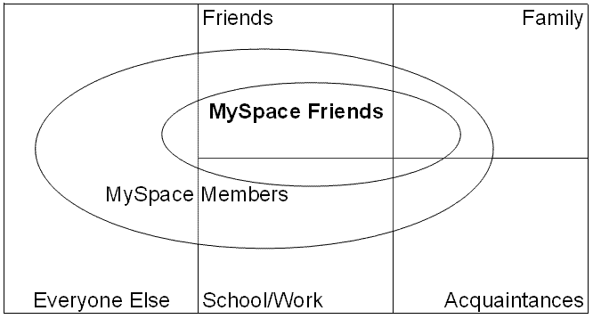
Figure 1. A breakdown of the potential friends for MySpace members.

It seems reasonable to expect the types of homophily found in offline friendship (as discussed in the section above) to also occur in MySpace Friendship, even though MySpace Friends probably tend to reflect much wider offline connections than just friendships. This is because studies of homophily have found similar results in a variety of different contexts, including business relationships (McPherson et al., 2001) and so the phenomenon is not just restricted to offline friendship.
One previous study has analysed an aspect of homophily in a large scale study of MySpace Friends: the tendency for Friends to have similar interests or tastes. Based upon the listed interests of 24,979 members and their Friends, Top 8 Friends were found to be more dissimilar than the average for random pairs of MySpace members (Liu, 2007). Since listing interests seems to be useful in attracting friends in social network sites (e.g., Lampe, Ellison, & Steinfield, 2007) the most likely explanation for this counterintuitive result was that members crafted their interest lists to display a unique identity in the context of their Friends (Liu, 2007). A smaller study of just 403 MySpace Friends found mixed evidence for gender homophily: both males and females had a majority of female Top 8 Friends and a majority of female Friends listed on their profile pages, although females had a higher proportion of female Top 8 Friends than did males (Thelwall, 2008).

Research questions
This is information-centred research, designed to demonstrate new methods and provide initial exploratory findings concerning a new information source (Friendship expressed in MySpace profiles). The following question drives the investigation. As appropriate for an initial exploratory analysis it is opportunistic: deriving as much relevant information as possible using the available information in order to support future, narrower research.
- To what extent does active MySpace Friendship reflect (a) baseline and (b) inbreeding homophily in terms of known offline factors, measurable online activities and other reported member attributes?

Research design and data
The overall research design was to gather a large systematic sample of active MySpace Friend connections and then to extract personal information from profiles in order to apply statistical techniques to identify homophily. The sample is a collection of people with standard profiles (not musicians, comedians or movie makers) together with a selection of their active Friends. Active Friends are operationalised as people who (a) are Friends and (b) have commented on the other’s profile. The assumption here is that many MySpace Friends are not real friends and that more active MySpace Friends are real friends and so the latter is a more suitable type of MySpace Friend to analyse. Of course, other MySpace Friendships may be active offline or active in less public (see Tufekci, 2008a) online ways such as email but (b) seems like a reasonable filter to produce a higher proportion of genuine friends than otherwise present in Friend lists.
The first data collection phase was to download the profiles of 30,000 MySpace members with one year’s standing. The joining date of members can be worked out from their ID. A systematic sample of IDs was generated by starting with approximately the first ID 203,295,564 and then adding 15 29,999 times until approximately the last ID for the joining date (June 18, 2007) was reached. These IDs were converted to home page URLs by adding them to the standard initial profile URL and the resulting URL list was fed to the SocSciBot 4 software (http://socscibot.wlv.ac.uk) for downloading at a maximum rate of 1 per 5 seconds, June 18-21, 2008.
The resulting 30,000 URLs were processed by SocSciBot 4 Tools (available from the author) to extract demographic information about each member and a list of comments and commenter URLs. At this stage all non-standard profiles (musicians, comedians and movie makers) were removed together with discontinued and private profiles, which do not list comments. In addition, profiles with more than 1,000 Friends were excluded as likely to belong to people who have significantly non-standard patterns of MySpace use. The choice of 1,000 was arbitrary because a graph of the data did not reveal a natural cut-off point for “standard” friendships. No further checking of the data was performed, for example to assess whether declared country affiliations, genders or ages were correct. A previous study has found evidence for age inflation amongst 8% of young MySpace members (Hinduja & Patchin, 2008), which suggests that the reported data is likely to be predominantly accurate, but some MySpace profile information will be deliberately false or will be a significantly different performed identity – i.e., an online identity taken by a person with different offline characteristics.
The commenters’ URLs were combined into a new list of profile pages and, after removing duplicates, the list of commenter URLs was fed to SocSciBot 4 for downloading at the same maximum rate, June 21-26, 2008. Once downloaded, profile information was extracted and unwanted profiles removed using the same procedure as for filtering the original profiles.
The basic complete comment data set was constructed by pairing the comments in the original data set with the commentee and commenter URLs and profile information, discarding comments for which the commenter (or commentee) had been excluded. The sampled data set used for the subsequent statistical analysis was compiled by extracting one commenter at random for each commentee. This filtering prevented individuals with many similar Friends from unduly influencing the results. The final data set is a total of 2,567 commenters, each with a different June 18, 2007 commentee.
Finally, note that the filtering procedure above results in the analysis below applying only to people with public profiles.

Methods
The perfect test for this data would be one that distinguishes between four factors: offline baseline and inbreeding homophily and MySpace baseline and inbreeding homophily (i.e., the latter being patterns that are additional to offline trends). This is not possible because the large and heterogeneous sample means that it is impractical to gather baseline offline data about the participants. For instance, in the case of gender baseline proportions of males and females could be expected to be approximately equal in families and the world as a whole. Nevertheless, there are many educational and work environments that are predominantly single gender and, conversely, heterosexual relationships with partners create a cross-gender impetus. Hence, this paper only differentiates MySpace inbreeding homophily from MySpace baseline homophily: i.e., the extent to which active Friends (those who comment on a given profile) are more similar than the pool of potential active Friends (those who comment on any profile).
Spearman tests were used on the numerical data in order to assess the extent of correlation between numerically similar numbers (age, Friends, comments). Spearman correlations were used instead of Pearson correlations because the data is not Normal. A significant Spearman test (i.e., p<0.05) indicates the presence of homophily (e.g., active Friends tend to have similar ages) and the larger the Spearman value, the larger the extent of the homophily.
Chi-square tests were used on the categorical data in order to assess whether the categories influence the relationship between commenters and commentees. This is not a direct test of homophily because it could also detect the opposite tendency, but if this test is significant then it is reasonable to comment on any evidence of homophily within the associated tables. Pearson chi-square values are reported. Yates’s correction was used for the 2x2 case (gender). In cases where the expected values of any of the contingency table cells were less than 5 (mainly the larger tables), chi-square results are not reliable and the exact probability test was used instead (using SPSS’s Exact option). In all cases the exact values could not be calculated precisely due to system memory limitations and SPSS Monte-Carlo approximations were used instead.
Some additional statistics were calculated to support hypotheses about patterns of friendship in the population underlying the data. Three issues with homophily calculations based upon MySpace data are proximity, family ties, and age as confounding factors. In terms of proximity, because MySpace members are international, some homophily may be identified that merely reflects national differences. For example presumably the Friends of MySpace members in Asia are likely to be predominantly Asian and this would register as homophily within a global analysis of MySpace. Hence, for some of the statistics reported, an additional analysis was carried out on the largest single country, the U.S. Of course, within the U.S. there are significant geographic concentrations of different ethnicities and so there is still likely to be an element of proximity-induced homophily within U.S. members.
In terms of family ties, some of the connections within MySpace may be between siblings and between parents and children. Such ties are to an extent involuntary connections and their inclusion may exaggerate the extent of homophily within voluntary active Friendship. Although it is not practical to eliminate all such ties from the data set, some of the analyses were recalculated after eliminating inter-generational ties through the simple expedient of removing all members aged over 30.
Some of the homophily results may be a by-product of age differences. For example attitudes towards children vary with age and so homophily in this variable may be solely due to age homophily. As a result, some of the statistics were rechecked with a restricted age group, such as members under 22 (the median age).
Some additional tests were carried out to check the meaning and accuracy of the data. Although it seems that there is relatively little inaccurate key data in MySpace (e.g., Hinduja & Patchin, 2008), it may affect some data more significantly. A sample of 100 commenter and commentee profiles for those aged 95+ were visited to ascertain whether there was evidence of age misrepresentation. A similar test was conducted for those aged 40-94. A sample of 100 commenter-commentee pairs was also checked to categorise their relationship (e.g., friend, family member, stranger).

Results

Established homophily variables

Ethnicity
Table 1 shows the breakdown of comments by reported ethnicity – but recall that this data is based upon the reported values of the profile owners. The table shows strong homophily (chi-square 1274, Monte-Carlo approximation to exact probability p=0.000, n=882), although the majority of members had not stated an ethnicity. Apart from the ambiguous “other” category and numbers below 3 in the table, in no case does the number of comments approach the expected value between different reported ethnicities. Baseline homophily is the proportion of all commentees that are of the same ethnicity as the commenter. Total homophily is the proportion of commentees that the commenter comments to and which have the same ethnicity as the commenter. Inbreeding homophily is the difference between the two: the percentage of commentees that have apparently been (presumably indirectly) selected as commentees for having similar ethnicity to the commenter.
The table shows a strong pattern of ethnically-based active Friendships in MySpace – as least for the minority that report an ethnicity. It may be that the act of reporting a category means that the member is more likely to regard it as an important aspect of their identity, so that the non-reporters may exhibit less homophily. If restricted to just U.S. members, the homophily is still significant (chi-square 864, Monte-Carlo approximation to exact probability p=0.000, n=643) and the pattern is very similar. Moreover, if restricted to U.S. members under 31 (to eliminate parental relationships) the homophily is still strong (chi-square 580, Monte-Carlo approximation to exact probability p=0.000, n=399) and with a similar pattern (e.g., 65 out of 89 commenters on Black profiles were Black and 169 out of 203 commenters on White profiles were White).

Table 1. Number of comments based upon declared ethnicity of commenter (top) and commentee*.
Commenter  Commentee | Asian | Black / African descent | East Indian | Latino / Hispanic | Middle East-ern | Native Amer-ican | Other | Pacific Islander | White/  Cauc-  asian | Total
Asian | 16.0 | 1.0 | 0.0 | 2.0 | 0.0 | 0.0 | 3.0 | 0.0 | 8.0 | 30
Expected | 1.0 | 4.4 | 0.1 | 4.9 | 0.1 | 0.6 | 1.5 | 0.4 | 16.9
Black/Af. desc. | 0.0 | 98.0 | 1.0 | 8.0 | 0.0 | 4.0 | 6.0 | 2.0 | 20.0 | 139
Expected | 4.7 | 20.2 | 0.5 | 22.7 | 0.5 | 2.8 | 7.1 | 2.0 | 78.5
East Indian | 0.0 | 1.0 | 0.0 | 2.0 | 0.0 | 0.0 | 1.0 | 0.0 | 0.0 | 4
Expected | 0.1 | 0.6 | 0.0 | 0.7 | 0.0 | 0.1 | 0.2 | 0.1 | 2.3
Latino/Hisp. | 2.0 | 7.0 | 1.0 | 100.0 | 1.0 | 2.0 | 9.0 | 1.0 | 14.0 | 137
Expected | 4.7 | 19.9 | 0.5 | 22.4 | 0.5 | 2.8 | 7.0 | 2.0 | 77.4
Middle East. | 2.0 | 0.0 | 0.0 | 1.0 | 0.0 | 0.0 | 0.0 | 0.0 | 0.0 | 3
Expected | 0.1 | 0.4 | 0.0 | 0.5 | 0.0 | 0.1 | 0.2 | 0.0 | 1.7
Native Am. | 0.0 | 2.0 | 0.0 | 1.0 | 0.0 | 3.0 | 0.0 | 1.0 | 8.0 | 15
Expected | 0.5 | 2.2 | 0.1 | 2.4 | 0.1 | 0.3 | 0.8 | 0.2 | 8.5
Other | 2.0 | 6.0 | 1.0 | 4.0 | 1.0 | 0.0 | 7.0 | 0.0 | 32.0 | 53
Expected | 1.8 | 7.7 | 0.2 | 8.7 | 0.2 | 1.1 | 2.7 | 0.8 | 29.9
Pacific Isl. | 1.0 | 1.0 | 0.0 | 0.0 | 0.0 | 0.0 | 2.0 | 4.0 | 4.0 | 12
Expected | 0.4 | 1.7 | 0.0 | 2.0 | 0.0 | 0.2 | 0.6 | 0.2 | 6.8
White/Cauc. | 7.0 | 12.0 | 0.0 | 26.0 | 1.0 | 9.0 | 17.0 | 5.0 | 412.0 | 489
Expected | 16.6 | 71.0 | 1.7 | 79.8 | 1.7 | 10.0 | 24.9 | 7.2 | 276.1
Total | 30 | 128 | 3 | 144 | 3 | 18 | 45 | 13 | 498 | 882
Baseline  homophily | 3% | 16% | 0% | 16% | 0% | 2% | 6% | 1% | 55%
Total  homophily | 53% | 77% | 0% | 69% | 0% | 17% | 16% | 31% | 83%
Inbreeding  homophily | 50% | 61% | 0% | 54% | 0% | 15% | 10% | 29% | 27%
*Expected is the number of comments that would be expected if there was no bias.

Age
Figure 1 illustrates the relationship between commenter and commentee listed age. From a visual inspection of the graph, there is strong homophily up to age about 40. There is weak homophily for ages 40-60 and apparently no homophily from 60-95, although the latter may be due to the dominance of younger users in the data set (i.e., baseline homophily). There is apparently some homophily for ages 96+ but this may be due to age misrepresentation. A Spearman correlation of 0.536 (p=0.000) confirms the significant correlation and if it is assumed that those aged approximately 100 are much younger then the correlation would be even higher. Commenters and commentees have the same median age: 22. A random check of a sample of 100 profiles of ages 96+ found clear evidence of age inflation in 48 and the checker estimated that all the profiles had incorrect ages based upon the owner’s interactions and profile content (this includes 11 organisational profiles). A similar random check of a sample of 100 profiles of ages 40-95 found clear evidence of age inflation in 10 and the checker estimated that a total of 20 of the profiles had incorrect ages (this includes 11 organisational profiles). This suggests that the high age anomalies on the graph are artificial and that age homophily is even stronger than reported.

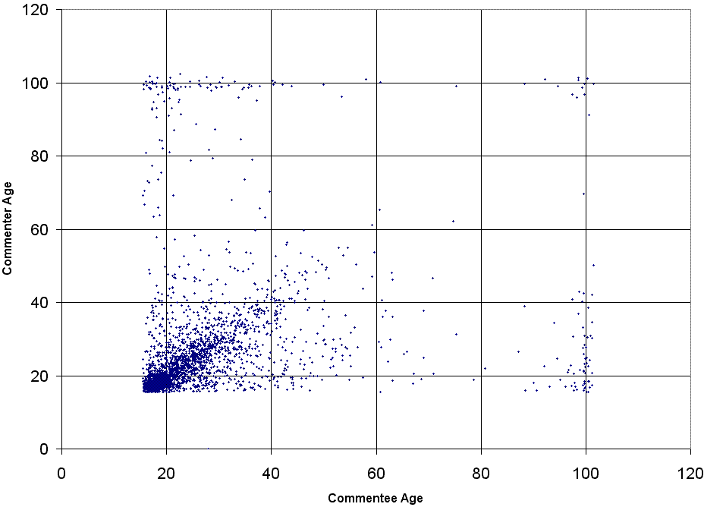
Fig. 1. Listed age of commenter against listed age of commentee. Random jitter of up to +/- half a year has been added to each age to minimise data overlap on the graph.

Figure 2 approximately parallels the overall demographics of MySpace members (with public profiles) but it is surprising that commenters tend to be younger than commentees (e.g., there are more age 16 commenters) – unless it is assumed that younger people have more spare time to use MySpace.

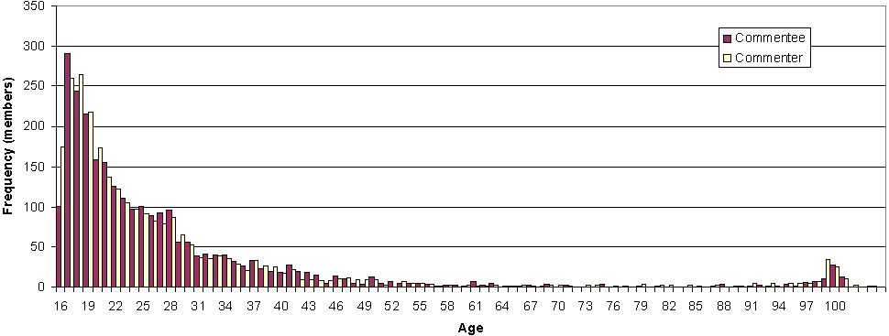
Fig. 2. Age distribution of commenters and commentees.

Some of the age homophily may be due to inter-generational family ties. Table 2 shows the results for those under 23. There is a significant degree of homophily (chi-square 311, Monte-Carlo approximation to exact probability p= 0.000, n=1,002; Spearman: 0.450, p=0.000) even for this narrow age range, with all categories having more active Friends than expected of the same age.

Table 2. Number of comments based upon declared age of commenter (top) and commentee, where both are under 23*.
Commenter  Commentee | 16 | 17 | 18 | 19 | 20 | 21 | 22 | Total
16 | 29.0 | 27.0 | 16.0 | 8.0 | 2.0 | 1.0 | 2.0 | 85
Expected | 12.0 | 18.1 | 19.1 | 14.2 | 10.9 | 6.5 | 4.3
17 | 56.0 | 85.0 | 50.0 | 25.0 | 14.0 | 9.0 | 5.0 | 244
Expected | 34.3 | 51.9 | 54.8 | 40.7 | 31.2 | 18.8 | 12.4
18 | 26.0 | 43.0 | 81.0 | 30.0 | 17.0 | 9.0 | 2.0 | 208
Expected | 29.3 | 44.2 | 46.7 | 34.7 | 26.6 | 16.0 | 10.6
19 | 15.0 | 22.0 | 36.0 | 50.0 | 30.0 | 16.0 | 5.0 | 174
Expected | 24.5 | 37.0 | 39.1 | 29.0 | 22.2 | 13.4 | 8.9
20 | 6.0 | 15.0 | 22.0 | 27.0 | 29.0 | 14.0 | 9.0 | 122
Expected | 17.2 | 25.9 | 27.4 | 20.3 | 15.6 | 9.4 | 6.2
21 | 6.0 | 11.0 | 12.0 | 16.0 | 24.0 | 14.0 | 12.0 | 95
Expected | 13.4 | 20.2 | 21.3 | 15.8 | 12.1 | 7.3 | 4.8
22 | 3.0 | 10.0 | 8.0 | 11.0 | 12.0 | 14.0 | 16.0 | 74
Expected | 10.4 | 15.7 | 16.6 | 12.3 | 9.5 | 5.7 | 3.8
Total | 141 | 213 | 225 | 167 | 128 | 77 | 51 | 1002
Baseline  homophily | 8% | 24% | 21% | 17% | 12% | 9% | 7%
Total  homophily | 21% | 40% | 36% | 30% | 23% | 18% | 31%
Inbreeding  homophily | 12% | 16% | 15% | 13% | 10% | 9% | 24%
*Expected is the number of comments that would be expected if there was no bias.

Religion
Table 3 shows the breakdown of comments by reported religion, excluding the religions with under 10 commenters and commentees. The table shows significant homophily (chi-square 941, Monte-Carlo approximation to exact probability p= 0.000, n=582). In particular, it seems that the agnostics and atheists have an affiliation (although the numbers are too small for this to be significant). It is clear that this homophily is less strong than for ethnicity because all the religions except the Catholics and Other Christians give a majority of their comments to members from other declared religions. When filtered to just U.S. members under 31 (religion is strongly associated with countries) the same pattern is evident (chi-square 589, Monte-Carlo approximation to exact probability p=0.000, n=234). For example 28 out of 45 comments on Catholic profiles were from Catholics and 92 out of 136 comments on Other Christian profiles were from Other Christians.

Table 3. Selected commenter and commentee listed religions, excluding those with under 10 members (row and column totals include the otherwise excluded religions)*.
Commenter  Commentee | Catholic | Protestant | Christian  - other | Muslim | Wiccan | Agnostic | Atheist | Other | Total
Catholic | 65.0 | 2.0 | 33.0 | 0.0 | 1.0 | 4.0 | 10.0 | 4.0 | 122
Expected | 26.8 | 2.9 | 57.0 | 4.0 | 1.3 | 6.3 | 9.4 | 8.8
Protestant | 5.0 | 1.0 | 4.0 | 0.0 | 0.0 | 2.0 | 0.0 | 2.0 | 16
Expected | 3.5 | 0.4 | 7.5 | 0.5 | 0.2 | 0.8 | 1.2 | 1.2
Christian  - other | 35.0 | 5.0 | 191.0 | 3.0 | 1.0 | 10.0 | 10.0 | 19.0 | 283
Expected | 62.2 | 6.8 | 132.3 | 9.2 | 2.9 | 14.6 | 21.9 | 20.4
Muslim | 2.0 | 0.0 | 1.0 | 16.0 | 0.0 | 2.0 | 0.0 | 0.0 | 22
Expected | 4.8 | 0.5 | 10.3 | 0.7 | 0.2 | 1.1 | 1.7 | 1.6
Wiccan | 3.0 | 1.0 | 2.0 | 0.0 | 2.0 | 1.0 | 3.0 | 0.0 | 14
Expected | 3.1 | 0.3 | 6.5 | 0.5 | 0.1 | 0.7 | 1.1 | 1.0
Agnostic | 3.0 | 2.0 | 7.0 | 0.0 | 0.0 | 2.0 | 5.0 | 3.0 | 24
Expected | 5.3 | 0.6 | 11.2 | 0.8 | 0.2 | 1.2 | 1.9 | 1.7
Atheist | 4.0 | 0.0 | 6.0 | 0.0 | 0.0 | 5.0 | 7.0 | 6.0 | 28
Expected | 6.2 | 0.7 | 13.1 | 0.9 | 0.3 | 1.4 | 2.2 | 2.0
Other | 7.0 | 3.0 | 22.0 | 0.0 | 1.0 | 3.0 | 7.0 | 6.0 | 51
Expected | 11.2 | 1.2 | 23.8 | 1.7 | 0.5 | 2.6 | 3.9 | 3.7
Total | 128 | 14 | 272 | 19 | 6 | 30 | 45 | 42 | 582
Baseline  homophily | 4% | 5% | 1% | 21% | 49% | 0% | 1% | 1%
Total  homophily | 7% | 16% | 11% | 51% | 70% | 50% | 11% | 50%
Inbreeding  homophily | 3% | 11% | 10% | 30% | 22% | 50% | 10% | 49%
*Expected is the number of comments that would be expected if there was no bias.

Gender
Table 4 shows the breakdown of comments by reported gender. Although the table shows a slight anti-homophily bias, with each gender tending to comment more on the other gender’s profile than would be expected from the proportions of commenters and commentees, this difference is not statistically significant (chi-square with continuity correction 0.277, p=0.598, n=2566). There is highly significant tendency for women to be commenters (Normal approximation to Binomial, p=0.000, n=2566) and a small and not significant tendency for men to be commentees (Normal approximation to Binomial, p=0.053, n=2567).

Table 4. Number of comments based upon the listed gender of commenter and commentee. In brackets are the number of comments that would be expected if there was no bias.
 | Male commenter | Female commenter | Total
Male commentee | 555 (562.1) | 778 (770.9) | 1333
Female commentee | 527 (519.9) | 706 (713.1) | 1233
Total | 1082 | 1484 | 2566
Baseline homophily | 52% | 48%
Total homophily | 51% | 48%
Inbreeding homophily | -1% | 0%

Other variables

Sexual orientation
Table 5 shows the breakdown of comments by declared sexual orientation. The table shows significant homophily and other patterns (chi-square 406, Monte-Carlo approximation to exact probability p=0.000, n=1,295) but a fair degree of interaction between the smaller groups and the Straight group. This category seems likely to include some inaccurate data, as a joke, a performance or an act of concealment.

Table 5. Commenter and commentee listed sexual orientations*.
Commenter  Commentee | Bi | Gay | Lesbian | Not Sure | Straight | Total
Bi | 0.0 | 3.0 | 0.0 | 2.0 | 24.0 | 29
Expected | 0.6 | 0.3 | 0.2 | 0.4 | 27.5
Gay | 0.0 | 6.0 | 1.0 | 0.0 | 10.0 | 17
Expected | 0.3 | 0.2 | 0.1 | 0.2 | 16.1
Lesbian | 2.0 | 1.0 | 3.0 | 0.0 | 5.0 | 11
Expected | 0.2 | 0.1 | 0.1 | 0.2 | 10.4
Not Sure | 0.0 | 0.0 | 0.0 | 1.0 | 28.0 | 29
Expected | 0.6 | 0.3 | 0.2 | 0.4 | 27.5
Straight | 24.0 | 4.0 | 3.0 | 16.0 | 1162.0 | 1209
Expected | 24.3 | 13.1 | 6.5 | 17.7 | 1147.4
Total | 26 | 14 | 7 | 19 | 1229 | 1295
Baseline  homophily | 2% | 1% | 1% | 2% | 93%
Total  homophily | 0% | 43% | 43% | 5% | 95%
Inbreeding  homophily | -2% | 42% | 42% | 3% | 1%
*Expected is the number of comments that would be expected if there was no bias.

Country
Table 6 is a breakdown of the country names extracted from the data set, showing U.S. members accounting for about three quarters of members. The country affiliations were not checked for accuracy, but, given the results, it seems reasonable to assume that they are mostly correct. Unsurprisingly there was a high degree of country homophily (chi-square 18,261, Monte-Carlo approximation to exact probability p=0.000, n=2056), with 96.4% of commenters and commentees affiliated to the same country. The largest number of international comments was 16, for U.S. commenters commenting on Mexican profiles; although this was only a quarter of the number that would be expected if no international bias was present (65.4).

Table 6. Commenter and commentee listed countries.
Country | Commentees | Commenters
Australia | 101 (4.7%) | 99 (4.6%)
Belgium | 9 (0.4%) | 8 (0.4%)
Brazil | 4 (0.2%) | 5 (0.2%)
Canada | 17 (0.8%) | 13 (0.6%)
China | 2 (0.1%) | 3 (0.1%)
Czech Republic | 0 (0.0 %) | 1 (0.0%)
Denmark | 10 (0.5%) | 10 (0.5%)
Germany | 92 (4.3%) | 89 (4.1%)
Mexico | 94 (4.4%) | 86 (4.0%)
Peru | 2 (0.1%) | 2 (0.1%)
Philippines | 3 (0.1%) | 2 (0.1%)
South Africa | 3 (0.1%) | 3 (0.1%)
United Kingdom | 212 (9.9%) | 211 (9.8%)
United States | 1594 (74.4%) | 1612 (75.2%)
Total identified | 2143 (100%) | 2144 (100%)
Missing | 424 | 423
Overall total | 2567 | 2567

Marital status
Table 7 shows the breakdown of comments by reported marital status. The table shows significant homophily (chi-square 268, Monte-Carlo approximation to exact probability p=0.000, n=2567), although much less strong than for ethnicity. People listing themselves as divorced comment on the profiles of singles slightly more than expected and married people comment on the profiles of divorcees slightly more than expected. Some of these differences are likely to be related to age homophily because younger members are less likely to be married or divorced. When restricted to members under 23, the same pattern occurs (chi-square 79, Monte-Carlo approximation to exact probability p=0.001, n=1002) but seems less strong because the Married category is much smaller - 56 married commenters and 33 married commentees.

Table 7. Commenter and commentee listed marital statuses*.
Commenter  Commentee | Divorced | Engaged | In a rel- ationship | Married | Single | Swinger | Total
Divorced | 2.0 | 2.0 | 7.0 | 7.0 | 13.0 | 1.0 | 32
Expected | 0.8 | 0.6 | 7.5 | 4.5 | 17.7 | 0.9
Engaged | 1.0 | 5.0 | 5.0 | 5.0 | 16.0 | 0.0 | 32
Expected | 0.8 | 0.6 | 7.5 | 4.5 | 17.7 | 0.9
In a relationship | 11.0 | 7.0 | 149.0 | 42.0 | 257.0 | 24.0 | 490
Expected | 11.8 | 9.5 | 115.3 | 68.1 | 271.6 | 13.6
Married | 6.0 | 5.0 | 85.0 | 128.0 | 125.0 | 5.0 | 354
Expected | 8.6 | 6.9 | 83.3 | 49.2 | 196.2 | 9.8
Single | 42.0 | 31.0 | 347.0 | 170.0 | 990.0 | 36.0 | 1616
Expected | 39.0 | 31.5 | 380.2 | 224.7 | 895.8 | 44.7
Swinger | 0.0 | 0.0 | 11.0 | 5.0 | 22.0 | 5.0 | 43
Expected | 1.0 | 0.8 | 10.1 | 6.0 | 23.8 | 1.2
Total | 62 | 50 | 604 | 357 | 1423 | 71 | 2567
Baseline  homophily | 1% | 1% | 19% | 14% | 63% | 2%
Total  homophily | 3% | 10% | 25% | 36% | 70% | 7%
Inbreeding  homophily | 2% | 9% | 6% | 22% | 7% | 5%
*Expected is the number of comments that would be expected if there was no bias.

Attitude towards children
Table 8 shows the breakdown of comments by stated attitudes towards children. The table shows significant homophily and other patterns chi-square 79, Monte-Carlo approximation to exact probability p=0.000, n=1,204). In particular, it seems that “I don’t want kids” and “Someday” have an affiliation as do “Proud parent” and “expecting” (although the numbers are too small for either of these to be significant). Both of these and the homophily may be explainable by an underlying factor of age: presumably people with children or expecting tend to be older than average. Restricting the data to members aged under 23 gave the same association (chi-square 292, Monte-Carlo approximation to exact probability p=0.000, n=453). The strongest association in the latter case was between Proud Parents – 11 out of 32 comments received by Proud Parents were from other Proud Parents. The other categories did not exhibit a strong pattern.

Table 8. Commenter and commentee listed attitudes towards children*.
Commenter  Commentee | Expecting | I don't want kids | Love kids, but not for me | Proud parent | Someday | Unde-  cided | Total
Expecting | 2.0 | 0.0 | 1.0 | 6.0 | 7.0 | 0.0 | 16
Expected | 0.3 | 0.5 | 0.4 | 5.2 | 8.8 | 0.9
I don't want kids | 0.0 | 3.0 | 2.0 | 7.0 | 40.0 | 2.0 | 54
Expected | 0.9 | 1.8 | 1.3 | 17.4 | 29.6 | 3.0
Love kids, but not for me | 0.0 | 2.0 | 3.0 | 10.0 | 25.0 | 2.0 | 42
Expected | 0.7 | 1.4 | 1.0 | 13.5 | 23.0 | 2.3
Proud parent | 9.0 | 4.0 | 1.0 | 255.0 | 133.0 | 16.0 | 418
Expected | 6.9 | 14.2 | 10.4 | 134.7 | 228.8 | 22.9
Someday | 9.0 | 29.0 | 20.0 | 97.0 | 418.0 | 36.0 | 609
Expected | 10.1 | 20.7 | 15.2 | 196.3 | 333.3 | 33.4
Undecided | 0.0 | 3.0 | 3.0 | 13.0 | 36.0 | 10.0 | 65
Expected | 1.1 | 2.2 | 1.6 | 20.9 | 35.6 | 3.6
Total | 20 | 41 | 30 | 388 | 659 | 66 | 1204
Baseline  homophily | 1% | 1% | 1% | 1% | 1% | 1%
Total  homophily | 10% | 7% | 10% | 66% | 63% | 15%
Inbreeding  homophily | 9% | 6% | 9% | 64% | 62% | 14%
*Expected is the number of comments that would be expected if there was no bias.

MySpace activity variables

Number of comments received
Figure 4 appears to show little or no homophily but a Spearman correlation of 0.178 (p =0.000) indicates that weak but significant homophily is present: commenters tend to comment on the profiles of commentees with similar ability to attract comments. Note that commenters also tend to receive many more comments (median 193 against median 26), which suggests that activity generates comments, which is consistent with the grooming hypothesis discussed above. An alternative explanation, however, might be that most of the commenters had been members for longer than the commentees (the median commenter ID is 138861520, which corresponds to December 14, 2006, [see http://cybermetrics.wlv.ac.uk/socialnetworks/], so the median commenter had used MySpace for six months longer than the commentees). A slightly stronger correlation 0.197 (p=0.000) covers the younger members under 23.

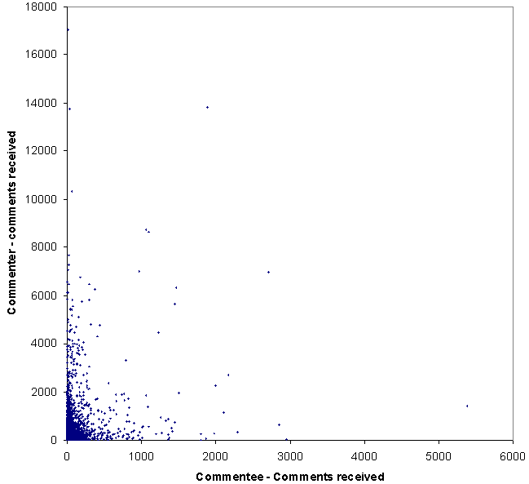
Fig. 4. Number of comments received by commenter against number of comments received by of commentee.

Number of Friends
Figure 5 is similar to Figure 4 and appears to show little or no homophily. A Spearman correlation of 0.220 (p=0.000) indicates that weak but significant homophily is present: commenters tend to comment on the profiles of commentees with similar numbers of Friends. Commenters also tend to have many more Friends (median 136 against median 34), which suggests that activity generates Friends, which is again consistent with the grooming hypothesis discussed above. A slightly weaker correlation 0.200 (p=0.000) covers the younger members under 23.

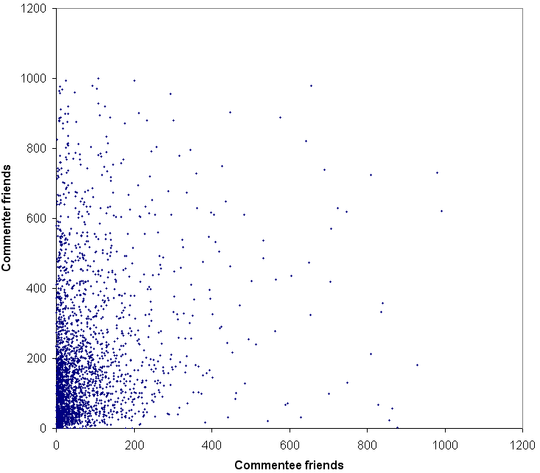
Fig. 5. Number of Friends of commenter against number of Friends of commentee.

Reason for joining MySpace
Table 9 shows the frequency of reasons for joining - note that the categories overlap. The pattern of reasons (not shown) shows significant homophily, although weaker than for many of the other variables (chi-square 329, Monte-Carlo approximation to exact probability p=0.015, n=1,202). The numerically largest examples of homophily are in the “Friends” category (410, expected value 353.1) and the “Networking, friends” category (62, expected value 43.6). It seems natural that people seeking to use MySpace for the same reason would make connections more easily in the site.

Table 9. Commenter and commentee reasons for joining.
Here For | Commentees | Commenters
Dating | 9 (0.6%) | 9 (0.5%)
Dating, friends | 82 (5.5%) | 100 (5.2%)
Dating, serious relationships | 5 (0.3%) | 6 (0.3%)
Dating, serious relationships, friends | 89 (5.9%) | 112 (5.8%)
Friends | 823 (54.3%) | 1065 (55.2%)
Networking | 70 (4.6%) | 46 (2.4%)
Networking, dating | 2 (0.1%) | 0 (0.0%)
Networking, dating, friends | 22 (1.5%) | 41 (2.1%)
Networking, dating, serious relationships | 1 (0.1%) | 0 (0.0%)
Networking, dating, serious relationships, friends | 105 (6.9%) | 134 (6.9%)
Networking, friends | 273 (18.0%) | 375 (19.4%)
Networking, serious relationships | 2 (0.1%) | 0 (0.0%)
Networking, serious relationships, friends | 13 (0.9%) | 15 (0.8%)
Serious relationships | 9 (0.6%) | 9 (0.5%)
Serious relationships, friends | 11 (0.7%) | 17 (0.9%)
Total | 1516 (100%) | 1929 (100%)
Missing | 1051 | 638
Overall total | 2567 | 2567

Content analysis of commeter/commentee relationships
Table 10 reports a content analysis of the relationships between commenters and commentees, as obtained by viewing the profiles of both and the messages exchanged between them. In most cases there was no clear evidence of the relationship and so the estimation is based upon intuition and detective work (e.g., people aged 17 living in different states are unlikely to be siblings). The results suggest that the vast majority of comments reflect real-world friendship, although the nature of the evidence means that this is not a strong conclusion and probably underestimates the proportion of family members, given the complicated life of many families today. More importantly, an unknown proportion of those classified as friends might be acquaintances instead. It seems impossible to make this distinction without asking the individuals concerned, especially given the loose nature of the concept of friendship.

Table 10. Apparent commenter-commentee relationship from a random sample of 200.
Relationship | Frequency
Friend | 172 (86%)
Family | 8 (4%)
Couple | 6 (3%)
Fan | 5 (2.5%)
Co-worker | 1 (0.5%)
Spam | 4 (2%)
Changed to private/deleted | 4 (2%)

Discussion and Limitations
One of the limitations of the approach is that all of the data about the individuals involved is self-reported in an environment that contains some deliberate falsehoods (Hinduja & Patchin, 2008; Tufekci, 2008a). Moreover, there also a possibility that Friends copy each others’ answers to some of the questions, such as that concerning reasons for joining. MySpace is an environment that encourages profile copying for appearance customisation (Perkel, 2006) so there is a copying precedent (but see also Liu, 2007). This factor perhaps undermines the weaker evidence of homophily, such as that concerning reasons for joining but seems unlikely to impact upon the more concrete types of information, including most of that used here.
Another limitation, introduced above, is that active Friendship is operationalised on the basis of commenting. Whilst this seems like a reasonable step that is unlikely to have affected the results, this has not been proven – for example, more dissimilar Friends may hide their friendship by sending private messages rather than commenting publicly on profiles and close friends my not feel the need to make their interactions publicly visible.
A constraint for the purpose of generalisation of these results to other social network sites is that they are all different. In particular, young members of the popular site Facebook have been found to be, on average, more educated than young MySpace users (boyd, 2007) and college students have been found to be more likely to use Facebook if there parents were more highly educated (Hargittai, 2007). Both of these are sources of homophily in the selection of social network site – although these differences may change significantly over time and may also vary by country. There are also social network sites like BlackPlanet that successfully target specific ethnic groups (Byrne, 2007), different ages (e.g., Club Penguin for children) and sexualities (e.g., glee.com for “Gays, Lesbians and Everybody Else”). Whilst it seems likely that the different types of homophily found above would be present in most social network sites, when relevant, it also seems likely that gender homophily would be present in some sites (e.g., glee.com). Moreover, it may be that individuals’ offline networks translate into multiple online networks in different sites in ways that influence homophily. For example, an individual’s school friends and relatives might communicate via MySpace whereas their college friends might choose Facebook instead.
Finally, to what extent might the results reflect offline phenomena? Despite the attempt to narrow down MySpace Friends to those who are more likely to be genuine friends by restricting the data to active Friends (on the basis of commenting), the results seem likely to reflect either a very loose notion of friendship or a wider network than that of friendship. Some active MySpace Friends are siblings, colleagues, lovers or others that would not view their relationship as friendship even though they were engaging in what could loosely be termed friendly behaviour (see Table 10). Hence, the findings suggest that these wider networks that are not gender homophilious, rather than friendship. In contrast, these wider networks still seem to display many other types of homophily. Of course, this translation to offline networks is subject to the distorting lens of each individual’s decision about whether to become an active member of MySpace (as in Figure 1).

Conclusions
The findings demonstrate that there is a wide range of homophily in MySpace in the sense of active Friends tending to be more similar than would be expected if Friends were chosen at random from potential MySpace Friends. Highly significant evidence of homophily was found for a range of existing known sources (ethnicity, age, religion), and other likely offline sources (sexual orientation, country, marital status) as well as attitude towards children, which seems to be a less likely factor. In terms of purely online factors, MySpace commenting activity, number of Friends and reasons for joining MySpace were all significant sources of homophily. Gender was not found to be a source of homophily, although females tended to comment more than males.
Although MySpace Friends are not technically restricted by geographic limitations, in reality they probably tend to reflect offline friendships (boyd, 2008) and so the homophily here confirms that the virtual world does not override real world issues. Conversely, online homophily does not necessarily map directly to offline homophily because of the self-selected nature of MySpace members (Figure 1). These tend to be young but even amongst the young there is a proportion that reject social networks for reasons related to privacy and understandings of friendship (Tufekci, 2008b), or may choose another site, perhaps even a relatively ethnically homogenous one. Hence for any MySpace member the set of other MySpace members that they could realistically expect to actively Friend would be their offline friends and acquaintances that are also members, which might well be a more homogeneous group than their offline friends.
From the perspective of society, online homophily seems undesirable because if people ghettoise themselves into predominantly similar groups then they may become less tolerant than others. The findings here echo in a new context (interpersonal relationships) the fears of Sunstein (2007) that despite the online availability of diversity (of information and opinions) people may choose to cocoon themselves away from the unfamiliar.
In the context of the extensive evidence for homophily in MySpace, its absence for gender is striking. Although gender seems to be the weakest of the main offline sources of homophily (McPherson et al., 2001) its complete absence here is perhaps unexpected, although a previous study gave similar findings for listed Friends (Thelwall, 2008). Perhaps there is more gender mixing amongst younger people or gender mixing is easier online? Alternatively, since social network profiles can be a form of identity projection (boyd, 2008; boyd & Heer, 2006), members might seek to interact with those of the opposite gender to boost their projected image.

Information-centred recommendations
As information-centred research, this article is an information science contribution to the analysis of friendship in MySpace. As such, it is designed to underpin and facilitate future research into the topic by disciplines outside of information science. Its main contributions are: (a) demonstrating the feasibility of investigating homophily in MySpace; (b) developing appropriate methods for this analysis (the comment-based approach); (c) developing software and datasets for applying the methods (available free from the author); and (d) reporting the initial exploratory findings to serve as background information and trigger ideas for future research.
Based upon the results above, a few avenues seem particularly suitable for future studies. The issue of cross-gender friendships seems important enough to merit follow-up qualitative research to find out why this phenomenon occurs and whether the lack of gender homophily is a specifically online phenomenon. It would also be useful to apply similar techniques to social network sites in other languages (e.g., Korean Cyworld) and to other popular social network sites in order to assess the extent to which the findings are unique to MySpace, but this is likely to be difficult due to privacy restrictions or difficulties getting a genuinely random sample. Longitudinal studies of MySpace would be particularly useful to identify homophily trends, potentially giving early warning of socially divisive friendship patterns and preventing areas of society from “sleepwalking towards racial segregation” (Gibson, 2004). Cross-referencing such studies with offline analyses (e.g., Johnston et al., 2007) would be needed to calibrate social network active Friend connections as an indicator of wider homophily, however. Finally homophily should be investigated in offline populations to differentiate the “MySpace effect” from offline homophily in order to see whether the contribution of MySpace was positive or negative, in the sense of encouraging or discouraging homophily in various dimensions.

Acknowledgement
Thank you to Alison Carminke for the age and friendship classifications and to the referees for helpful comments and contributions.

References
BBC. (2005). Schools 'must fight segregation'. BBC Online, Retrieved July 28 from: http://news.bbc.co.uk/21/hi/uk/4269988.stm.
boyd, d. (2006). Friends, Friendsters, and MySpace Top 8: Writing community into being on social network sites. First Monday, 11(2), Retrieved June 23, 2007 from: http://www.firstmonday.org/issues/issue2011_2012/boyd/index.html.
boyd, d. (2007). Viewing American class divisions through Facebook and MySpace. Apophenia Blog Essay (June 24), Retrieved July 12, 2007 from: http://www.danah.org/papers/essays/ClassDivisions.html.
boyd, d. (2008). Why youth (heart) social network sites: The role of networked publics in teenage social life. In D. Buckingham (Ed.), Youth, identity, and digital media (pp. 119-142). Cambridge, MA: MIT Press.
boyd, d., & Ellison, N. (2007). Social network sites: Definition, history, and scholarship. Journal of Computer-Mediated Communication, 13(1), Retrieved December 10, 2007 from: http://jcmc.indiana.edu/vol2013/issue2001/boyd.ellison.html.
boyd, d., & Heer, J. (2006). Profiles as conversation: Networked identity performance on Friendster. Proceedings of the Hawai'i International Conference on System Sciences (HICSS-39, January 4-7), Retrieved July 3, 2007 from: http://www.danah.org/papers/HICSS2006.pdf.
Byrne, D. (2007). Public discourse, community concerns, and their relationship to civic engagement: Exploring black social networking traditions on blackplanet.com. Journal of Computer-Mediated Communication, 31(1), Retrieved May 18, 2008 from: http://jcmc.indiana.edu/vol2013/issue2001/byrne.html.
Coates, J. (2003). Men talk. Maldon, MA: Blackwell.
Dispatches. (2008). It shouldn't happen to a Muslim. Channel 4 News, Retrieved July 9, 2008 from: http://www.channel2004.com/news/articles/dispatches/it+shouldnt+happen+to+a+muslim/2314592.
Dixon, T. L. (2008). Crime news and racialized beliefs: Understanding the effects of news exposure and news orientation on perceptions of African Americans and crime. Journal of Communication, 58(1), 106-125.
Donath, J., & boyd, d. (2004). Public displays of connection. BT Technology Journal, 22(4), 71-82.
Donath, J. (2007). Signals in social supernets. Journal of Computer-Mediated Communication, 13(1), Retrieved June 17, 2008 from: http://jcmc.indiana.edu/vol2013/issue2001/donath.html.
Dunbar, R. (1996). Grooming, gossip and the evolution of language. London: Faber and Faber Limited.
Dutton, W. H., & Elsper, E. J. (2007). The Internet in Britain 2007.Oxford: Oxford Internet Institute.
Ellison, N. B., Steinfield, C., & Lampe, C. (2007). The benefits of Facebook "friends:" Social capital and college students' use of online social network sites. Journal of Computer-Mediated Communication, 12(4), 1143-1168.
Fischer, M. J. (2008). Does campus diversity promote friendship diversity? A look at interracial friendships in college. Social Science Quarterly, 89(3), 631-655.
Gibson, S. (2004). Is London sleepwalking towards segregation? London Housing Magazine, Retrieved July 28 from: http://www.londonhousing.gov.uk/doc.asp?doc=16096&cat=12093.
Golder, S. A., Wilkinson, D., & Huberman, B. A. (2007). Rhythms of social interaction: Messaging within a massive online network, 3rd International Conference on Communities and Technologies (CT2007), East Lansing, MI.
Hargittai, E. (2007). Whose space? Differences among users and non-users of social network sites. Journal of Computer-Mediated Communication, 13(1), Retrieved June 10, 2008 from: http://jcmc.indiana.edu/vol2013/issue2001/hargittai.html.
Hinduja, S., & Patchin, J. W. (2008). Personal information of adolescents on the Internet: A quantitative content analysis of MySpace. Journal of Adolescence, 31(1), 125-146.
Ibarra, H. (1993). Personal networks of women and minorities in management: A conceptual framework. Academy of Management Review, 18(1), 56-87.
Johnston, R., Poulsen, M., & Forrest, J. (2007). The geography of ethnic residential segregation: A comparative study of five countries. Annals of the Association of American Geographers, 97(5), 713-738.
Kossinets, G., & Watts, D. J. (2006). Empirical analysis of an evolving social network. Science, 311(5757), 88-90.
Lampe, C. A. C., Ellison, N., & Steinfield, C. (2007). A familiar face(book): Profile elements as signals in an online social network. Proceedings of the SIGCHI conference on Human factors in computing systems, 435 - 444.
Lenhart, A., Madden, M., Macgill, A. R., & Smith, A. (2007). Teens and Social Media: The use of social media gains a greater foothold in teen life as they embrace the conversational nature of interactive online media (12/19/2007). Pew Internet & American Life Project, Retrieved May 1, 2008 from: http://www.pewinternet.org/PPF/r/2230/report_display.asp.
Liu, H. (2007). Social network profiles as taste performances. Journal of Computer-Mediated Communication, 13(1), Retrieved June 5, 2008 from: http://jcmc.indiana.edu/vol2013/issue2001/liu.html.
Livingstone, S. (2008). Taking risky opportunities in youthful content creation: Teenagers' use of social networking sites for intimacy, privacy and self-expression. New Media & Society, 10(3), 393-411.
McPherson, M., Smith-Lovin, L., & Cook, J. M. (2001). Birds of a feather: Homophily in social networks. Annual Review of Sociology, 27, 415-444.
Nowak, K. L., & Christian, R. (2006). The influence of the avatar on online perceptions of anthropomorphism, androgyny, credibility, homophily, and attraction. Journal of Computer-Mediated Communication, 11(1), 153-178.
Pahor, M., Skerlavaj, M., & Dimovski, V. (in press). Evidence for the network perspective on organizational learning. Journal of the American Society for Information Science & Technology.
Perkel, D. (2006). Copy and paste literacy: Literacy practices in the production of a MySpace profile. Informal Learning and Digital Media, Retrieved April 23, 2007 from: http://www.dream.dk/uploads/files/perkel%2020Dan.pdf.
Pew Research Center for the People & the Press. (2007). Social networking websites and teens: An overview. Retrieved June 4, 2007, from http://www.pewinternet.org/PPF/r/198/report_display.asp
Prescott, L. (2007). Hitwise US consumer generated media report. Retrieved March 19, 2007 from: http://www.hitwise.com/.
Raacke, J., & Bonds-Raacke, J. (2008). MySpace and Facebook: Applying the uses and gratifications theory to exploring friend-networking sites. Cyberpsychology & Behavior, 11(2), 169-174.
Sunstein, C. R. (2007). Republic.com 2.0.Princeton: Princeton University Press.
Suter, C. (2006). Trends in gender segregation by field of work in Higher Education. In Women in Scientific Careers: Unleashing the Potential (pp. 95-104). Paris: OECD Publishing.
Thelwall, M. (2008). Social networks, gender and friending: An analysis of MySpace member profiles. Journal of the American Society for Information Science and Technology, 59(8), 1321-1330.
Thelwall, M., Wouters, P., & Fry, J. (2008). Information-Centred Research for large-scale analysis of new information sources. Journal of the American Society for Information Science and Technology, 59(9), 1523-1527.
Tufekci, Z. (2008a). Can you see me now? Audience and disclosure regulation in online social network sites. Bulletin of Science, Technology and Society, 28(1), 20-36.
Tufekci, Z. (2008b). Grooming, gossip, Facebook and MySpace: What can we learn about these sites from those who won't assimilate? Information, Communication & Society, 11(4), 544-564.
Yuan, Y. C., & Gay, G. (2006). Homophily of network ties and bonding and bridging social capital in computer-mediated distributed teams. Journal of Computer-Mediated Communication, 11(4), 1062-1084.

Thelwall, M. (2009). Homophily in MySpace, Journal of the American Society for Information Science and Technology.60(2), 219-231. © copyright 2008 John Wiley & Sons.
http://profile.myspace.com/index.cfm?fuseaction=user.viewprofile&friendID=

