A combined bibliometric indicator to predict article impact
Jonathan M. Levitt [corresponding author]
Department of Information Science, Loughborough University, England. E-mail: j.levitt@lboro.ac.uk and j.m.levitt@wlv.ac.uk

Mike Thelwall
Statistical Cybermetrics Research Group, School of Technology, University of Wolverhampton, Wulfruna Street, Wolverhampton WV1 1SB, UK.

Abstract
In both the UK and Australia there has been a recent move to use citation analysis in the evaluation of the research of individuals. In particular, the future UK Research Excellence Framework (REF), proposes using citation data in the research evaluation of articles published as recently as the year prior to the evaluation. In response to this move, this research develops an indicator at the level of individual articles that, when normalized, can supplement peer review. The new hybrid indicator is the weighted sum of two indicators in common usage: the article’s total number of citations in a citation window, and the Impact Factor of the journal in which the article was published. This research compares this new indicator with the article’s total number of citations in a longer citation window (the standard indicator of article impact). For citation windows of 0 or 1 years, the correlation of the simplified weighted sum with long-term citation is substantially higher than the correlation of the standard indicator of article citation with long-term citation. Moreover, for citation windows of as long as 3 years the standard indicator of citation correlates significantly with the month of publication, in that articles published earlier in the year are on average more highly cited than those published later in the year. By contrast, the skewing of the simplified weighted sum towards articles published early in the year is considerably less than that of the standard indicator.
Keywords: bibliometrics, research evaluation, research impact, REF, RAE, citation analysis

Introduction
In recent years there has been a move in some countries (notably the UK and Australia) towards using bibliometric data to supplement peer review decisions in research evaluation (http://www.hefce.ac.uk/Research/ref/ and http://www.arc.gov.au/era/default.htm) and in Spain financial rewards are given on the basis of the Impact Factor (IF) of journals (López-Cózar, Ruiz Pérez & Jiménez Contreras, 2007).
The Higher Education Funding Council for England (HEFCE) stated that bibliometrics are likely to be used to supplement peer review in the UK’s Research Excellence Framework (REF): “The quality of research outputs will be assessed by the expert panels against international standards of excellence. We expect that some of the panels will make use of citation information to inform their review of outputs” (http://www.hefce.ac.uk/Research/ref/). The REF is the latest of a series of assessments of UK university departments that are conducted by HEFCE approximately every 6 years to determine part of the research funding from the UK government.
When evaluating the impact of research using citations for articles published over a range of years, steps must be taken to ensure that articles published earlier do not have the advantage of having a longer period in which to attract citations. In the context of the REF this is a serious issue and hence the REF framework suggests that only articles from the same year should have their citations compared (HEFCE, 2009b). Another way to attempt to redress, and understand, this issue is to predict the future citations of each article using a simple formula that adjusts for the time interval since publication. This could be done by multiplying the citation count of an article by a number dependant on the number of months or years since it was published: more recent papers would have a higher multiplier to compensate for fewer years elapsing since publication. This approach would not work well for very recent articles, however, as several years may be needed to get a realistic indication of the rate at which they are likely to attract citations. An alternative approach is to incorporate the Impact Factor of the journal in which each article is published. This is reasonable on the basis that articles in journals with a higher IF are, on average, likely to be more highly cited than other articles. Moreover, publication in a high impact journal arguably indicates research quality irrespective of whether an article attracts citations.
This research investigates a new indicator, the weighted sum of two readily available indicators that are in common use: the number of citations of the article in a citation window and the Impact Factor (IF) of the journal in which the article is published. The number of citations in a citation window is the standard indicator for gauging long-term citation. The IF was introduced in Garfield (1955), and is used in Thomson-Reuters’ Journal Citation Reports (JCRs); the history of the Impact Factor is described by Garfield (2006). JCRs present data on two-year and five-year IFs; this research uses two-year IFs, as it investigates articles published between 2000 and 2004 and the JCRs do not present five-year IFs in Economics for years prior to 2007. For brevity, this article refers to the ‘two-year IF’ as ‘IF’. The IF of a journal for 2000 is the sum of the citations to the articles published in the journal in 1998 or 1999, from articles published in 2000, divided by the number of articles in the journal in 1998 or 1999.
In the UK’s 2008 Research Assessment Exercise, peer review panels evaluated articles published as recently as 2007; accordingly, it would be useful to have some indication of long-term citation for very recently published articles. For this reason, this study examines whether for very short citation windows, the proposed indicator correlates more highly with long-term citation counts than does the total citations in a citation window.

Background
The concept of using bibliometrics to supplement peer review is long established within scientometrics. For example, Moed suggested three ways in which bibliometrics and peer review are related: “Bibliometric indicators are applied as supplementary tools in peer review processes ... The outcomes of peer reviews are used as a validation instrument of bibliometric indicators. Bibliometric indicators are applied as tools for monitoring and studying peer review processes” (Moed, 2005, p. 229).
Some studies have focused on the second of Moed’s suggestions, in that they have evaluated correlations between the outcomes of peer review and bibliometric indicators. For example, statistically significant correlations were found between UK Research Assessment Exercise scores and citation counts in Library and Information Management (Oppenheim, 1995), Anatomy, Genetics and Archaeology (Oppenheim, 1997), Archaeology (Norris & Oppenheim, 2003) and Economics (Sussmuth, Steininger & Ghio, 2005).
Other studies have focused on the third of Moed’s suggestions to use bibliometrics to examine the funding process. Cronin and Shaw’s (1999) investigation of four LIS journals did not find a correlation between citation and whether the research was funded. Lewison, Lipworth and de Francisco (2002) used data from the articles’ acknowledgements to calculate the fraction of malaria research expenditure attributable to individual funding agencies. Gaughan and Bozeman (2002) used curriculum vitae to examine the impact of NSF research grants, and Boyack and Borner (2003) used funding data from the National Institute on Aging to visualise the structure of research on aging.
Regarding his first suggestion, Moed (2005, 233) wrote “When citation analysis does not constitute an official source of information in a peer review process, it does not follow that citation or publication data do not play a role at all.” Several studies (e.g., Nederhof & van Raan, 1987; Aksnes & Taxt, 2004; Lundberg, 2007; Costas, van Leeuwen & Bordons, 2009) have recommended combining bibliometric indicators with peer review (a process called ‘informed peer review’). Lundberg (2007) and Costas, van Leeuwen and Bordons (2009) suggest that bibliometric indicators could be used in the assessment of individuals by a peer review panel; Lundberg recommends a single indicator based on citations, whereas Costas, van Leeuwen and Bordons recommend using three indicators (the number of publications, citation impact and the rating of the journals in which the article was published). However, we have not found any study that assesses the influence of publication date on bibliometric indicators, at the article level, or that attempts to correct for any such bias. The HEFCE (2009a) report indicates the timeliness of developing such an indicator.
Various indicators of citation level, other than the sum of citations in a citation window, have been used, including the field normalised crown index introduced by Leiden University and used in the Leiden rankings of universities (http://www.cwts.nl/ranking/LeidenRankingWebSite.html) and the h-index for the ranking of individuals, introduced by Hirsch (2005). Van Raan (2006) compared the correlation between the crown index, the sum of citations in a citation window and the h-index for 147 chemistry research groups, and found that the correlation of the h-index with the sum of citations was higher (R² = 0.88) than the correlation of the crown index with the sum of citations (R² = 0.21) suggesting the h-index was a better indicator of citation in the first few years after publication. Ingwersen, Schneider, Scharff and Larsen (2007), in order to provide an indicator for funding bodies, compared the citation of articles in 2001-2005 with their citation in 2004-2005 and 2005. They found that: (a) at highly aggregated (national and domain) levels or for smaller countries, citation in a 2-year citation window correlates strongly with citation in a 5-year citation window and (b) in social science and some science domains, citation in a 1-year citation window correlates substantially less strongly with citation in a 5-year citation window.
Predicting the long-term citations for an individual article is problematic even when using a citation window as long as ten years, as found by Mingers’ (2008) investigation of over 600 management science papers published in 1990. However, Adams (2005), in an investigation of UK life and physical sciences papers published in 1993, found a highly significant correlation between citation during the year of publication and citation during the first ten years after publication. Moreover, journal IFs seem to correlate reliably with long term citation. In an investigation of 428 articles in crime psychology journals published in 2003, Walters (2006) found a statistically significant univariate correlation between the IF and long-term citation. In addition, Racki (2009), in an investigation of 378 Polish geological papers published in 1989-1994, found that two thirds of the articles published in journals in geology with Impact Factors in the top 25% of geology journals were cited more than the average for the field.

Research questions
This study investigates the weighted sum of article citation and journal impact, W_{(c,t)} (called the ‘weighted sum indicator’), defined by
W_{(c,t)} = c x A_{t} + (1 - c) x IF
where A_{t} is the cumulative number of citations of the article t years after publication, IF is the impact factor of the journal in which the article was published (evaluated for the year of publication), and c is a constant weight with 0 <= c <= 1. Note that W_{(1,t)} is the standard indicator of article citation (the number of citations of the article in the citation window of t years).
The focus of this investigation is on three rank correlations: (a) between W_{(c,t)} and the long term number of citations of an article, (b) between W_{(c,t)} and the IF of the journal containing the article and (c) between W_{(c,t)} and the month of publication of the article. The rationale for examining the first correlation (a) is that the long-term citation of an article is an indicator of its impact. The rationale for examining the second correlation (b) is that IF is an indicator of journal quality, as a journal with a higher IF has a higher average citation level and, in general, has more stringent standards for accepting articles. The rationale for examining the third correlation (c) is that it is likely that articles published early in the year will be more highly cited than articles published later in the same year; the third correlation has been used to test this hypothesis and to find whether this skewing, if it exists, is lower for an indicator that uses the journal IF in addition to article citation. Skewing is topically relevant to research policy, as according to the proposals for the REF (http://www.hefce.ac.uk/Pubs/HEFCE/2009/09_38/09_38.doc), citation windows of one year will be used and no allowance will be made for the differences in month of publication.
This study examines the following research questions:
(1) For articles published in the same year, how do the correlations of W_{(c,t)} with long-term citation, with journal IFs, and with months of publication depend on the values of c and t?
(2) Are there any simple values of c other than 1 that produce a weighting that may be of interest to peer review and if there are, what are their advantages and disadvantages over W_{(1,t)}?
It also seeks to address the following sub-questions:
(s1) For which values of t are there values of c for which W_{(c,t)} correlates substantially more highly with long-term citation than does W_{(1,t)}?
(s2) To what extent is the sum of citations in a citation window, W_{(1,t)} , skewed towards the month of publication?
Note that the two indicators from which W_{(c,t)} is formed (A_{t} and IF) have different date ranges. It is theoretically justifiable to combine the two since both are used as indicators for the underlying impact of the work in question. In principle a version of W_{(c,t)} that normalises for the range of A_{t} and IF could be used instead of W_{(c,t)}; however, this would have resulted in a more complex indicator that, using different of weights, compensates for the different ranges of its component indicators. The Discussion describes two ways of normalising W_{(c,t)} .

Method
The research questions were addressed by examining the correlations of W_{(c,t)} with the article’s long-term citation, the journal’s IF and an article’s month of publication. The first part investigates all UK SSCI Economics articles published in 2000 and the second part all UK SSCI Economics articles recorded in the SSCI as published in the years 2001, 2002, 2003 and 2004. The first part examines the extent to which the correlations of W_{(c,t)} vary with c; the second part compares the correlations of W_{(1,t)}, the standard indicator of article citation, with W_{(.5,t)}, the average of the standard indicator of article citation and the impact factor of the journal containing the article.
The data used to calculate W_{(c,t)} was collected by: (a) Isolating all SSCI articles published in the year investigated in the subject category of ‘Economics’ with at least one author’s country listed as England, Scotland, Wales or Northern Ireland and (b) Using Create Citation Report to obtain, for each article, the number of citations in each year. The data used to evaluate the values of IF was obtained from the online Journal Citation Reports for Economics from 2000 to 2004. The number of Economics articles by authors from the four UK countries was 998 in 2000, 964 in 2001, 948 in 2002, 1011 in 2003 and 1057 in 2004. The data was collected in 2009. It is, of course, recognised that the notional publication date of an article does not necessarily reflect the true publication date; frequently a journal issue appears many months before or after its notional publication date. It was not practical to assess how often this applied to the publications in this study. Moreover, comparison between fields requires the weighted sum indicator to be normalized.

Results
Analysis of articles published in 2000
This section addresses the first research question: For articles published in a single year, how do the correlations of W_{(c,t)} with long-term citation, with journal IFs, and with months of publication depend on the values of c and t?
As background for the first research question and in order to illustrate the skewing of citation towards articles published early in the year, Table 1 presents for every month and for diverse time periods the percentage of articles cited in the month. For 2000, the average for January to March is 9.7% whereas the average for October to December is 3%, and a Spearman correlation between citations and month of publication is low but significant (0.11, p <0.05). However, the trend towards months earlier in the year having a higher percentage of cited articles is not uniform, in that for 2000 the percentage for October is substantially higher than the percentage for May, possibly due to a natural variability in the data because of the relatively low numbers involved. In addition the rankings of the months can vary substantially from period to period; 2000 and 2000-01 January has the highest percentage of cited articles, whereas 2000-03 January has the second lowest percentage of cited articles.

Table 1: Citation rates for articles published in 2000.
Publication Month | % cited in 2000 | % cited in 2000-01 | % cited in 2000-02 | % cited in 2000-03 | Articles in the month
Jan | 13 | 38 | 51 | 68 | 63
Feb | 9 | 37 | 58 | 73 | 78
Mar | 7 | 32 | 55 | 77 | 75
Apr | 10 | 33 | 63 | 79 | 63
May | 4 | 29 | 51 | 78 | 76
Jun | 8 | 36 | 55 | 76 | 66
Jul | 2 | 26 | 51 | 75 | 61
Aug | 3 | 25 | 47 | 76 | 68
Sep | 5 | 21 | 41 | 61 | 80
Oct | 7 | 35 | 59 | 79 | 71
Nov | 2 | 30 | 46 | 79 | 57
Dec | 0 | 13 | 35 | 74 | 102
All | 5 | 29 | 50 | 74 | 860

Figures 1 to 4 present, for t= 0, 1, 2, the correlations of W_{(c,t)} with the number of citations of the article in 2000-08, with the impact factor for the year 2000 of the journal in which the article was published, and with the month of publication of the article. In each figure the weighting of the Sum of citations, c in W_{(c,t)}, takes the values 0, 0.1, 0.2, ... 1.
In all four figures all correlations with citations to 2008 and with journal IF are highly significant (p <= .01). In Figure 1, the correlation with publication month is highly significant for the weighting of 1 but not significant for the other weightings. In Figure 2, the correlation with publication month is highly significant for all weightings above 0.2, significant (.01 < p <=.05) for the weighting of 0.1 and not significant for the weighting of 0. In Figure 3, the correlation with publication month is highly significant for all weighting above 0.4, significant (.01 < p <=.05) for the weightings of 0.3 and 0.4 and not significant for the weightings of 0 and 0.1. In Figure 4, the correlation with publication month is only significant (.01 < p <=.05) for the weightings of 1 and not significant for the other weightings.

In Figures 1 and 2, the correlation with citations to 2008 is higher for the weightings of 0.5 to 0.9 than for the weighting of 1; however, in Figures 3 and 4, the correlation with citations to 2008 is lower for the weighting of 0.5 to 0.9 than for the weighting of 1. For all Figures, the correlation with IF is much higher for the weighting of 0.5 to 0.9 than for the weighting of 1, and the correlation with publication month is lower. In the next section the correlations of the weighting of 0.5 are compared with the correlations for the weighting of 1. The rationale for investigating the weighting of 0.5 is that 0.5 is a particularly simple weighting and that in Figures 1 to 4, the findings vary little over the range 0.5 to 0.9.

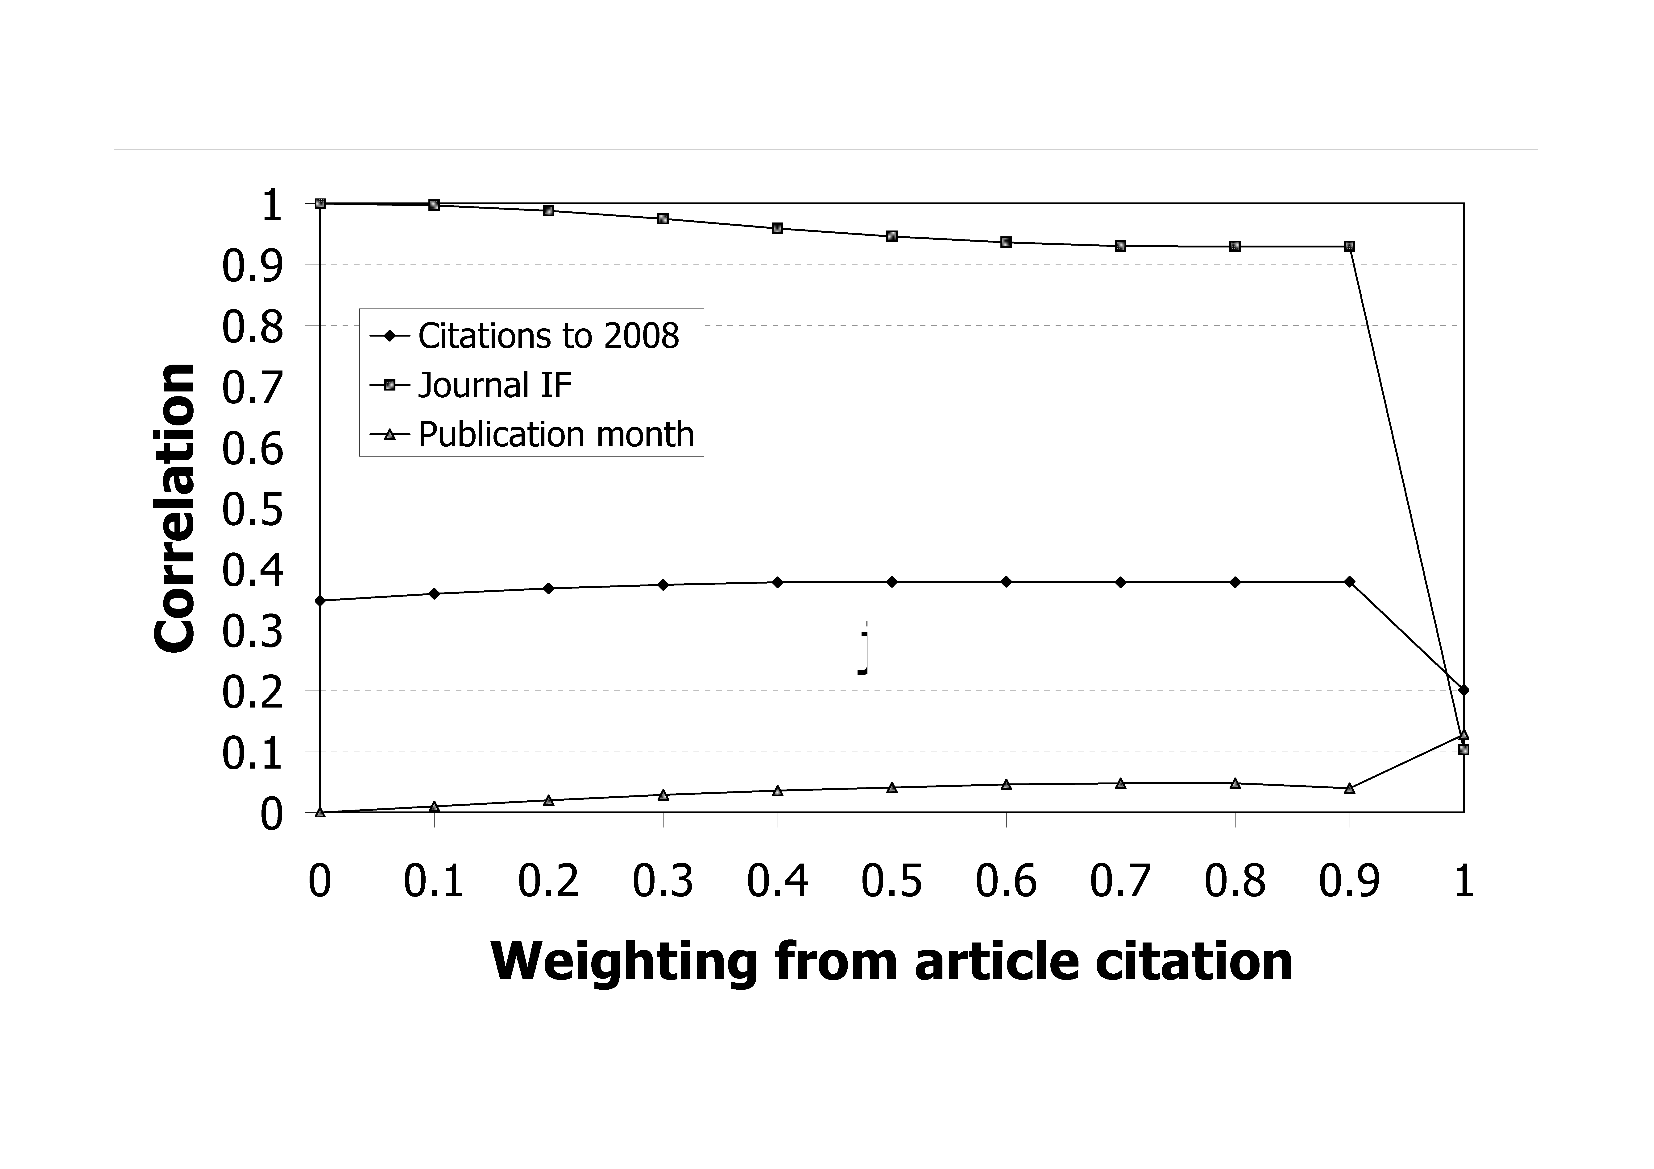
Figure 1: Correlations of W_{(c,0)}, weighted sums for citations in 2000, with long-term citation, journal IF and month of publication of the article
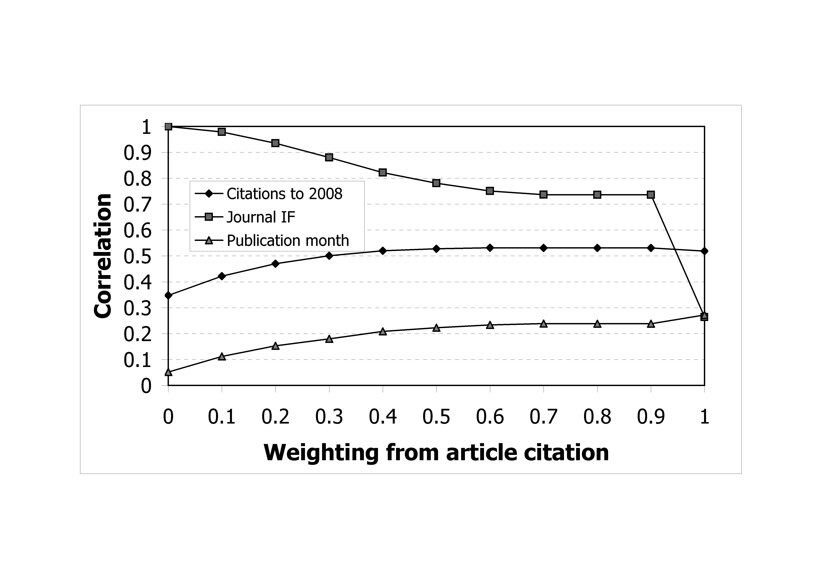
Figure 2: Correlations of W_{(c,1)}, weighted sums for citations to 2001, with long-term citation, journal IF and month of publication of the article

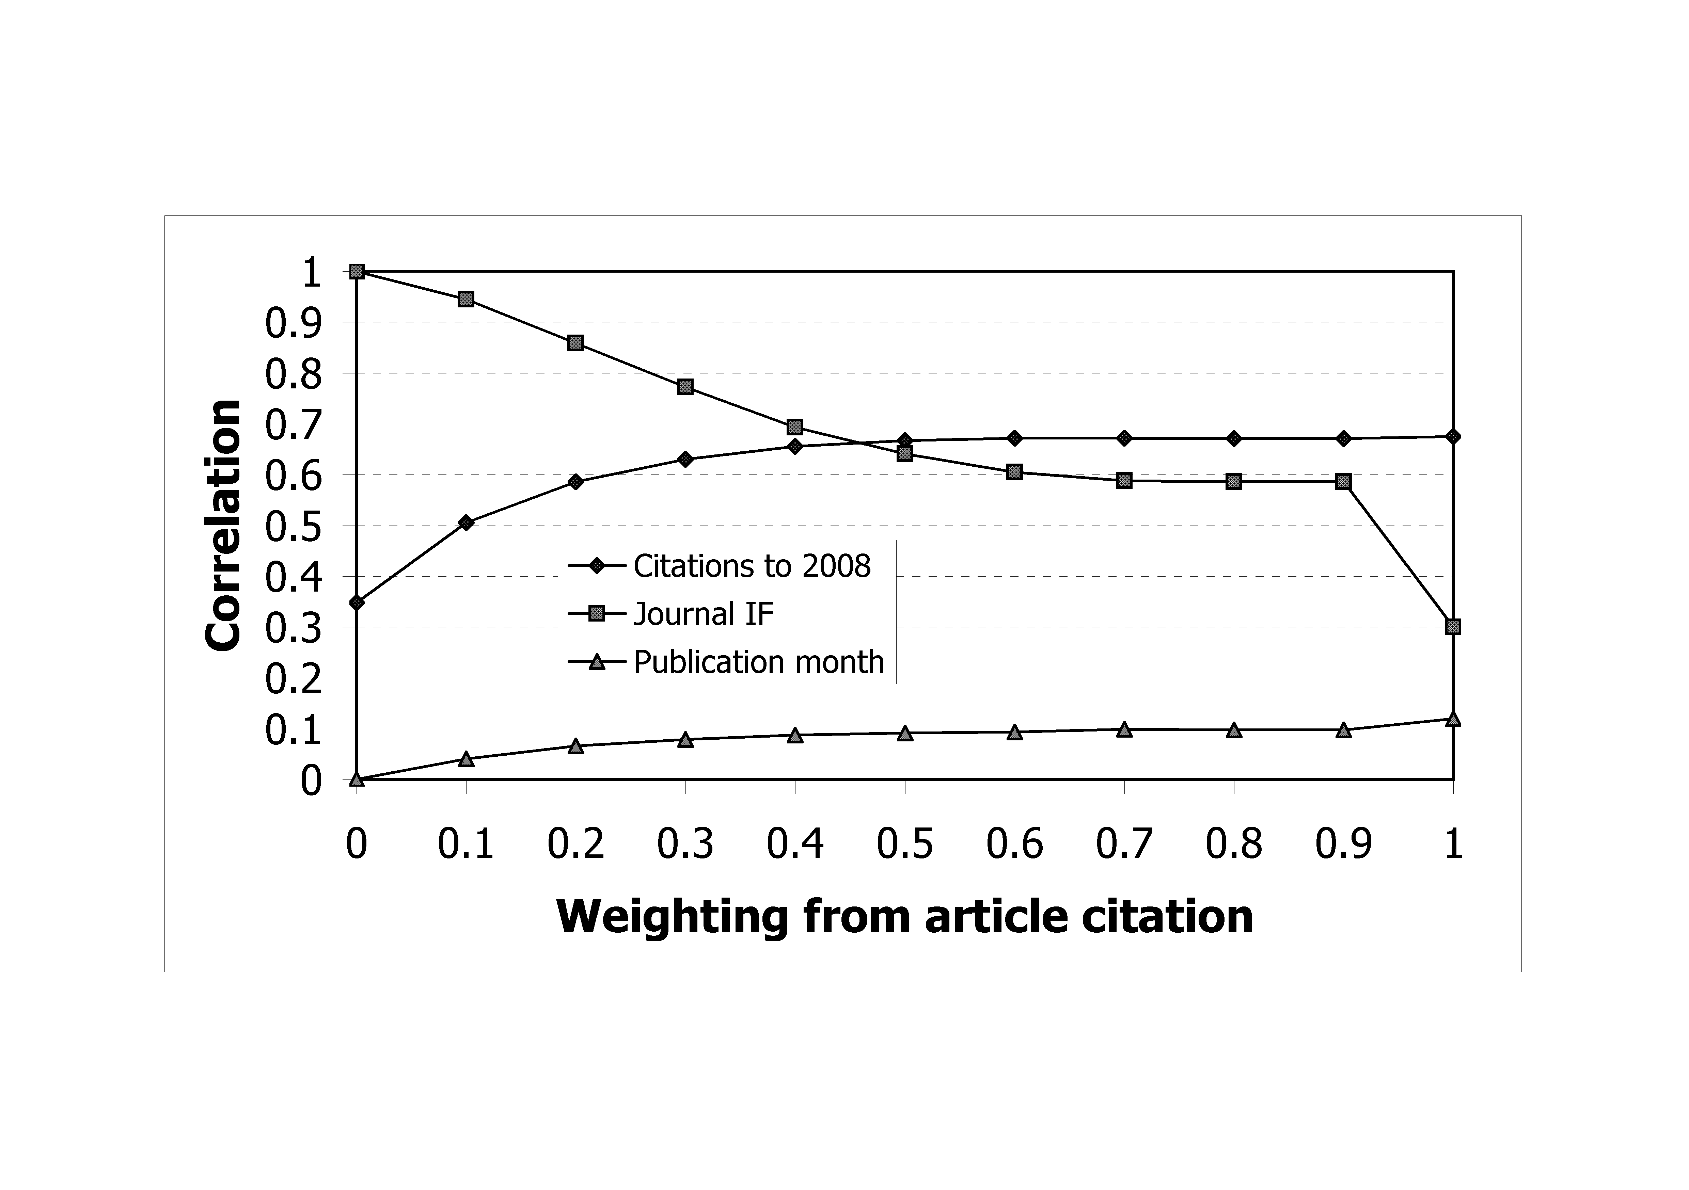
Figure 3: Correlations of W_{(c,2)}, weighted sums for citations to 2002, with long-term citation, journal IF and month of publication of the article

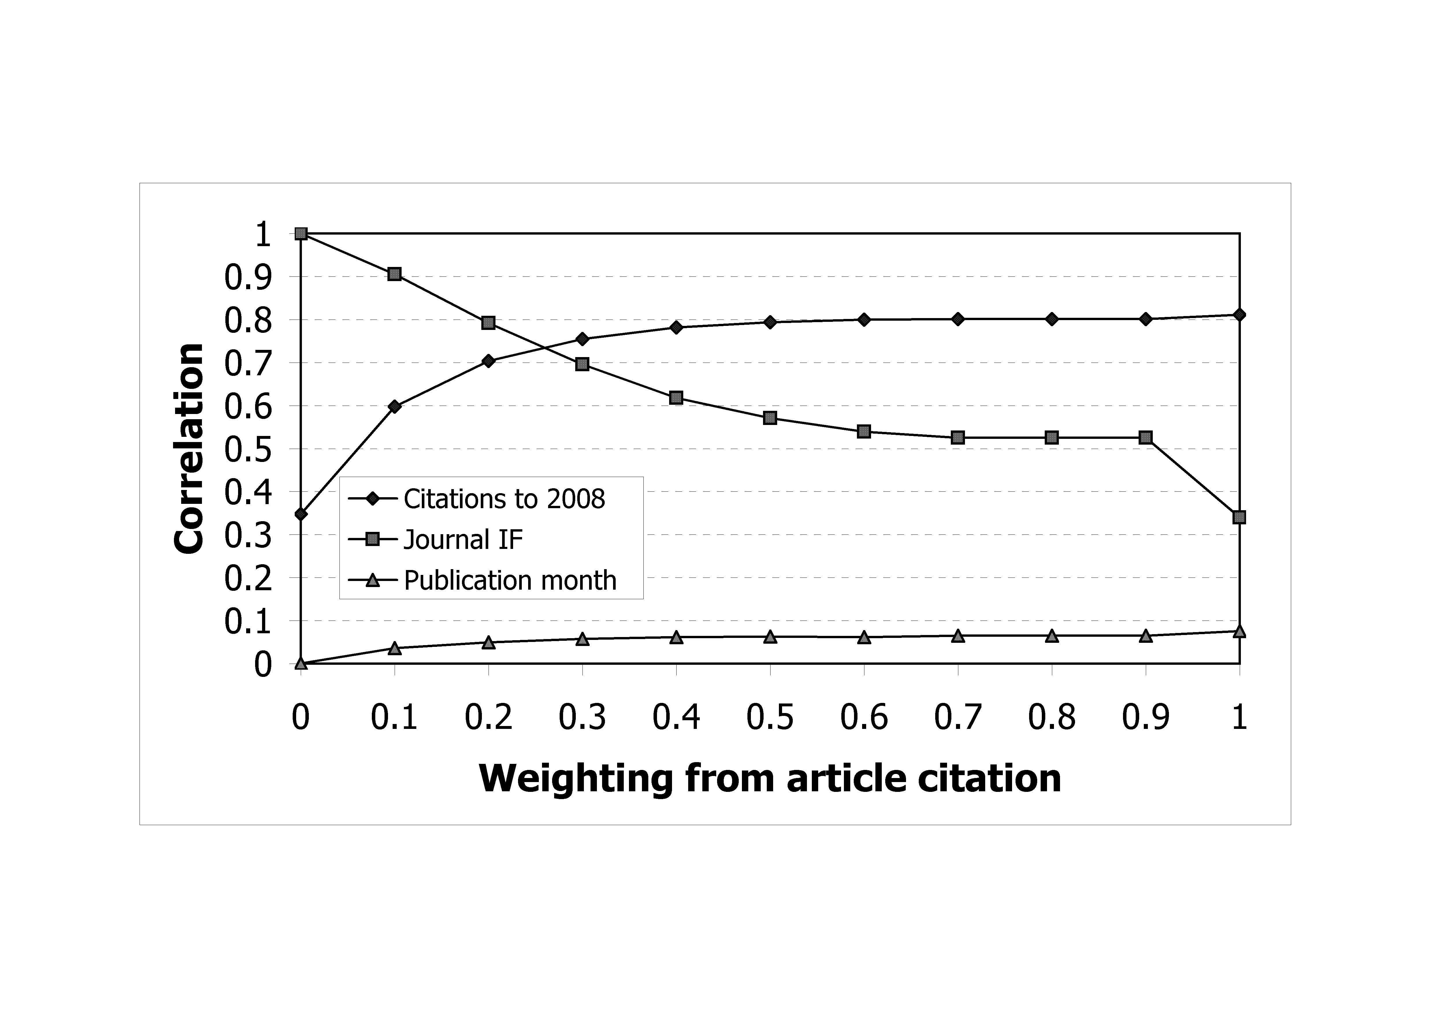
Figure 4: Correlations of W_{(c,3)}, weighted sums for citations to 2003, with long-term citation, journal IF and month of publication of the article.

The first part of the second research question asks: Are there any simple values of c other than 1 that produce a weighting that may be of interest to peer review? Figures 1 to 4 indicate that the weighting of 0.5 may be of interest to peer review. The figures indicate that for t < 2 and for values of c close to 0.5 the weighting of W_{(c,t)} has the following advantages over W_{(1,t)}, the sum of citations in a citation window of t years: (a) The correlation with long-term citation is higher, (b) The correlation with IF is higher and (c) The correlation with publication month is lower. However, as t increases, the advantage of using a weighting other than 1 decreases and the correlation of W_{(1,t)} is relatively small for t > 1.

Articles published 2001 to 2004
This section addressees the second part of the second research question by examining the advantages and disadvantages of using W_{(.5,t)} as opposed to W_{(1,t)}.
Tables 2 to 5 present the correlations for articles published in 2001 to 2004. In Tables 2 and 3, for every year the correlation with citations to 2008 is higher for the weighting of 0.5 than for the weighting of 1. In Table 3, for all years apart from 2004, the correlation with citations to 2008 is higher for the weighting of 0.5 than for the weighting of 1; however in Table 4, for every year apart from 2003, the correlation with citations to 2008 is lower for the weighting of 0.5 than for the weighting of 1.

Table 2: Correlations of W_{(1,0)} and W_{(.5,0)}, weighted sums for citations in the year of publication
Publication year | 2001 |  | 2002 |  | 2003 |  | 2004
 | W_{(1,0)} | W_{(.5,0)} | W_{(1,0)} | W_{(.5,0)} | W_{(1,0)} | W_{(.5,0)} | W_{(1,0)} | W_{(.5,0)}
Citations to 2008 | .15** | .44** | .22** | .48** | .26** | .51** | .27** | .43**
Journal IF | .078* | .95** | .11** | .94** | .16** | .94** | .10** | .92**
Publication month | .17** | .015 | .22** | .051 | .25** | .082* | .22** | .10**
* significant at p=0.05, ** significant at p=0.01

Table 3: Correlations of W_{(1,1)} and W_{(.5,1)}, weighted sums for citations in the year and first year after publication
Publication year | 2001 |  | 2002 |  | 2003 |  | 2004
 | W_{(1,1)} | W_{(.5,1)} | W_{(1,1)} | W_{(.5,1)} | W_{(1,1)} | W_{(.5,1)} | W_{(1,1)} | W_{(.5,1)}
Citations to 2008 | .49** | .56** | .56** | .62** | .56** | .63** | .60** | .62**
Journal IF | .24** | .76** | .30** | .78** | .31** | .78** | .27** | .75**
Publication month | .12** | .071* | .23** | .13** | .21** | .15** | .24** | .18**
* significant at p=0.05, ** significant at p=0.01

Table 4: Correlations of W_{(1,2)} and W_{(.5,2)}, weighted sums for citations in the first two years after publication
Publication year | 2001 |  | 2002 |  | 2003 |  | 2004
 | W_{(1,2)} | W_{(.5,2)} | W_{(1,2)} | W_{(.5,2)} | W_{(1,2)} | W_{(.5,2)} | W_{(1,2)} | W_{(.5,2)}
Citations to 2008 | .69** | .71** | .74** | .76** | .76** | .78** | .81** | .79**
Journal IF | .34** | .64** | .37** | .66** | .39** | .66** | .34** | .62**
Publication month | .086** | .062 | .14** | .11** | .14** | .12** | .21** | .20**
* significant at p=0.05, ** significant at p=0.01

Table 5: Correlations of W_{(1,3)} and W_{(.5,3)}, weighted sums for citations in the first three years after publication
Publication year | 2001 |  | 2002 |  | 2003 |  | 2004
 | W_{(1,3)} | W_{(.5,3)} | W_{(1,3)} | W_{(.5,3)} | W_{(1,3)} | W_{(.5,3)} | W_{(1,3)} | W_{(.5,3)}
Citations to 2008 | .84** | .83** | .88** | .87** | .89** | .89** | .93** | .91**
Journal IF | .40** | .60** | .43** | .60** | .44** | .62** | .35** | .54**
Publication month | .037 | .029 | .11** | .10** | .10** | .09** | .17** | .16**
** significant at p=0.01

Average weighted sum correlations were calculated from data in Tables 2 to 5 and presented in Table 6.

Table 6: Average correlation for weighted sums for the period 2001 to 2004
Publication year | W_{(1,0)} | W_{(.5,0)} | W_{(1,1)} | W_{(.5,1)} | W_{(1,2)} | W_{(.5,2)} | W_{(1,3)} | W_{(.5,3)}
To 2008 | .224 | .467 | .552 | .609 | .750 | .760 | .883 | .876
IF | .112 | .939 | .282 | .768 | .360 | .641 | .406 | .588
Month | .213 | .063 | .201 | .133 | .145 | .122 | .103 | .094

Table 6 indicates that for t = 0 and 1, the average correlation of W_{(1,t)} with citation to 2008 is substantially lower than the correlation of W_{(.5,t)} with citation to 2008, but for t = 2 and 3, the average difference between the correlations is relatively small. For all values of t, the correlation of W_{(1,t)} with IF is lower than the correlation of W_{(.5,t)} with IF and the correlation of W_{(1,t)} with publication month is lower than the correlation of W_{(.5,t)} with publication month, however the difference in the correlation decreases as t increases.

Discussion

Section 3 defined W_{(c,t)} by
W_{(c,t)} = c x A_{t} + (1 - c) x IF
where A_{t} is the number of citations of the article t years after publication, IF is the impact factor of the journal in which the article was published, and c is the weighting constant.
The first sub-question asks: For what values of t are there values of c for which W_{(c,t)} correlates substantially more highly with long-term citation than does W_{(1,t)}? Table 6 indicates that the merits of using c < 1 in place of W_{(1,t)} (citation in the citation window of t years) as an indicator of article quality reduces as t increases. Nonetheless, for t <= 2, using W_{(.5,t)} has the advantages of higher correlation with IF and lower correlation with publication month and on average higher correlation with citation to 2008. Figures 1 to 4 indicate that at least for articles published in 2000 the advantages of W_{(c,t)} over W_{(1,t)} are not substantially increased by the choice of other values of c.
The second sub-question asks: To what extent is the sum of citations in a citation window, W_{(1,t)}, skewed towards the month of publication? The correlations of W_{(1,t)} with publication month presented in Table 6 indicates a citation advantage of articles published early in the year even when using a citation window as long as 3 years (W_{(1,3)}). Compensating for this advantage is not straight-forward, as the advantage varies. For instance, in Table 5, the correlation of W_{(1,t)} with publication month varies substantially according to year of publication, in that it ranges from 0.04 for the articles published in 2001 to 0.17 for the articles published in 2004. Interestingly, (a) In Table 1, October had a substantially higher percentage of cited articles than May and (b) In Table 2 for 2000 and 2000-01, January has the highest percentage of cited articles, whereas for 2000-03, January has the second lowest percentage of cited articles.
In order for a peer review panel that crosses different fields to utilise the W_{(.5,t)} indicator, it is important to normalise the values. Normalising facilitates the interpretation of the data and the comparison between years and subjects. Normalising can be accomplished by using percentiles that can readily be evaluated by arranging the values of W_{(.5,t)} in decreasing order. Alternatively, normalising can be accomplished by expressing W_{(.5,t)} as a multiple of the average value of W_{(.5,t)}. However, further research is needed to establish the extent to which the findings apply to other subjects and other periods of research.
The main findings are: (a) For citation windows of less than three years the average of the article’s citations in the window and the impact factor of the journal in which the article was published correlates more strongly with long-term citation than does the sum of citations in the citation window and (b) For citation windows of less than three years the average of the article’s citations in the window and the impact factor of the journal in which the article was published is less skewed towards articles published early in the year than is the sum of citations in the citation window.

Limitations and Conclusions
An obvious limitation is that the findings are on only one subject category and may not apply to other subjects. Further research is needed to establish the extent to which the results obtained for Economics apply to other subjects. Another limitation is that the findings are confined to articles published in the years 2000 to 2004 and may not apply to articles published in other years. A third limitation, is that comparisons between the weighed sum indicators and the indicators from which it is derived (sum of citation and IF) need to be conducted with care. Finally, as previously noted, nominal publication dates may not correspond to actual publication dates.
Nonetheless, this study suggests that indicators other than the standard indicator of citation (citation in a citation window) for short citation windows can correlate more highly with long-term citation than does the standard indicator of citation. The indicator investigated, the average of the standard indicator of citation and the IF of the journal containing the article, also correlates more highly with the impact factor of the journal in which the article was published, and less highly with the month of publication.
These findings indicate that particularly for very recently published articles, an indicator based on the average of the standard indicator of citation and the IF of the journal, when normalized, could form the basis of a useful indicator for peer review panels; two ways of normalising were described in the final paragraph of the Discussion.
A peer review panel, without any knowledge of bibliometrics, can readily interpret and effectively use normalised values of this weighted sum indicator. In principle other weightings of the standard indicator of citation and the IF of the journal might be preferable to the weighting of 0.5, but a weighting of .5 is particularly simple and the investigation in the first part of the Results did not identify an alternative weighting preferable to 0.5.
This study also found that citations are often skewed towards articles published early in the year and that rectifying this skewing is not straight-forward as the skewing is not uniform, at least for small data sets. Nonetheless, it seems important to take into account month of publication when analysing short citation windows. This study has also demonstrated a possible way of reducing this skewing.
A simple and practical recommendation for the UK REF, that follows from the findings, is that the proposed method for comparing citation of articles published in the same year is acceptable for articles published at least two years previously but for more recent articles would be disadvantageous for those articles published later in the year. For the most recent two years, it seems more appropriate to use a weighted sum of the citations to date and the IF of the journals publishing the articles. Of course, this is based on the assumption that long term citation is a good indicator of the value of an article; some may argue that the quality of the journal in which an article is published is an equally valid indicator and hence that a similar weighted sum should be used for all articles, irrespective of their date of publication.
This study compared the weighted sum indictor with the sum of citations, showing that a hybrid indicator that combines the journal IFs with citations to date can be a better predictor of long term citations than either IFs or citations to date and is therefore recommended as a replacement indicator these two existing indicators, for individual articles. Nevertheless, policy makers sometimes prefer indicators that operate at an aggregate level, such as the h-index. It would therefore be an interesting area of further research to examine the correlations between the weighted sum indictor and other indicators, such as the h-index, so see if the weighted sum indicator has advantages over aggregate indicators or can be used to improve the h-index.

Acknowledgements

The research is supported by the Economic and Social Research Council [grant number PTA-026-27-2228].
We wish to thank Professor Charles Oppenheim, Department of Information Science, Loughborough University, for his very useful feedback.

References
Adams, J. (2005). Early citation counts correlate with accumulated impact. Scientometrics, 63(3), 567−581.
Aksnes, D.W. & Taxt, R.E. (2004). Peer reviews and bibliometric indicators: a comparative study at Norwegian university. Research Evaluation, 13(1), 33−41.
Boyack, K.W. & Borner, K. (2003). Indicator-assisted evaluation and funding of research: Visualizing the influence of grants on the number and citation counts of research papers. Journal of the American Society for Information Science and Technology, 54(5), 447−461.
Costas R., van Leeuwen, T.N. & Bordons, M. (2009). A bibliometric methodology for supporting research assessment at individual level. Proceedings of the 12th International Conference on Scientometrics and Informetrics, 817−828.
Cronin, B. & Shaw, D. (1999). Citation, funding acknowledgement and author nationality relationships in four information science journals. Journal of Documentation, 55(4), 402−408.
Garfield, E. (2006). The History and Meaning of the Journal Impact Factor. Journal of the American Medical Association (JAMA), 293, 90-93. Fuller version of the paper is at http://garfield.library.upenn.edu/papers/jifchicago2005.pdf (last visited 15th July 2010).
Garfield, E. (1955). Citation Indexes for Science. Science, 122, 108-111. (http://garfield.library.upenn.edu/essays/v6p468y1983.pdf, last visited 15th July 2010).
Gaughan, M. & Bozeman, B. (2002 ). Using curriculum vitae to compare some impacts of NSF research grants with research Center funding. Research Evaluation, 11(1), 17−26.
HEFCE (2009a). Interim report of the REF bibliometrics pilot exercise (http://www.hefce.ac.uk/Pubs/rdreports/2009/rd13_09/rd13_09.doc, last visited 15th July 2010).
HEFCE (2009b). Research Excellence Framework: Second consultation on the assessment and funding of research (http://www.hefce.ac.uk/Pubs/HEFCE/2009/09_38/, last visited 15th July 2010).
Hirsch, J.E. (2005). An index to quantify an individual's scientific research output. Proceedings of the National Academy of Sciences of the United States of America, 102(46), 16569-16572.
Ingwersen, P., Schneider, J.W., Scharff, M. & Larsen B. (2007). A National Research Profile-Based Immediacy Index and Citation Ratio Indicator for Research Evaluation. Proceedings of the 11th conference of the International Society for Scientometrics and Infometrics, 864-865.
Lewison, G., Lipworth, S. & de Francisco, A. (2002). Input indicators from output measures: a bibliometric approach to the estimation of malaria research funding. Research Evaluation, 11(3), 155−163.
López-Cózar, E; Ruiz Pérez, R. & Jiménez Contreras, E. (2007). Impact of the impact factor in Spain. British Medical Journal, 334, 561-564.
Lundberg, J. (2007). Lifting the crown-citation z-score. Journal of Informetrics, 1 (2).
Mingers J. (2008). Exploring the dynamics of journal citations: Modelling with s-curves. Journal of the Operational Research Society, 59(8), 1013−1025.
Moed, H.F. (2005). Citation analysis in research evaluation. Kluwer Academic Publishers, New York.
Nederhof, A.J. & van Raan, A.F.J. (1987). Peer review and bibliometric indicators of scientific performance: a comparison of cum laude doctorates with ordinary doctorates in physics. Scientometrics, 11(5-6), 333−350.
Norris, M. & Oppenheim, C. (2003). Citation counts and the Research Assessment Exercise V - Archaeology and the 2001 RAE. Journal of Documentation, 59(6), 709c730.
Oppenheim, C. (1997). The correlation between citation counts and the 1992 research assessment exercise ratings for British research in genetics, anatomy and archaeology. Journal of Documentation, 53(5), 477−487.
Oppenheim, C. (1995). The correlation between citation counts and the 1992 research assessment exercise ratings for British library and information science university departments. Journal of Documentation, 51(1), 18−27.
Racki G. (2009). Rank-normalized journal impact factor as a predictive tool. Scientometrics, 57(1), 39−43.
Sussmuth, B., Steininger, M. & Ghio, S. (2006). Towards a European economics of economics: Monitoring a decade of top research and providing some explanation. Scientometrics, 66(3), 579−612.
Van Raan A.F.J. (2006). Comparison of the Hirsch-index with standard bibliometric indicators and with peer judgment for 147 chemistry research groups. Scientometrics, 67(3), 491-502.
Walters G.D. (2006). Predicting subsequent citations to articles published in twelve crime-psychology journals: Author impact versus journal impact. Scientometrics, 69(3), 499−510.

Levitt, J., & Thelwall, M. (in press). A combined bibliometric indicator to predict article impact. Information Processing & Management.

