Webometric Research with the Bing Search API 2.0

Mike Thelwall
Statistical Cybermetrics Research Group, School of Technology, University of Wolverhampton, Wulfruna Street, Wolverhampton WV1 1SB, UK.
E-mail: m.thelwall@wlv.ac.uk
Tel: +44 1902 321470 Fax: +44 1902 321478
Pardeep Sud
Statistical Cybermetrics Research Group, School of Technology, University of Wolverhampton, Wulfruna Street, Wolverhampton WV1 1SB, UK.
E-mail: p.sud@wlv.ac.uk
Tel: +44 1902 328549 Fax: +44 1902 321478

In May 2011 the Bing Search API 2.0 had become the only major international web search engine data source available for automatic offline processing for webometric research. This article describes its key features, contrasting them with previous web search data sources, and discussing implications for webometric research. Overall, it seems that large-scale quantitative web research is possible with the Bing Search API 2.0, including query splitting, but that legal issues require the redesign of webometric software to ensure that all results obtained from Bing are displayed directly to the user.

Keywords: Webometrics, Bing, Bing API, search engines.

Introduction
Within information science, many researchers analyse the web with a quantitative approach and the term webometrics has been coined to describe this activity (Björneborn & Ingwersen, 2001). The raw data for webometric research is often collected from commercial search engines via their Applications Programming Interfaces (APIs). These APIs allow automated data collection by letting programmers write code to access search engine results. For example, a researcher could write a program to submit searches for web pages mentioning the names of prominent LIS academics and to save all the results to a database. Although at one stage all three major search engines (Google, Bing, Yahoo!) had APIs for automated web searches, by May 2011 Google’s API had limited access and Yahoo!’s free search API had closed, leaving Bing’s API as the only choice for authorised offline automated web searches from a major search engine. This was a problem for webometric link analysis because the Yahoo! API had been the only source of automated hyperlink searches for webometrics due to its support of Yahoo!’s link: and linkdomain: advanced search commands (Thelwall, 2009). In May 2011 Bing replaced its web API with version 2 that had different capabilities and legal requirements. The Bing API 2.0 is therefore an important data source for webometrics and for many types of large-scale quantitative research. There is hence a need for a comprehensive analysis of this service to guide future webometric research.
A wider context for the Bing API is that many commercial organisations now give free access to their databases, including YouTube, Flickr and Technorati, subject to certain usage restrictions, and presumably with the ultimate motive of increasing profitability. API releases seem to be designed to give creative freedom to developers to create new and innovative applications, i.e., crowdsourcing (Brabham, 2008). Nevertheless, companies cannot guarantee that each individual application generates a profit. They might perhaps hope that the cumulative effect of many slightly profitable applications gives them significant profits overall (a long-tail effect) or that a few applications are very profitable and that this compensates for the majority of irrelevant programs.
It seems likely that commercial API releases are not intended to provide data for research and hence that this is an unintended by-product. In principle, companies could regard such uses as parasitic and undesirable but they could also believe them to be acceptable because they wish to support research or to gain researchers’ goodwill. The Google University Research Programme (see below) allowances are an example of an apparently altruistic commercial initiative to give free data access to researchers. This may be motivated, however, by computer science research that is related to improving the search experience (Bendersky, Croft, & Smith, 2010; Huston & Croft, 2010), although this is not explicitly stated.
There is currently (July 2011) no published academic research that analyses the Bing API 2.0 because it is relatively new. Previous APIs have been analysed in the context of particular types of web query (e.g., Mayr & Tosques, 2005; Truran, Schmakeit, & Ashman, 2011), changes in results over time (Altingovde, Ozcan, & Ulusoy, 2011), or for comparisons with web interfaces (McCowan & Nelson, 2007a, 2007b), but not to give an overview and not taking into account legal issues. For example, the results of the Bing, Yahoo! and Google APIs were compared in one study (Thelwall, 2008b) and the results of particular types of query were investigated in two others (Uyar, 2009a, 2009b).
This article gives an overview of the capabilities and legal requirements of the Bing Web API 2.0 from the perspective of webometric research requirements. Although some experiments are included the objective is to give an overview of the API’s capabilities rather than a detailed investigation of its performance. This article also surveys similar services to evaluate their suitability as a Bing replacement, if this becomes necessary. Finally, the article reports the results of experiments with two key types of data collection from the new API. The results may also be relevant to wider information science research related to commercial search engines (Bar-Ilan, 2004; Lewandowski, 2008; Vaughan & Thelwall, 2004) because they shed some light on the internal workings of Bing.

The Bing API 2.0
The Bing API 2.0 was released as a successor to the original Bing API, which shut down in May 2011 (Bing, 2010). It is an interface to the Bing Search engine, meaning that it accepts information requests from other computer programs and has access to some or all of Bing’s resources to respond to such requests. For example, a program may request pages containing the word university and receive in response the URLs, titles and descriptions of 50 matching web pages, ranked in approximately the same order as the results from a similar query in the normal Bing web interface (www.bing.com). With certain restrictions, then, developers could use the API to recreate Bing in another web site or in a separate computer program. Designing and maintaining a commercial search engine is expensive so, as discussed above, Bing presumably gives away its capabilities in the hope that the creative efforts of designers using the API will produce innovative applications that generate new Bing users. For example, a simple application might incorporate Bing search results for relevant news into the home page of an organisation.
The main web interface for Bing does not permit programs to access search results (This is specified by the line Disallow: /search in the www.bing.com/robots.txt file, as of September 24, 2011). Hence the API is the only legitimate source of Bing data for automatic queries. Although both the web interface and the API access Bing’s web data, they can give different results, have different usage restrictions and somewhat different terms of use.
The Bing API can return multiple source types, including: web pages, images, videos, answers and spelling, but only web pages are considered here. A computer program or web page can use the service by submitting a query, using a keyword search, and then processing and formatting the results to deliver them to the user. The results are returned in XML (eXtensible Mark-up Language) or JSON (JavaScript Object Notation) format and hence require some formatting to be human-readable.
In addition to the keyword query, the request can specify a document type for the results (e.g., pdf), a language or location to centre the results on (e.g., en-us for English in the USA, known as the search market), and a longitude, latitude and radius for the query, although this seems to be irrelevant to the web search results, but to be used for the phone number results instead. Requests can be for up to 50 URLs at a time. If more than 50 URLs are required then additional URLs can be requested by resubmitting the same query with an “offset” of up to 1000. Hence, in theory, up to 1050 matching URLs could be retrieved by submitting the same search with offsets 0, 50, 100,… 1000. At the time of testing and experimenting, however, a maximum of 200 different URLs were returned per query, an apparently undocumented additional, and perhaps temporary, restriction.

Alternatives to the Bing Web Services API 2.0
There are several APIs that can also deliver web search results and so it makes sense to test these as potential alternatives to Bing. Another alternative is manual searches with the normal web interface of search engines. These typically do not restrict the uses that can be made of the results, as long as they are legal (e.g., Microsoft, 2010a). This has the drawback of being slow and potentially error-prone. The latter issue could be removed by the use of software to transfer the results from a web browser to a simple file format but the former is unavoidable. For research requiring many pages of results, this could mean days or weeks of a tedious task. Some webometrics studies have used this approach, however.
Search engines normally do not allow automatic data gathering from their web interfaces. For example, Google’s robot.txt file of instructions to web crawlers (http://www.google.com/robots.txt) bans all automatic web searching, as does Bing’s (http://www.bing.com/robots.txt) and its terms and conditions (Microsoft, 2010a). Moreover, search engines employ methods to detect and block automatic searches. For instance, searches that are not submitted with the signature of a recognised web browser or that are submitted too quickly receive a standard Google error page rather than results. Nevertheless, a researcher willing to violate the terms and conditions of a search engine can build a program that imitates a human using a web browser well enough so that search engines cannot detect the difference. This approach has two drawbacks. First, it risks attracting sanctions from the search engine if it is discovered. Second, the impact of the associated research methods may be lessened if the approach cannot be publicised. In addition, breaching the terms and conditions in such a clear way in order to gain access to the resources for research risks legal action.
Google has a specific initiative to give universities access to its search functions, the University Research Program for Google Search http://research.google.com/university/search/. To use this API, a request must be submitted for each separate research project and, when approved, the project can start. Google does not specify the types of projects that will be supported and warns that, “Due to the volume of requests, please be patient” (automated email response to request, May 17, 2011). No response to a request placed on this date was received by the end of July, 2011. Google also has a general service, Google Custom Search API (Google, 2011) but this is only for searching a limited number of web sites and not the whole web. The Google Web Search API (Google, 2010) is a JavaScript-based web search service for web pages and was set as depreciated by 1 November 2010, and hence is due to be phased out.
Yahoo! Search BOSS (Build your Own Search Service) is an alternative method from which to get Yahoo!/Microsoft results (Yahoo!, 2011a), which charged $0.080 per 1000 queries (on July 3, 2011). It is not suitable for webometrics, however, because the terms and conditions explicitly state that it can only be used to generate web pages listing results (Yahoo!, 2011b).
You are permitted to use the Services only for the purpose of incorporating and displaying Results from such Services as part of a Search Product deployed on Your Web site (“Your Offering”). A “Search Product” means a service which provides a response to a request in the form of a search query, keyword, term or phrase (each request, a “Query”) served from an index or indexes of data related to Web pages generated, in whole or in part, by the application of an algorithmic search engine.
Although Bing (incorporating Yahoo!) and Google are the most popular international search engines, other search engines offer international or national results and so in principle are potential sources of webometric data if they have an API. To check this we investigated all the international search engines listed in the ProgrammableWeb search services section that listed a general web search capability (ProgrammableWeb, 2011) for a suitable API. Most listed services offer very limited scope (e.g., only bioinformatics databases or only travel information) but the results for general search services are discussed below.
Amazon A9 OpenSearch API (http://a9.com/-/opensearch/). This is based upon user-submitted search results from their own web sites and is not expected to give good web coverage.
Entireweb Search API (http://www.entireweb.com/search_api/). This seems to give about 10% as many results as Bing and Google. Otherwise, it seems suitable and its terms and conditions are not too restrictive. It requires that the results must be made available unchanged to any third party that wants to see it and must be deleted after 24 hours (http://www.entireweb.com/support/searchapi/Search_API_Terms_and_Conditions.pdf, June 5, 2011) but does not seem to ban the calculation of statistics from the results.
Naver (http://dev.naver.com/) is a Korean search engine. It seems to incorporate complex content such as English books mostly translated into Korean in its results. Experiments with its web interface suggested that its coverage of the web outside Korea is limited and that it prioritises non-academic content, such as online discussions and news.
Yandex (http://help.yandex.ru/xml/?id=396706) is a Russian search engine. Its terms and conditions suggest, but do not require, that the results are web-based; users must also register with a Russian phone number and a maximum of 1,000 queries are allowed per day. These restrictions make it awkward but not impossible to use for Webometrics and hence it is a possible alternative API, especially because its initial testing of the online interface (www.yandex.com) suggested that its international coverage is similar to that of Bing.

Legal issues for the Bing Web Services API 2.0
The new Bing API can only be used following agreement to a number of terms and conditions that restrict how the data gathered can be used (Bing, 2011). A careful analysis is needed to determine whether such data can be used for webometric purposes. This is particularly relevant because the conditions seem to be designed to only allow displaying the results to users. The key conditions are copied and discussed below.
Although not explicitly stated, all results should be given to the users. This is implicit in condition 2, which grants the right to “make limited intermediate copies of the Bing results, solely as necessary to display them on your Website or application” (emphasis added). From 3 (n), there is a prohibition to, “copy, store, or cache any Bing results, except for the intermediate purpose allowed in §3(b)” and 3(b) states that “You will not, and will not permit your users or other third parties to […] distribute, publish, facilitate, enable, or allow access or linking to the services from any location or source other than your Website or application”. In some previous webometrics and other applications, such as in linguistics (Cafarella & Etzioni, 2005; Gamon & Leacock, 2010; Taboada, Anthony, & Voll, 2006), the results have been hidden from the users and abstract visualisations have been presented instead or the numbers derived from the search results used in another, hidden way. For example, a study might submit 2500 queries to a search engine to determine the extent of interlinking between 50 web sites and the data used to produce a network diagram of the results. In this case the user would see none of the individual URLs matching the results, hence violating the terms and conditions. This problem could be resolved in two ways. Either the full results could be delivered separately to the network diagram or they could be incorporated into it. In the former case the results could be combined into a single web page that the user could scroll through and then close to see the network diagram produced with the same data. In the latter case the results could be associated with the lines in the network and presented to the user when they clicked on the appropriate line. The latter case presents the results only indirectly since the user must complete a number of actions – clicking on all lines – to see all the results. Hence it is arguable whether this satisfies the terms and conditions, and the former approach is recommended. If a large web page of results is created to show all the results then it could be argued that a user is unlikely to view all results and that the terms and conditions are therefore violated. This seems unreasonable, however, as no application could guarantee to always show users all results since even a single set of 50 results might be difficult to scroll through on a small web device and so no application developer could reasonably be expected to meet this requirement.
The need to save Bing results is important for longitudinal Webometric research that needs to compare the contents of pages or search engine results over time (e.g., Bar-Ilan & Peritz, 2009; Mettrop & Nieuwenhuysen, 2001). It can also affect the reliability of all types of Webometric research projects using Bing because it is good practice to save the results pages so that they can be checked for errors or inconsistencies, especially if anomalies are identified. Condition 3(n) quoted above does not seem to prevent the long-term storage of the Bing results (although an earlier wording of the terms and conditions had suggested that long term storage of results was not allowed), as long as they are saved for access in the application that requested them. The purpose of condition 3(n) seems to be to prevent applications from obtaining the data indirectly without agreeing to any terms and conditions. This is potentially a problem for Webometric studies that use specialist software (e.g., Webometric Analyst, http://lexiurl.wlv.ac.uk) to submit queries and save them locally but then display or process the results in other applications, such as spreadsheets or web browsers. As an example of the latter, the Web Impact Reports produced by Webometric Analyst and included in a variety of commissioned webometric studies (Thelwall, 2010), take the form of locally-saved HTML pages designed to be viewable in a web browser. Nevertheless, it is technically easy to embed one application inside another in some programming environments, such as dot net. For example, Internet Explorer can be embedded with a few mouse clicks, “You can use the WebBrowser control to duplicate Internet Explorer Web browsing functionality in your application” (Microsoft, 2010c). Hence the prohibition from accessing results saved by a Webometric application in a non-Webometric application could be circumvented by embedding the desired non-Webometric application inside the Webometric application. This does not seem to violate the wording, spirit or intent of Condition 3(n). For example, Webometric Analyst has Internet Explorer browser embedded within it and can therefore display its locally saved HTML reports from within this embedded browser rather than requiring the user to launch a browser (i.e., a separate application) for this purpose. A strict interpretation of condition 3(n) would necessitate users of any Webometric application to agree not to access the saved data (e.g., HTML pages) from other applications, but only from applications embedded within the Webometric software. It seems, however, that a user viewing or editing saved data in any application that could be embedded in the Webometric application that saved the data would not be seriously breaching the regulations because they are doing something that would be permitted by a small software redesign to incorporate the application.
A grey area is the extent to which it is permissible to save information derived from the Bing results rather than the results themselves. For example, a webometric study might need a table or graph showing the number of Bing matches to a search or set of searches, or might use a network diagram encoding the results of a set of searches. If this information is included in an academic publication or report then clearly it is “saved” in this format for the long term. Whilst the intention of the Microsoft restriction may be to stop the URL lists being reused for other purposes or delivered to end users when they are no longer fresh, the wording probably includes other information delivered with the results, such as the hit count estimates (HCEs) that are typically used for network diagrams and in some tables of summary statistics. A way to keep the HCE information whilst deleting the individual HCEs would be to convert them to approximate values, such as percentages or line widths in network diagrams, in such a way that their exact values cannot be recreated. Keeping information derived from the results but not the results themselves seems permissible since typical general users could be expected to save some information derived from Bing results – even if it is just to bookmark the most useful pages found in the query results. The same argument could also be used to justify keeping the exact HCEs, however, since these are only a small part of each results set.
One further restriction potentially impacts upon one webometric technique: query splitting. The Web Service API terms of use retain for Bing the right to “throttle”, i.e., limit the rate and extent of access to the results that it delivers. As part of this, the terms of use include restrictions to “the length of individual content segments that may be [] served from the services” and states that “you will not take steps to circumvent any technical measures we may put in place to enforce Throttling”. The query splitting method gets additional results beyond the normal maximum delivered by search engines (1,000) by creating sets of derivative queries with results that match the original query. For example, if the query “Webometrics” returned 1,000 results compared to a HCE of 2,000 then additional results could be obtained by submitting the queries “Webometrics Ingwersen” and “Webometrics –Ingwersen” and combining the results of the three queries. This approach circumvents a limitation of the API that could be viewed as throttling but does not seem to violate the precise wording of the terms and conditions because it does not relate to an individual content segment (the largest of which is a “page” of 50 results) but relates to a collection of content segments, i.e., all the (up to 20) “pages” of results returned for a single query. Hence query splitting seems to be a permissible technique.
Three other Bing conditions require webometric software redesign but are not critical: results must carry Bing branding; any adverts served with the results must be presented to the user; and the user must be pointed to a Bing terms and conditions URL. The terms also include a specific requirement that the service should not be used for Search Engine Optimisation. Whilst this is not the purpose of webometric analyses, to be safe the terms and conditions of use for any webometric software could copy this requirement.

Experiments
This section reports the results of two experiments with Webometric applications of the Bing Search API 2.0. The first experiment assesses the accuracy of the HCEs reported by it. These are used in some Webometric applications instead of lists of URLs and their accuracy is therefore important. The second experiment assesses the query splitting technique that is necessary to get extended lists of URLs matching a query. This is important for most Webometric techniques that use lists of URLs rather than HCEs. Hence the two experiments cover two key types of data that Webometric methods may need.

5.1 Bing Search API 2.0 HCE accuracy
When a search engine returns a page of results matching a query, it typically also reports a HCE, an estimate of the number of URLs matching the query. Some webometric and other applications only use the HCE as raw data and do not use the URL lists (e.g., Tian, Geller, & Chun, 2010; Vaughan & You, 2010). For these applications, the primary concern is with the accuracy of the HCE. Since search engines do not index the whole web, this concern is typically about whether the results of multiple HCEs are consistent in the extent to which they reflect the search engine index rather than accurate about the web itself.
Previous studies have found a major source of HCE inconsistencies. It seems that Bing HCEs over 8,000 on initial results pages tend to reflect the total number of matching URLs in the Bing index. In contrast, Bing HCEs under 300 on initial results pages tend to reflect the number of matching URLs in the Bing index after filtering out duplicates, near duplicates and multiple URLs from the same web site. The difference between the two seems to be a reduction of approximately 50% when Bing calculates the filtered results. Bing HCEs between 300 and 8000 probably reflect partially filtered results (Thelwall, 2008a). Nevertheless, a study found Bing, Yahoo! and Google HCEs to be broadly comparable for all ranges of HCE values, suggesting that the Bing HCEs are relatively reliable. Despite this, Bing (then Live Search) returned 5-6 times fewer URLs than Google (Thelwall, 2008b).
Given the above HCE anomaly, it would be useful to check the Bing Search API 2.0 HCE results. For this, an experiment was designed with simple related queries to test whether the results were consistent. A list of 59,545 words was systematically sampled from a convenient web-related source: words extracted from RSS texts (Thelwall & Prabowo, 2007). From the same list 100 high frequency words were extracted. For each word w1 in the first list and each word w2 in the second list, three queries were submitted to Bing: w1, w1 w2, and w1 –w2. Since the default for combining keywords in Bing is the Boolean logical AND, the HCE for the first query should be the sum of the HCEs of the second and third, since they are mutually disjoint. The extent to which this is true for all pairs of terms can therefore be used as a consistency indicator. Similar tests have previously been used in webometrics (e.g., Bar-Ilan, 2005; Snyder & Rosenbaum, 1999; Vaughan & You, 2010). Figures 1-4 give the results.
If the HCE scores were exact indications of the number of matching URLs in Bing then HCE(w1)would be equal to HCE(w1 w2) + HCE(w1 -w2) and so HCE(w1)- HCE(w1 w2)- HCE(w1 -w2) would always be zero. This is not the case, and the y axis of Figure 1 gives this number, normalised by dividing by HCE(w1). The x-axis is ordered by size of HCE(w1)to reveal any size-based trends. The graph contains some odd aspects and patterns. First, there are no HCEs between about 99 and 776. Second, there are clusters in two places above the x-axis, at about 1000 and at the end. Third, the lowest values in the graph seem to be predominantly at HCE(w1) values of about 100,000. Finally, the overall shape is not uniform but seems to be predominantly above the x-axis at 1,000 and at the end, and predominantly below the x-axis between. This is confirmed by Figure 4, which gives the same data but plots the moving 51-median to smooth out individual variations. The moving 51-median of a word is the median of the (HCE(w1)- HCE(w1 w2)- HCE(w1 -w2)) / HCE(w1) scores of the 25 words w1 before the word, the 25 words w1 after the word, and the word itself. Comparing figures 1 and 4, it is clear that the HCE scores for single words can significantly differ from the sum of HCEs that they are logically equivalent to – with difference of up to about 50% being common. This undermines the reliability of the HCEs involved and shows that there are systematic differences depending upon HCE magnitudes.
Figures 2 and 3 give the individual results for the two composite queries HCE(w1 -w2)and HCE(w1 w2). Figure 2 shows that HCE(w1 -w2) is normally approximately equivalent to HCE(w1) because the line generally clusters close to 100% for HCE(w1 -w2) / HCE(w1). Logically, this value should always be less than 100% since any page that contains w1and not w2 will contain w1 but there are some values above 100%. These are presumably caused either by approximations in the HCE process driven by the fact that the results will not all be processed at once and that the fraction initially processed might be different for w1 compared to w1 -w2. The same is true for Figure 3 except that the data seems to cluster close to 0% rather than close to 100%, although the effect appears less pronounced than in Figure 2.

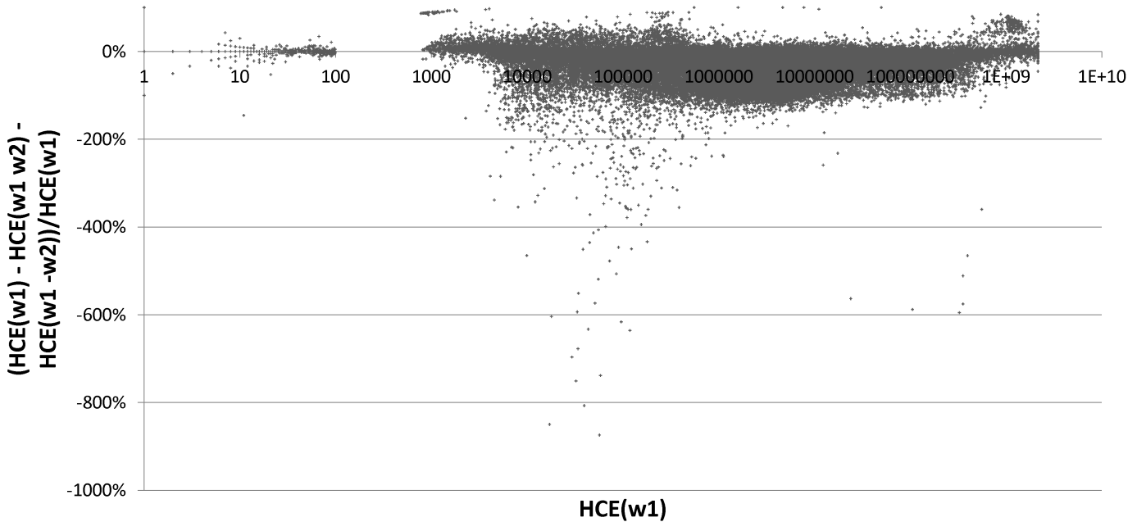
Figure 1. (HCE(w1)- HCE(w1 w2)- HCE(w1 -w2)) / HCE(w1) for 59,545 words w1, paired with another word w2 from a set of 100.

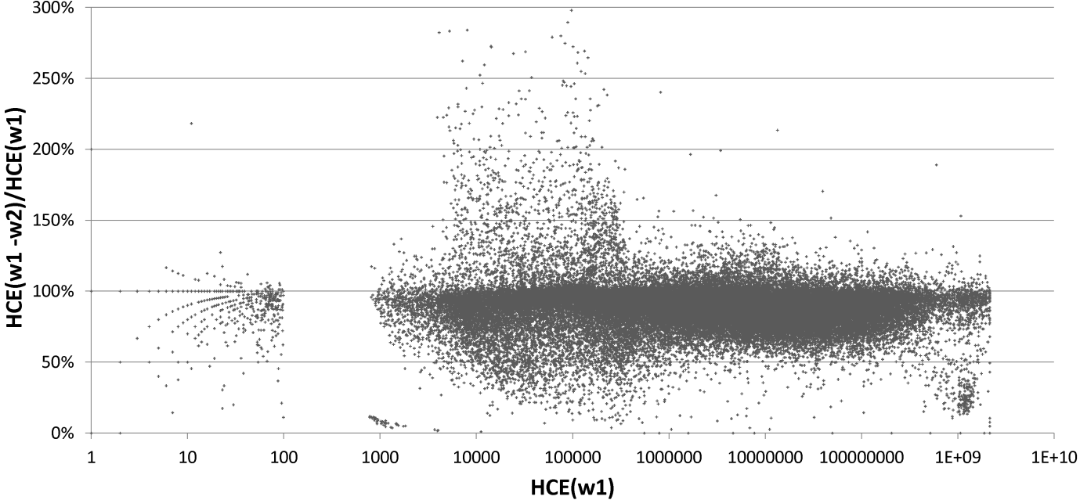
Figure 2. HCE(w1 -w2) / HCE(w1) for 59,545 words w1, paired with another word w2 from a set of 100.

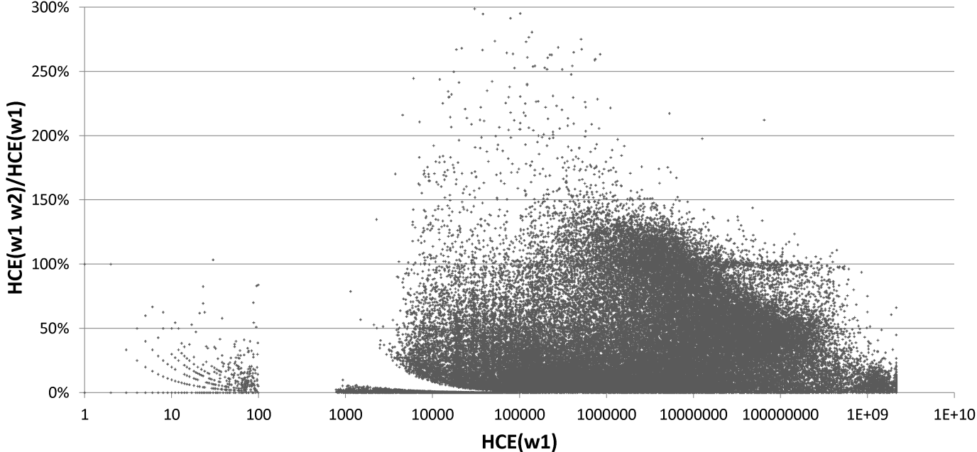
Figure 3. HCE(w1 w2)/ HCE(w1) for 59,545 words w1, paired with another word w2 from a set of 100.

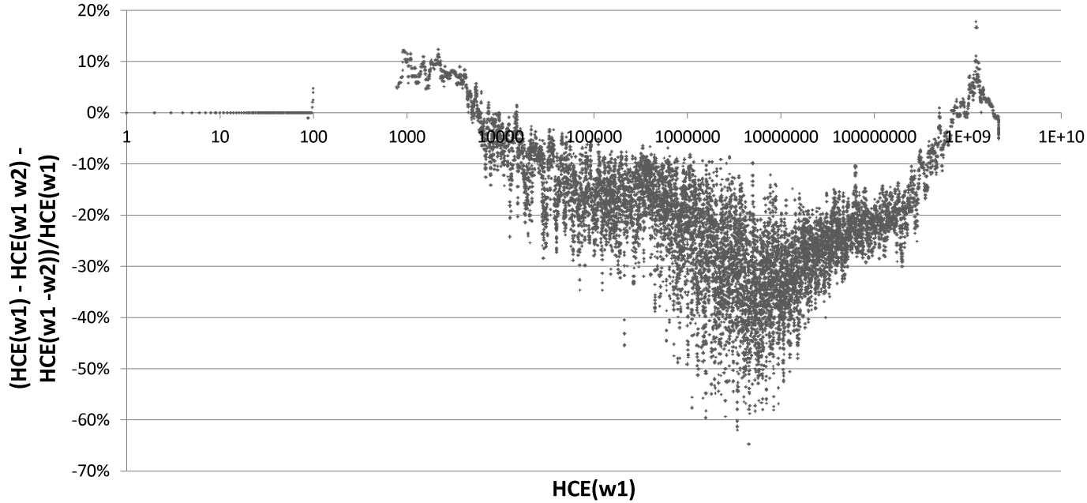
Figure 4. Moving 51-median HCE(w1)- HCE(w1 w2)- HCE(w1 -w2) / HCE(w1) for 59,545 words w1, paired with another word w2 from a set of 100.

To summarise the above discussion, the results suggest that there are a few individual major anomalies in the results for particular queries, but there are also overall trends that make it clear that HCEs are unreliable for values above 100 and that variations of up to about 50% should be treated as normal. Hence webometric applications using HCEs should not rely upon small differences in HCEs to identify patterns but should recognise that there may be spurious causes of differences of this magnitude.

5.2 Query splitting with the Bing Search API 2.0
The relatively low number of URLs returned by Bing for queries, a maximum of 200 in all tests, seems likely to be too low for many webometric applications but could be extended by the technique of query splitting (Thelwall, 2008a). This method generates new URLs matching a query beyond the normal maximum by automatically generating derivative queries and combining the URL lists from the original query with the URL lists of all the derivative queries. The new queries are created (e.g., in Webometric Analyst) by identifying a high frequency word in the results of the initial query and generating two new queries, the original query with the word added and the original query with the word subtracted. For example, suppose that the query Informetrics generates a HCE of 10,000 and a list of 200 results from the Bing API 2.0. Suppose also that the word Journal occurs often in the snippets returned for the 200 matches by Bing. Then the first query split for the query might be the two queries Informetrics Journal and Informetrics –Journal. Since all matches for the two new queries should also match the first one, their results can be combined, potentially tripling the number of matching URLs. In the above example, if the two new queries each generate 200 results then since matches to either query must also match the original query, the total number of matches by combining the three sets of results must contain at least 400 different URLs (since the last two queries are logically disjoint) and could possibly contain 600 URLs if all the results are different. This process can be repeated iteratively to increase the number of URLs more substantially although it cannot continue indefinitely because it is limited by the maximum query length allowed, 256 characters (Microsoft, 2010b).
To test whether query splitting works and how many additional URLs it can potentially get, 180 words of different estimated frequencies from the RSS list described above were submitted to Bing by Webometric Analyst with query splitting. From Figure 5, this technique can be expected to get about 10% as many unique URLs as given by the HCE, if the initial HCE is about 200,000-800,000 (the largest number of URLs extracted by this process was 230,229) but a higher proportion for initial HCEs lower than this. For all HCE sizes, the typical percentage of matches obtained by query splitting seems likely to be significantly less than 100%. It is not clear whether the HCE or the URL count (number of matches obtained by query splitting) is the better estimate of the number of matching URLs, however.

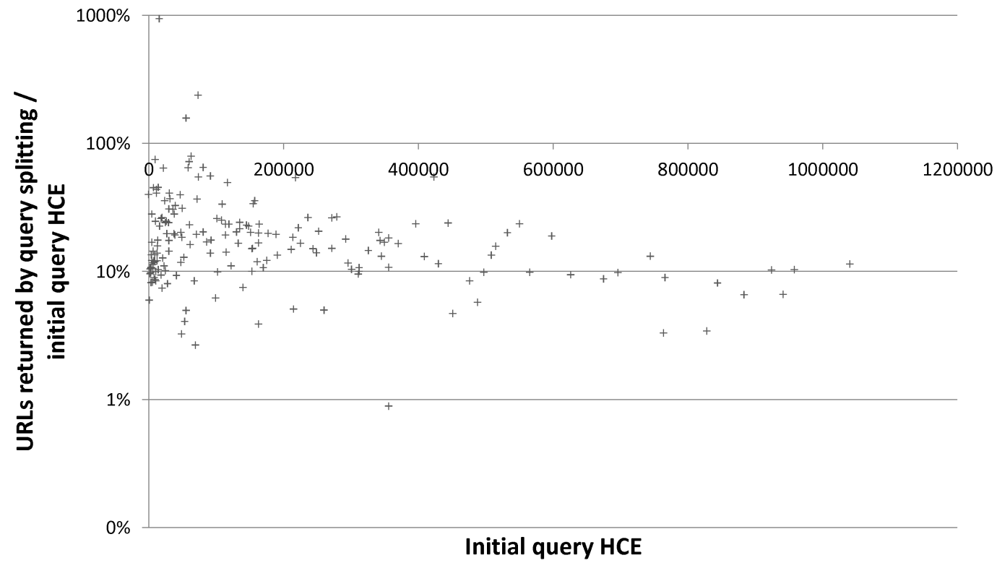
Figure 5. Query splitting results as a percentage of the initial query HCE for 180 words.

Discussion and conclusions
Overall, the Bing Web Services API 2.0 is a practical tool for webometric research but has some important limitations and care must be taken to keep within the legal guidelines when using it. Although it is the last remaining free API from a major international search engine, there are alternatives that could be used as a replacement if it closes in the future or changes its conditions of use to exclude academic research. Of the current alternatives, the major Russian search engine Yandex seems to be the most promising, although a full-scale evaluation is needed to verify this.
In terms of legal requirements, the terms of use for the API show that it is aimed at developers creating applications to deliver Bing search results to end users. Despite this, only search engine optimisation uses of the API are explicitly banned and the terms are phrased in such a way that webometric applications are possible. Nevertheless, the requirement that the users should see all results gathered from any application using the API means that Webometric software should be able to show the user all the information gathered. It also seems reasonable to save parts of the data permanently, such as the HCEs, and to save information derived from the data permanently, such as counts of the numbers of URLs matching searches, which would be useful for many webometric applications. The full data can also be saved to allow the application to display it and it seems that users can view or process it in other applications, such as web browsers or spreadsheets, as long as these other applications are embedded in the Webometric application.
The results of the first experiment discussed above shed light on the performance of the API for webometric purposes. They suggest that Bing’s HCEs should be treated with caution when used in webometrics research and that variations of up to 50% should be considered normal. Hence, it would be unjustifiable to draw conclusions based upon differences of this size in HCEs. Systematic biases are also likely to occur between the accuracy of HCEs of different orders of magnitude, which also serves to undermine comparisons between results. An important limitation of this experiment is that it does not fully assess the reliability of the HCEs – it is possible that Bing HCEs are more unreliable in different ways to that measured here.
For applications needing lists of URLs matching a search that are as complete as possible, the query splitting technique is capable of extracting hundreds of thousands of matching URLs for a single query, but the number of URLs that can be extracted by this method is likely to be less than 100% and closer to 10% for queries with initial HCEs of at least 200,000.
An important limitation of this paper is that all aspects investigated, from Bing itself to its terms and conditions, are subject to change without notice and hence future researchers are advised to check its performance and the terms and conditions before using it for webometric research. In terms of future work, it would be useful to conduct more systematic studies of the anomalies discussed above to seek clear reasons for their occurrence that would help researchers to develop methods to accommodate them.

Acknowledgement
This work was supported by a European Union grant by the 7th Framework Programme. It is part of the ACUMEN project (contract 266632).

References
Altingovde, I. S., Ozcan, R., & Ulusoy, Ö. (2011). Evolution of Web Search Results within Years. Proceedings of the 34th Annual International ACM SIGIR Conference on Research and Development in Information Retrieval (SIGIR'11), Retrieved July 25, 2011 from: http://www.cs.bilkent.edu.tr/~oulusoy/sigir2011_2012.pdf.
Bar-Ilan, J. (2004). The use of Web search engines in information science research. Annual Review of Information Science and Technology, 38, 231-288.
Bar-Ilan, J. (2005). Expectations versus reality – Search engine features needed for Web research at mid 2005. Cybermetrics, 9(1), Retrieved September 26, 2011 from: http://cybermetrics.cindoc.csic.es/articles/v2019i2011p2012.html.
Bar-Ilan, J., & Peritz, B. C. (2009). A method for measuring the evolution of a topic on the Web: The case of “Informetrics”. Journal of the American Society for Information Science and Technology, 60(9), 1730-1740.
Bendersky, M., Croft, W. B., & Smith, D. A. (2010). Structural annotation of search queries using pseudo-relevance feedback. In Proceedings of the 19th ACM international conference on Information and knowledge management (pp. 1537-1540).
Bing. (2010). Phasing out the Bing Search API 1.1. Bing Developer Blog, Retrieved July 7, 2011 from: http://www.bing.com/community/site_blogs/b/developer/archive/2010/2008/2006/phasing-out-the-bing-search-api-2011-2011.aspx.
Bing. (2011). Bing developer center terms of use. Retrieved September 26, 2011 from: http://www.bing.com/developers/tou.aspx (login required).
Björneborn, L., & Ingwersen, P. (2001). Perspectives of Webometrics. Scientometrics, 50(1), 65-82.
Brabham, D. C. (2008). Crowdsourcing as a model for problem solving: An introduction and cases. Convergence: The International Journal of Research into New Media Technologies, 14(1), 75-90.
Cafarella, M. J., & Etzioni, O. (2005). A search engine for natural language applications. In Proceedings of the 14th international conference on the World Wide Web (pp. 442-452). New York, NY: ACM Press.
Gamon, M., & Leacock, C. (2010). Search right and thou shalt find...: using web queries for learner error detection. In Proceedings of the NAACL HLT 2010 Fifth Workshop on Innovative Use of NLP for Building Educational Applications (pp. 37-44). Stroudsburg, PA: Association for Computational Linguistics.
Google. (2010). Google Web Search API. Retrieved July 18, 2011 from: http://code.google.com/apis/websearch/.
Google. (2011). Google custom search APIs and tools. Retrieved July 18, 2011 from: http://code.google.com/apis/customsearch/.
Huston, S., & Croft, W. B. (2010). Evaluating verbose query processing techniques. In SIGIR 2010 (Vol. New York, NY, pp. 291-298): ACM.
Lewandowski, D. (2008). A three-year study on the freshness of web search engine databases. Journal of Information Science, 34(6), 817-831.
Mayr, P., & Tosques, F. (2005). Google Web APIs: An instrument for webometric analyses? . Retrieved January 20, 2006 from: http://www.ib.hu-berlin.de/%2007Emayr/arbeiten/ISSI2005_Mayr_Toques.pdf.
McCowan, F., & Nelson, M. L. (2007a). Agreeing to disagree: Search engines and their public interfaces. Joint Conference on Digital Libraries, Retrieved June 18, 2007 from: http://www.cs.odu.edu/~fmccown/pubs/se-apis-jcdl2007.pdf.
McCowan, F., & Nelson, M. L. (2007b). Search engines and their public interfaces: Which APIs are the most synchronized? WWW 2007, Retrieved January 8, 2008 from: http://www2007.org/htmlposters/poster2868/.
Mettrop, W., & Nieuwenhuysen, P. (2001). Internet search engines - fluctuations in document accessibility. Journal of Documentation, 57(5), 623-651.
Microsoft. (2010a). Microsoft Service Agreement. Microsoft.com, Retrieved July 7, 2011 from: http://explore.live.com/microsoft-service-agreement?ref=none&mkt=en-gb.
Microsoft. (2010b). SearchRequest.Query property. MSDN Library, Retrieved July 6, 2011 from: http://msdn.microsoft.com/en-us/library/cc966954.aspx.
Microsoft. (2010c). WebBrowser control overview. MSDN Library, Retrieved September 27, 2011 from: http://msdn.microsoft.com/en-us/library/w2290k2023d.aspx.
ProgrammableWeb. (2011). Web services directory. Retrieved May 17, 2011 from: http://www.programmableweb.com/apis/directory/2011?apicat=Search.
Snyder, H. W., & Rosenbaum, H. (1999). Can search engines be used for Web-link analysis? A critical review. Journal of Documentation, 55(4), 375-384.
Taboada, M., Anthony, C., & Voll, K. (2006). Methods for creating semantic orientation dictionaries. In Proceedings of Fifth International Conference on Language Resources and Evaluation (LREC 2006) (pp. 427-432). Genoa, Italy: ELRA.
Thelwall, M. (2008a). Extracting accurate and complete results from search engines: Case study Windows Live. Journal of the American Society for Information Science and Technology, 59(1), 38-50.
Thelwall, M. (2008b). Quantitative comparisons of search engine results. Journal of the American Society for Information Science and Technology, 59(11), 1702-1710.
Thelwall, M. (2009). Introduction to webometrics: Quantitative web research for the social sciences. New York: Morgan & Claypool.
Thelwall, M. (2010). Webometrics: emergent or doomed? Information Research, 15(4), Retrieved July 18 from: http://informationr.net/ir/15-14/colis713.html.
Thelwall, M., & Prabowo, R. (2007). Identifying and characterising public science-related concerns from RSS feeds. Journal of the American Society for Information Science & Technology, 58(3), 379-390.
Tian, T., Geller, J., & Chun, S. A. (2010). Predicting web search hit counts. In 2010 IEEE/WIC/ACM International Conference on Web Intelligence and Intelligent Agent Technology (Vol. 1, pp. 162-166). Los Alamitos: IEEE.
Truran, M., Schmakeit, J.-F., & Ashman, H. (2011). The effect of user intent on the stability of search engine results. Journal of the American Society for Information Science and Technology, 62(7), 1276-1287.
Uyar, A. (2009a). Google stemming mechanisms. Journal of Information Science, 35(5), 499-514.
Uyar, A. (2009b). Investigation of the accuracy of search engine hit counts. Journal of Information Science, 35(4), 469-480.
Vaughan, L., & Thelwall, M. (2004). Search engine coverage bias: evidence and possible causes. Information Processing & Management, 40(4), 693-707.
Vaughan, L., & You, J. (2010). Word co-occurrences on Webpages as a measure of the relatedness of organizations: A new Webometrics concept. Journal of Informetrics, 4(4), 483-491.
Yahoo! (2011a). Yahoo! Search BOSS. Retrieved July 18, 2011 from: http://developer.yahoo.com/search/boss/.
Yahoo! (2011b). Yahoo! Search BOSS services terms of use. Retrieved July 25, 2011 from: http://info.yahoo.com/legal/us/yahoo/search/bosstos/bosstos-2317.html.

Thelwall, M. & Sud, P. (in press). Webometric research with the Bing Search API 2.0, Journal of Informetrics. © copyright 2011 Elesevier, Inc.

