User Manual for Mozdeh RSS Feed Analyser

User Manual for Mozdeh RSS Feed Analyser 1
Introduction 1
What is this document? 1
What can Mozdeh RSS Feed Analyser do? 1
System requirements 2
Basic Mozdeh operations 2
Starting up 2
Searching for keywords 2
Producing time series 3
Fast onscreen results 3
Time Series Scanning 4
Main Options 5
Top Stories Report Options 6
What is all the information in the time series file? 7
Producing a new project of aggregated daily feeds 8
Producing a new project by combining two or more other projects 9
Producing a new time series of items containing a word 9
Using Boolean searching 10
Using combinations of basic operations 10
Glossary 10

Introduction

What is this document?
This is the user manual for Mozdeh in its role as RSS Feed Analyser. To use this manual you must have (a) Mozdeh and (b) a set of pre-collected RSS feeds collected with Mozdeh. The (separate) Mozdeh RSS Feed Collector manual covers instructions for the collecting of RSS feeds. When analysing pre-collected feeds many of the Menu options in Mozdeh will be permanently unavailable: these are options that are only usable in Collector mode: you will not need them.

What can Mozdeh RSS Feed Analyser do?
It can do the following:
- Produce daily time series of the frequency in which particular words occur.
- Identify the words with the biggest increase in frequency.
- Search the corpus for items that contain a particular word.
- Create a new corpus consisting of just the items or feeds that contain a given word.
- Both 3 and 4 above for Boolean expressions instead of words (e.g., science OR technology AND fear)
- All of the above in any combination
- All of the above either based on individual feed items or whole daily feeds (see below for more information)

System requirements
Mozdeh runs on any version of Windows after Windows 95. Its memory requirements depend on the size of the corpus, but it may run slowly with <1Gb of RAM. It may need three times the hard disk space that is taken up by the initial corpus. If you conduct many analyses this may increase to ten times the initial corpus size, or more. The reason is that each new derivative project that you make could take up to one and a half times the size of the initial corpus.

Basic Mozdeh operations

Starting up
When you start Mozdeh you will be asked to select a project to open. The first time you open a project you will probably be asked if you want to prepare the project for searching. You can choose not to do this, but if you don’t take this option then you will not be able to search for keywords or produce time series. The only things you can do if you do not prepare the project for searching are (a) look at information about the feeds (e.g. Feed URLs) and (b) produce a new aggregated corpus (see below).

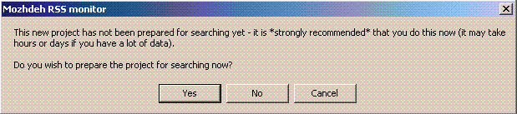
If you opt to prepare the project for searching then beware that this may take a very long time – maybe days if you have a corpus of 1 Gb or more. Once the indexing has started it is not possible to stop it – if you have to stop it or the computer crashes during the index then you will need to delete the corpus and then reinstall it. Sorry.

Searching for keywords
Select Analyse|Find Items Containing Word and Make New Project From Matching Items.
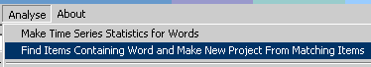
Now in the box at the bottom, type a keyword (e.g. maths) and then click on the Boolean Search button. Make sure the tickboxes are NOT checked.
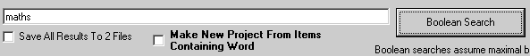

The results will appear in the box above. If there are loads of results then you will only be allowed to see the first 100 or last 100 – whichever you prefer. Below is an example of the results (for the maths search).
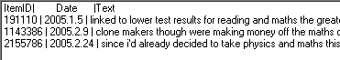
- You can ignore the ItemID.
- The Date is the date on which the information was originally colleted.
- The Text is a selection of words extracted from the RSS Item matching your search. Normally you will see your word somewhere in this list.
If you click on one of the items then you will get an extended list of words from the item. Note that this is not the original item but an extraction of words from the item. All the capital letters have been removed and most of the punctuation, so you may find it difficult to make sense of.
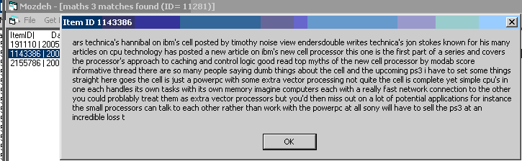
Note that at the top of the screen after a search the total number of matches is shown. This is the number of items containing your word (3 items in the project contain the word maths in the above case). Next to this at the top of the screen is the ID of the word (maths has ID 11281). Word IDs can be used to produce a time series analysis of individual words (see below).

Producing time series
There are two options here: fast onscreen results or saving a summary file.

Fast onscreen results
Select Analyse|Time Series Graph.
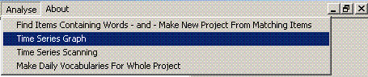
We will just use the left-hand side of the screen. Enter your word in the box at the bottom and click the Search button (note that Boolean searches are not possible here –see below for where they are possible).
The time series graph will then appear as shown below.
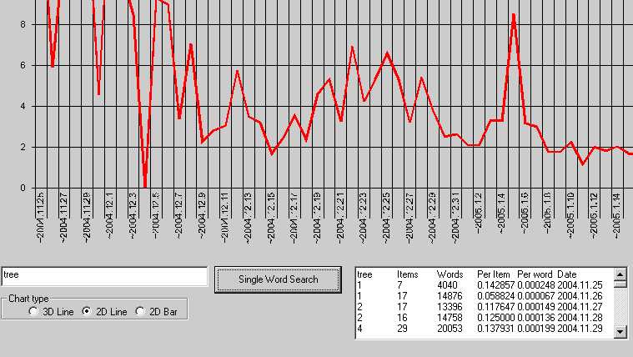

In addition, the results are available in text form below the graph: the full results are in the box, even though only the first few are shown. You can select the results and then cut and paste them elsewhere (e.g. into word or Excel) using Ctrl-C and Ctrl-V.
The results below illustrate the data available.

science Items Words Per Item Per word Date
0 0 0 0.000000 0.000000 2004.12.4
7 33 22076 0.212121 0.000317 2004.12.6
5 22 9375 0.227273 0.000533 2004.12.7
8 22 12985 0.363636 0.000616 2004.12.8

- The last column gives the date to which the information in the row refers.
- The first column contains the number of items in which the word was found on that date.
- The second column gives the number of items in the project on that date.
- The third column gives the total number of words in all items on that date.
- The fourth column gives the proportion of items on that date containing the word.
- The fifth column contains the proportion of words on that date that were equal to the keyword.

Time Series Scanning
These are the main, heavy-duty time series results, based upon scanning some or all of the words in the corpus and identifying all the spike words.
Select Analyse| Time Series Scanning
.
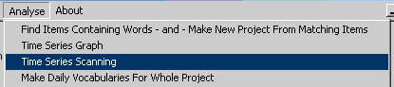

There are very many options for scanning on the right-hand side of the screen.
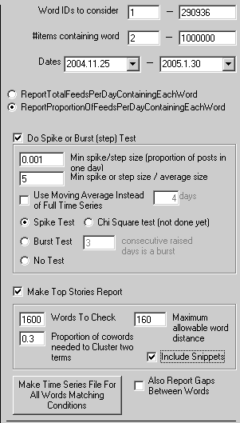
All the options above Make Top Stories Report should work well without being changed for most corpuses. They are described below.
Checking Make Top Stories Report starts a process of automatically clustering the results. This may take a very long extra amount of time. For 1600 words to check, it might take 4 hours for a large corpus. If you increase the Words to Check beyond 1600 it might really take a long time.

Main Options
You may need to change some of the options in the box to get a better set of results. They are as follows:
Word ID to consider The default upper and lower bounds are the full range of words in the data set. You may need to change these if you get too many results. If you only want the time series of one word, you can enter its ID in both boxes and you will just get the one time series. Use the Searching for Keywords facility to find the ID of any word.
# of items containing word You can specify a minium and maximum value for the number of items containing the words to give a time series for. Setting a high minimum value filters out rare words and setting a low maximum value filters our common words.
Do a spike or burst test Checking this box means that time series are only produced for words that produce a spike or burst in the data set because their use suddenly increases at some point in time.
Lead in time (days) If this number is set >0 then the data for the number of days specified is ignored. Use this if the first few days in your data set are unreliable, perhaps because they have only a few feeds. Use it also if you are only interested in recent data and want to ignore the early part of your data set.
Min spike size/step size This number (<1) specifies the minimum proportion of daily items that the word should occur in when it spikes or bursts. Setting a high value for this ensures that your time series only include words that occur across a significant proportion of the feed items.
Spike or step size / average size This is the minimum number of times more frequent than average a spike or word frequency must be to count. Setting this number high ensures that only the biggest spikes or bursts are saved in the time series file. The average used is a word average – this means that a spike is when a word occurs much more often one day than it did the day before.
Use moving average instead of full time series Select this option if part of your time series is unreliable. If this option is NOT selected then the average word frequency is calculated using all data prior to the date analysed. If it is selected then only the date for the previous few days (the number in the adjacent box) will be used for averages.
Type of test
- A spike test is a test for a high word frequency on a single day
- A burst test is a test for high word frequencies on several consecutive days (the number specified in the adjacent box)
- No test No testing is used.

Top Stories Report Options
Words To Check is the number of top spiking words to be processed for this section of processing, which is based upon identifying spike words that tend to occur in the same stories.
Maximum allowable word distance This is how many words is the maximum that you will allow to separate two words and still consider them to be about the same topic. Setting this to 2 means that the words have to be consecutive. Any larger number means that they do not have to be consecutive but must be close in some sense. If using Whole Feeds, the words must always be in the same item (post), irrespective of the distance set.
Proportion of cowords needed to Cluster two terms This is the minimum proportion of times two words must occur together (as defined by the Maximum allowable word distance setting) in order for them to be flagged as clustered. For example, if “stem” and “cell” occur together in 5 out of 10 stories on the peak day of the highest frequency word, then they would be clustered as long as the proportion had not been set higher than 0.5.
Include snippets If checked, an extra column will be added to the results file to contain a section of a post on the peak day of each word. This is to give some context to why the word spiked.
Also report gaps between words You probably don’t want to do this, but if you select this option then a file will be created that for each word records the number of days between consecutive appearances of that word.
Clicking on the Make time Series File… button will start the process of producing a file containing a time series for words in the data set. After clicking on the button you will be asked to give a file name – make sure you also select a location for the file that you will be able to find later (e.g. My Documents). The file produced must be loaded into a spreadsheet so that you can make sense of it.

What is all the information in the time series file?
Here is an annotated example of the top few rows of a time series file, which contain information about how the file was produced – the options selected.

Data Folder: c:\rss_data\ Project: time sci etc worry etc\ | The project name and where it was stored
MinWordFrequency:1 MaxWordFrequency:1000 | The minimum and maximum word frequencies for all words in the reported time series
LeadInPeriodDays:5 | The number of initial days’ data ignored before the analysis started.
Using cumulative frequency, not moving average | Whether using the moving average method to calculate average frequencies, or using the full data set
MinSpikeSize:0.001 SpikeSizeOverAverageSize:5 | The minimum proportion of items the word must occur in to count as a spike or burst; and the minimum number of times larger than average the word must occur to count as a spike or burst
EarliestWordIDToConsider:1 LastWordIDToConsider:61307 | The IDs of the first and last words to be checked
Burst test. Min burst duration (days):3 | Whether a spike test (1 day) or a burst test (several days). If a burst test, the number of days of consecutive high values.
Tip: if loading the time series file into a spreadsheet, cut and paste the lines above into a separate worksheet so they do not obstruct the data.

After the information section is the actual data. Here is the start of some…
ID | Count | Items | Max relative spike | Max absolute spike | Word
92 | 1306 | 801 | 7.9 | 0.276 | fear
2530 | 1021 | 585 | 999999 | 0.241 | heart

The meanings of these are as follows:

- ID The word ID
- Count The number of times the word appears in the project
- Items The number of items the word appears in the project
The others are more complicated. They are based upon the statistic word proportion = [items containing word in one day]/[total items for that day]
A relative spike is the word proportion for one day divided by the average word proportion for the same word on previous days.
An absolute spike is the word proportion for one day subtract the average word proportion for the same word on previous days.
- Max relative spike The maximum value of the relative spike for the word for the whole time period assessed.
- Max absolute spike The maximum value of the absolute spike for the word for the whole time period assessed.

The rest of the information is daily word frequency data. For each day the proportion of feeds containing the word is given. In the example below, the word heart does not occur on any of the days and the word fear only occurs on the 29th of November, 2004. On this date it occurs in 0.2 of all items, i.e. a fifth of all items.

Word | 2004.11.26 | 2004.11.27 | 2004.11.28 | 2004.11.29 | 2004.11.30
fear | 0 | 0 | 0 | 0.2 | 0
heart | 0 | 0 | 0 | 0 | 0

TIP: if you can get your spreadsheet set up as below, with all the daily data columns shrunk in width, then it is easy to create time series graphs.
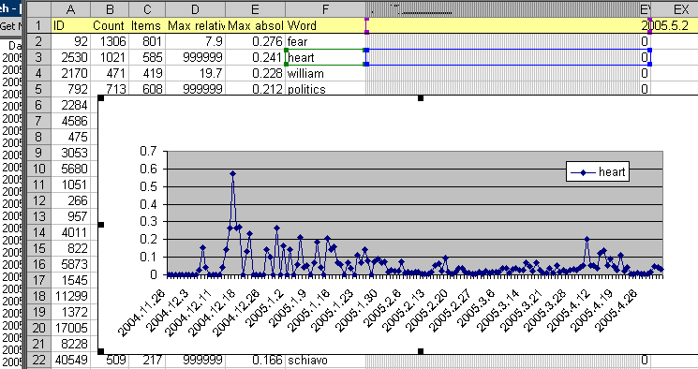

Producing a new project of aggregated daily feeds
What is this for? Time series analyses often work best if all the items from a feed on one day are merged into a single daily feed item. This section shows you how to tell Mozdeh to create a new project with all the feed items merged together for each feed and for each day (i.e. a maximum of one big feed item per feed, per day).
Select Aggregate|Make DailyFeeds From Individual Items.
When you have selected this option you will see a message box to confirm that this is what you want to do.
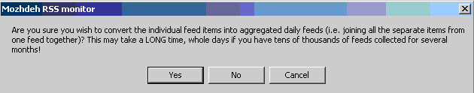
Note that this process takes a long time! So click Yes only if you are able to wait while this is happening.
When this has finished, the next time you start Mozdeh you will see a new project with the same name as your old project except with “.Whole Feeds” at the end of its name.

Producing a new project by combining two or more other projects
You can merge two or more projects together into a new combined project. To do this, open up one of the projects in Mozdeh, then:
Select Aggregate|Merge Projects
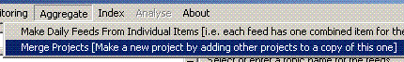
Select the names of all the project that you want to add to this one by choosing their names in the drop-down dialog box. If you select the wrong project, click on the project name in the lower part of the window to remove it. When you have selected all the projects that you want to add to the project already loaded, click OK.
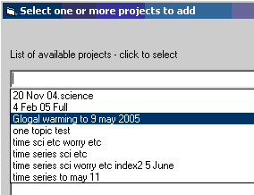
When the program has finished, the next time you start Mozdeh you will see the new project.

Producing a new time series of items containing a word
Select Analyse|Find Items Containing Word and Make New Project From Matching Items.
Enter the word that you would like to search for in the bottom of the new screen.
Check the Make New Project From Items Containing Word button.
Click on the Boolean Search button.
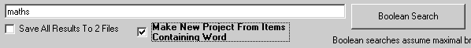
You will be asked for a name for the new project. Creating the new project may take a long time. When the process has finished, you will see the new project in the list of projects when you next start Mozdeh.

Using Boolean searching
Boolean searching is using a number of words and constructing a logic statement to declare which combinations of words you want to search for. Mozdeh’s Boolean searching is very simple, just consisting of the commands AND and OR (implicit). It is available for keyword searching and for producing new projects but not for time series analysis.
Select Analyse|Find Items Containing Word and Make New Project From Matching Items.
In the box at the bottom of the screen you can enter several words. If none of the words are AND then they will be processed as OR. For example, if you enter “maths day Tuesday” then the results will be all items that contain the word maths or the word day or the word Tuesday.
Use the word AND to refine your search to ensure that the matches contain all the words that you want. For example to search for items containing all of the words maths, day and Tuesday, enter “maths AND day AND Tuesday”. You will get a much smaller set of results!

Using combinations of basic operations
Here are some suggestions for useful ways of combining the basic operations.
- If you produce time series using the original project data you might find a few individual feeds dominating the results because they repeatedly post the same story throughout the day. This can be avoided by converting the project to a daily feed-based project and then producing the time series.
- If you are only interested in feed items related to a particular topic, such as science concerns, then you could produce a new project containing just the feed items containing science or concerns (i.e. using “science concerns” in the Boolean Search box above) and then conduct your time series analysis on this new project.

Glossary
RSS Stands for Really Simple Syndication or Rich Site Syndication (take your pick). This is the name for the structured format in which RSS Feed information is posted. In fact there are many variants of the RSS format, including Atom and RSS 1.5. RSS in an application of XML. You don’t need to know any of this to use Mozdeh effectively.
RSS Feed This is a URL to which is posted information that is regularly updated. For example the BBC Football web site RSS feed contains the results of the most recent matches as well as the headlines and short descriptions of the most recent stories. RSS feeds are used by many newspapers and Blogs as well as many other sites.
RSS Feed Corpus This is collection of RSS Items collected from a number of RSS Feeds by monitoring them and checking for updates over a period of time.
RSS Feed Item When an RSS Feed URL is accessed and downloaded, it consists of a list of separate Items. Each item is a self-contained piece of information, typically the title and a brief description of a single news story/single blog posting.

